Mathematics Instructional Plan – Algebra I

Curve of Best Fit
Strand: Statistics
Topic: Developing a curve of best fit for data
Primary SOL: A.9 The student will collect and analyze data, determine the equation of the curve of best fit in order to make predictions, and solve practical problems, using mathematical models of linear and quadratic functions.
Related SOL: A.1, A.6

Materials
- Computers with internet access
- Curve of Best Fit activity sheet (attached)
- Graphing calculators

Vocabulary
curve of best fit, linear equation, line of best fit, quadratic equation, regression equation, slope, y-intercept

Student/Teacher Actions: What should students be doing? What should teachers be doing?
Note: If you would prefer using a non-computer-graphing utility, use the lesson Curve of Best Fit. Before using this activity, the teacher will need to use the link provided below to visit Desmos, set up an account, familiarize himself/herself with the activity, and create a class code. This class code allows the teacher to see each student’s progress from a desktop computer as they work through the activity. (https://teacher.desmos.com/activitybuilder/custom/59d2765ce7b4ed0fb26d187b)
- Students should each have a computer with internet access on the day this activity is used.
- Have students visit the website https://student.desmos.com/ and enter the class code shared by the teacher.
- The students will progress through the 14 slides provided. As a teacher, you can monitor their progress on your desktop and see who might need your help.
- When students land on screen 8, they will need the attached worksheet to record their answers.

Assessment

Questions
    - What is a real-world data-collection situation that would lend itself to a linear relationship?
    - What is a real-world data-collection situation that would not have a linear relationship? What shape would the data in this situation make when graphed?

Journal/Writing Prompts
    - Explain how some jobs might use linear or quadratic regression equations that best fit data to make predictions.
    - Describe how the sliders for m and b (y = mx + b) affected the line of best fit as you worked through the Desmos activity. How did the sliders for a, b, and c (y = ax² + bx + c) change the quadratic curve?

Other
    - Have students create a display, such as a poster, to show data, the graph, and the curve of best fit.

Extensions and Connections
- Teachers should follow this activity with instruction relating to how to use a graphing calculator to find the regression equation for a curve of best fit.
- Students could analyze data, of their choosing, to determine an equation for a curve of best fit and make a prediction for some time in the future.
- Teachers could discuss the shifts seen when students change the values of the coefficients or the constant in the quadratic expression of an equation. This would be a form of preteaching higher-level algebra concepts.

Strategies for Differentiation
- Teachers can project the activity using a demonstration tool (e.g., document camera, digital display) and allow for a more guided atmosphere.
- Provide a printed version of the entire activity and manipulate a string or yarn to fit curve/line.
- Create a small group for the activity that is more teacher-led.

Note: The following pages are intended for classroom use for students as a visual aid to learning.

Virginia Department of Education © 2018

Curve of Best Fit
Name Date
Directions: Use this worksheet to record your answers for the five examples provided at the end of the Desmos exploration.

1.)  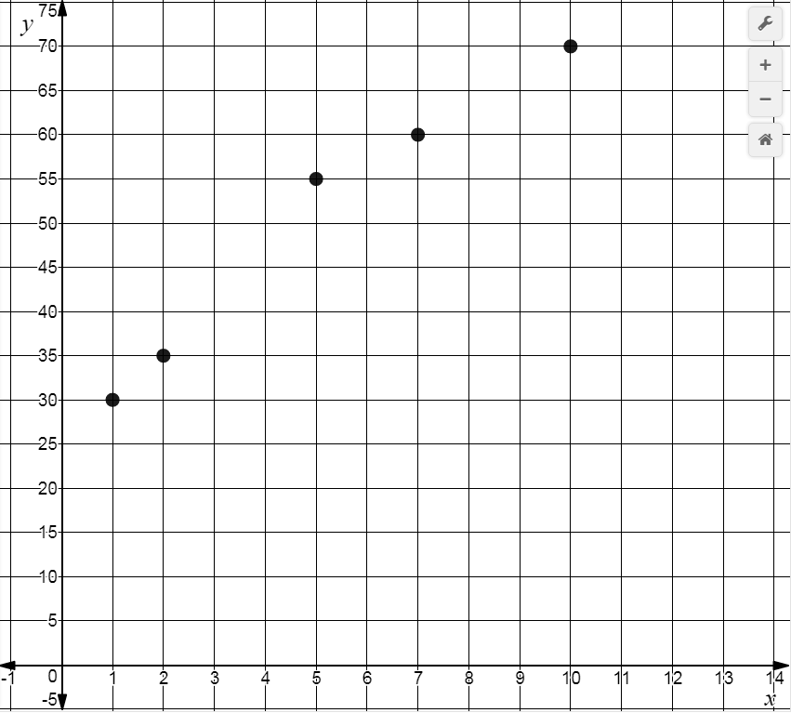 | Circle the appropriate term to  describe the curve of best fit:  Linear Quadratic  Record an equation for your curve  of best fit in the space below:
2.)  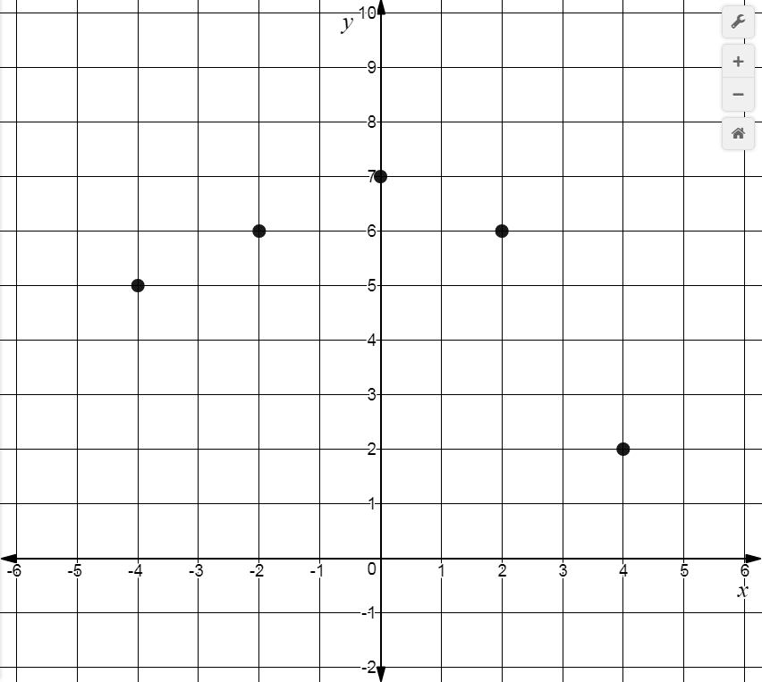 | Circle the appropriate term to  describe the curve of best fit:  Linear Quadratic  Record an equation for your curve  of best fit in the space below:

3.)  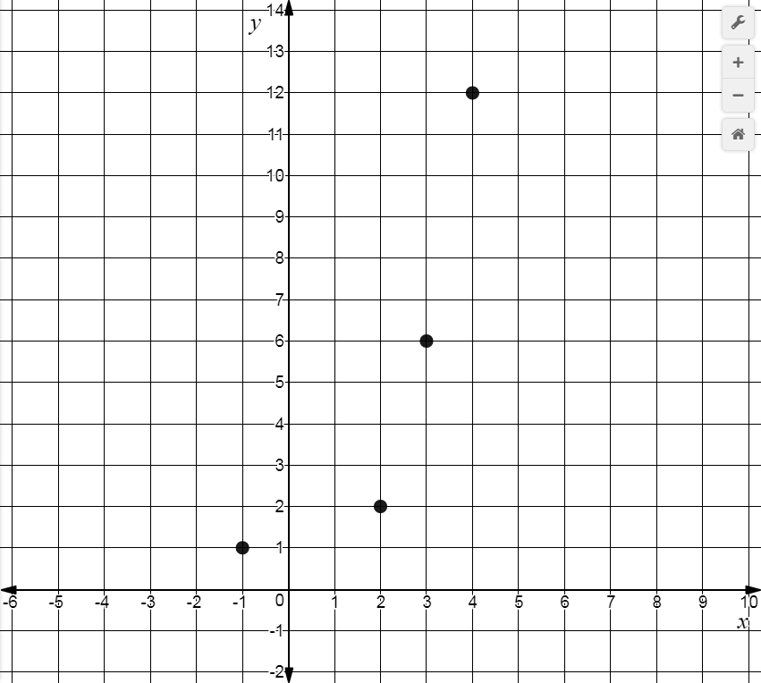 | Circle the appropriate term to  describe the curve of best fit:  Linear Quadratic  Record an equation for your curve  of best fit in the space below:
4.)  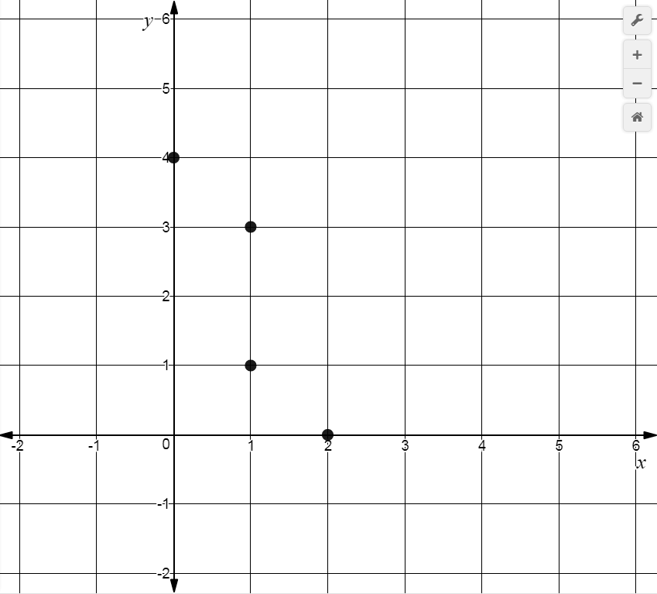 | Circle the appropriate term to  describe the curve of best fit:  Linear Quadratic  Record an equation for your curve  of best fit in the space below:
5.)  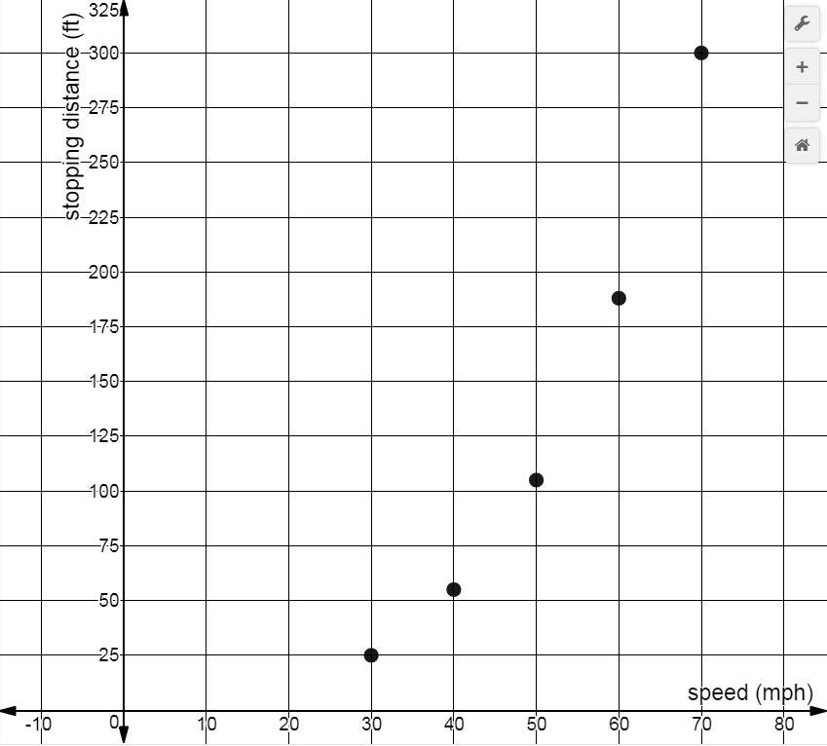 | Circle the appropriate term to  describe the curve of best fit:  Linear Quadratic  Record an equation for your curve  of best fit in the space below:

The last graph displays data collected regarding the stopping distance (in feet) for a car travelling at a speed of x mph. Use your equation to predict how many feet it would take a car travelling at 100 mph to come to a stop.

