Mathematics Instructional Plan – Algebra I

Inverse Variation
Strand: Functions
Topic: Determining inverse variation
Primary SOL: A.8 The student, given a data set or practical situation, will analyze a relation to determine whether a direct or inverse variation exists, and represent a direct variation algebraically and graphically and an inverse variation algebraically.
Related SOL: A.1, A.4e

Materials
- Graphing calculators (optional)
- Direct, Inverse, or Neither activity sheet (attached)

Vocabulary
dependent variable, direct variation, factor, independent variable, rate (A.8)

Student/Teacher Actions: What should students be doing? What should teachers be doing?
- Display the following problem: “You are currently planning a road trip across the United States. You plan to stop and take a break every 120 miles. How long might you be driving between breaks?” Give students some time to think, and then ask them to share ideas. The idea of speed making a difference in the time it takes to go 120 miles should come up, but if not, ask students whether the speed they drive makes a difference. Ask them to identify the independent variable (speed), the dependent variable (time), and the constant (distance) in this situation.
- Have students work in pairs or small groups to find various speeds and times it would take to travel 120 miles. As students work, take note of how they are calculating speeds and times (e.g., taking the distance and dividing it by the speed or using factors of 120). Also, take note of the units they are using for speed and time. (Most will use miles per hour for speed, but they may use hours and/or minutes for time. As they share ideas, they should use hours for consistency and to show the inverse relationship between speed and time.)
- Have the class share their solutions. Ask them to suggest an effective way to organize the data involved in their solutions (a table). Ask them to explain why they should use hours and not minutes as the unit for time (because the units for speed and time must be comparable in order to see the relationship between them). Some pairs or groups may have fractions of hours for their time. Set up a table with speed as the left column and time as the right. As students share their solutions, record them in the chart for the class to see.
- Ask students to explain how they arrived at their solutions, and record the strategies in words for the class to see. (You should include the strategies of dividing 120 by the speed and of using factors of 120, as well as any others offered. This will allow you to make connections to the equation y = $\frac{k}{x}$ and to emphasize that the speed and time have a constant product—distance—shown by the equation k = xy. You might explain solutions that involve fractions of hours in terms of the first strategy mentioned and whole-number solutions in terms of the second strategy.)
- Ask students how they could make an equation so that they could easily find any solution to this problem. You may suggest looking at their strategies written in words and deriving equations from them. Once both equations, y = $\frac{120}{x}$ and 120 = xy, are posted, ask whether these equations are equivalent. Have students explain why.
- Tell the class that they have just investigated an inverse variation, which is a relationship in which two variables vary inversely (i.e., when one variable increases, the other decreases in proportion so that the product remains the same). This particular inverse relationship can be called an inverse variation, because the speed and time values have a constant product, a distance of 120 miles. This constant product makes it possible to create an equation for the inverse variation. All inverse-variation equations are of the form y = $\frac{k}{x}$ , where k is the constant of variation. Have students compare this equation with the ones they created.

Assessment

Questions
    - How can you tell whether a situation or set of values represents an inverse variation?
    - What does an equation for an inverse variation look like?

Journal/Writing Prompts
    - Give your own example of an inverse variation, and explain why your example meets the criteria for an inverse variation.
    - Explain how you could create an equation for an inverse variation, given a context or given a table of values.
    - Compare and contrast direct and inverse variations.

Other
    - Provide students with several tables, graphs, equations, and situations. Ask them to group them into those representative of direct variations, those representative of inverse variations, and those that represent neither.

Extensions and Connections (for all students)
- Have students explore the graphs of inverse variations, using graphing calculators.
- After students have made observations about the graph of an inverse variation, ask, “Is it what you expected to see? Why isn’t the graph linear? Why doesn’t it touch either of the axes?” It may help to revisit the context of the problem, asking, “What do the variables on the axes represent? Is there a speed at which you could go 120 miles in zero hours? Could you drive at zero mph and still travel a distance of 120 miles? If you drove 1 mph, would you get there? How long would it take?” Link their answers to the graph.

Strategies for Differentiation
- Have students create a graphic organizer for mathematical relations with examples of inverse variations, direct variations, and neither.
- Instead of cutting up the cards on the Direct, Inverse, or Neither activity sheet, consider making the activity a standalone activity.
- Limit the number of problems students are expected to complete in order to show mastery.

Note: The following pages are intended for classroom use for students as a visual aid to learning.

Virginia Department of Education © 2018

Direct, Inverse, or Neither
Directions: Walk around the room. When the music stops pair up with the person closest to you. Tell them whether they have a direct, inverse, or neither relationship. They will check your answer and then you will switch cards.
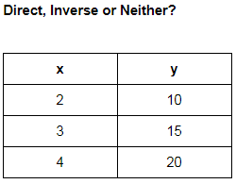 | 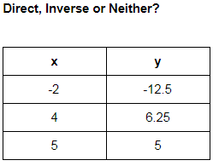 | 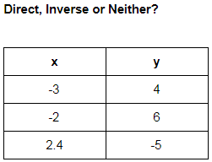
Direct, Inverse or Neither?  {(12, 4), (9, 3), (6, 2), (3, 1)} | Direct, Inverse or Neither?  {(-4, 2), (-2, 1), (6, 3), (8, -4)} | Direct, Inverse or Neither?  {(-8, 2), (-6, 1.5), (0, 4), (16, 4)}
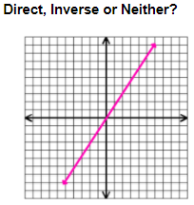 | 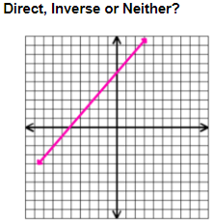 | 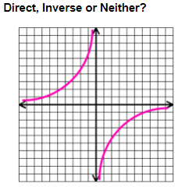
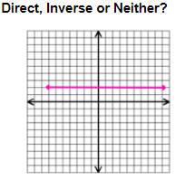 | 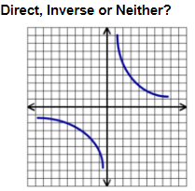 | Direct, Inverse or Neither?  y = 3x

Direct, Inverse or Neither?  y = 1/2x | Direct, Inverse or Neither?  y = 4x + 1 | Direct, Inverse or Neither?  12 = xy
Direct, Inverse or Neither?  5 = y/x | Direct, Inverse or Neither?  8 = xy | Direct, Inverse or Neither?  y = 4/x
Direct, Inverse or Neither?  y = 5x | Direct, Inverse or Neither?  18 = xy | 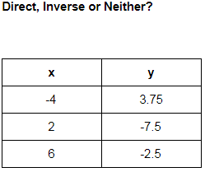
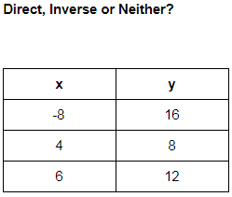 | 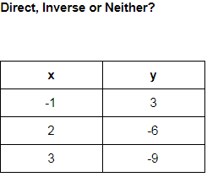 | 