Mathematics Instructional Plan – Algebra I

Quadratic Connections
Strand: Functions
Topic: Relating the roots (zeros) of a quadratic equation and the graph of the equation
Primary SOL: A.7 The student will investigate and analyze linear and quadratic function families and their characteristics both algebraically and graphically, including
          - zeros;
          - intercepts;
Related SOL: A.2c, A.4b

Materials
- Graphing calculators
- Quadratic Connections activity sheet (attached)

Vocabulary
factor, quadratic equation, root of a function, x-intercept, zeros of a function

Student/Teacher Actions: What should students be doing? What should teachers be doing?
- Distribute the Quadratic Connections activity sheet.
- Direct students to work in pairs to complete the table on the first page of the activity and investigate the relationships between the various pieces of information.
- The partners should then continue to the second page and respond to questions 4 through 9 together.
- When students have finished this part of the activity, hold a class discussion about the information in the table and the associated questions.
- Have pairs of students continue and complete the table on the last page of the activity.
- Encourage each pair to check their work with a graphing calculator to verify the accuracy of their answers.

Assessment

Questions
    - If you know the x-intercepts of a quadratic graph, how do you use that information to write the factors of the equation?
    - How do you use the factors to write the equation of the quadratic?

Journal/writing prompts
  - Explain the relationship between the more general function $y=x^{2}-8x+15$ and the specific equation $x^{2}-8x+15=0$. Include in your explanation how the graph of the function can help you factor and solve the equation.
  - Some quadratic equations have one solution, while others have no solution. What do you think the graphs of the functions associated with these equations might look like? Explain your reasoning.

Other Assessments
  - Students could be provided with a sorting activity where they are asked to match the graph of a quadratic function with its x-intercepts, zeros, an equation with the same factors used to create the function, and a solution set for the equation.
  - Students can determine two points on the graph of the function
$y=x^{2}+10x+21$ by factoring the equation $x^{2}+10x+21=0$.

Extensions and Connections
- Provide students with the graph of a cubic function and ask them to determine an equation for the function.
- Connect this content with that of solving a system of equations, because we are looking for the points of intersection between the quadratic function and the line $y=0$.

Strategies for Differentiation
- Encourage the use of graph paper or individual dry-erase boards with grids for students to make connections between the graphing technology and the content.
- Have students complete 1-3 with their partner, and use 4-9 in small-group instruction led by teacher.
- Use a graphic organizer to help find what the sum “b” and product of “ac” are in a quadratic expression in the form ax² + bx + c.
- Cut the first page of Quadratic Connections activity into strips to isolate each problem.
- Have students complete each column first before moving on to the next column for 1-3.

Note: The following pages are intended for classroom use for students as a visual aid to learning.

Virginia Department of Education © 2018

Quadratic Connections
For each quadratic equation below,
- Rewrite the quadratic equation in factored form.
- Use a graphing calculator and its table function to help you sketch the graph of the function with the same polynomial expression set equal to y instead of 0.
- List the x-intercepts seen on the graph.
Quadratic Equation | a. Factored Form | b. Graph | c. x -intercepts
Example:  $$x^{2}+x-2=0$$ | $$(x-1)(x+2)=0$$ | 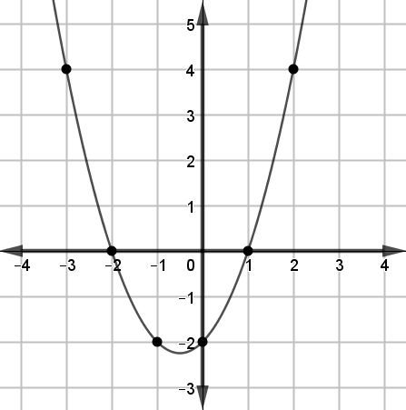  $$y=x^{2}+x-2$$ | (-2, 0) and (1, 0)
1.

$$x^{2}+x-6=0$$

2.

$$x^{2}-5x+4=0$$

3.

$$x^{2}+4x+3=0$$

- Describe where you find the x-intercepts of a graph.

- The x-intercepts for the graph of $y=x^{2}+x-2$ are located at (-2, 0) and (1, 0).
  - What do all coordinate pairs for an x-intercept have in common?

- What relationship do you notice between the factors you created in part a of the table on the previous page and the x-intercepts that you recorded in part c?

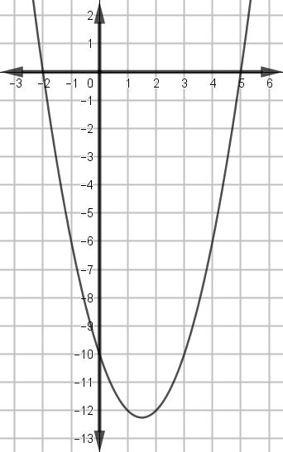
- Use the relationship that you described in question 6 to predict what quadratic function (in factored form) was used to create the graph to the right.

- Why is the x-coordinate of an x-intercept also referred to as a zero of the function?

- How do the zeros of a function relate to the solution set for the quadratic equation that, when set equal to zero, has a polynomial expression that matches that of the function?

Use your knowledge of the relationships between x-intercepts, zeros, factors, and solution sets to complete the table below.
Graph | x-intercepts | Zeros of the function | Quadratic Equation  (in factored form) that may prompt you to look at the graph provided | Solution Set for the equation
Example:  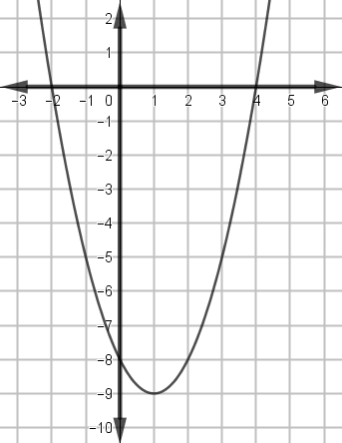 | (–2, 0)  and  (4, 0) | -2 and 4 | $$(x+2)(x-4)=0$$ | {–2, 4}
10.
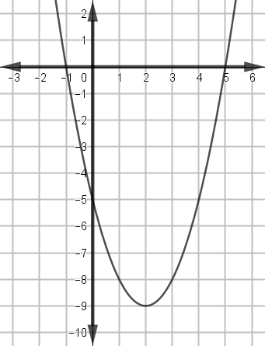

11.
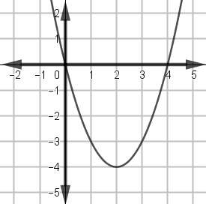

Note: You may want to use your graphing calculator to verify that the equation you recorded in the fourth column produces
the graph pictured in the first column.

