Mathematics Instructional Plan – Algebra I
Functions 2: Exploring Quadratic Functions
Strand: Functions
Topic: Investigating domain, range, intercepts, and zeros
Primary SOL: A.7 The student will investigate and analyze linear and quadratic function families and their characteristics both algebraically and graphically, including
        - domain and range;
- zeros;
- intercepts;

Related SOL: A.1, A.4, A.6

Materials
- Graphing calculators
- Exploring Functions activity sheet (attached)
- Exploring Transformational Graphing of Quadratic Functions

Vocabulary
dependent variable, domain, independent variable, function, range, y-intercept (A.6)
x-intercept, zero (A.7)

Student/Teacher Actions: What should students be doing? What should teachers be doing?
- Ask students whether they have ever felt pressure in their ears when they were underwater. Ask whether they ever wondered how fireworks shows are orchestrated. Tell them these situations, along with many others, can be related to mathematics and functions. They will explore two situations: one concerning the amount of pressure on a submarine’s hull as it descends in the water and one concerning the height of a firework over time.
- Distribute the Exploring Functions activity sheet, and have students complete it in pairs or small groups, allowing for discussion while they work.
- After students have completed the handout, facilitate a whole-class discussion, using some or all of the following questions and ideas:
- What did you find for the domain and range, given your graph?
- How did the situation change the domain and range? (You may want to introduce and discuss set-builder notation for domain and range.)
- How did you find other values of the function?
- Did you use the graph or the equation? Why, or why not?
- What do you notice about the x-intercepts and the zeros?
- Why do you think we call them “zeros”?

Assessment

Questions
    - Both of the situations on the Exploring Functions activity sheet limited the domain and range to positive values. Can you think of situations that would allow for negative values in either the domain or range, or both? If so, explain.
    - Explain how you can identify the domain and range, given a graph, table, or equation.
    - Explain how you can identify the x- and y-intercepts, given a graph, table, or equation.

Journal/Writing Prompts
    - Give an example of a real-life situation that is a function, and explain the type of function (linear, quadratic) it is. Explain whether and how the domain and range of the function are restricted, given the situation. Explain what the x-intercept and the y-intercept represent in the situation.

Other
    - Give students a variety of functions, using different representations (i.e., concrete, verbal, numeric, graphic, and algebraic), and have them identify domain, range, x-intercept, y-intercept, and zeros for each.

Extensions and Connections (for all students)
- Have students explore more real-life situations involving functions in order to explore domains, ranges, x-intercepts, y-intercepts, and zeros. Include in these situations functions other than linear and quadratic, such as step functions or exponential functions.
- Have students rewrite the functions used in class in function notation. Ask them to find function values, given domain values, using function notation.

Strategies for Differentiation
- Demonstrate calculations on a large-screen calculator.
- Have students draw pictorial representations of the problems.
- If needed for ELL students, explain some of the vocabulary unique to the specific problems (e.g., submarine hull, fireworks).
- Put students in groups to work on the Exploring Functions activity.
- Provide a graphic organizer to summarize domain, range, zeros, and intercepts of a function.
- Use highlighters and colors to highlight domain and range of a function after it has been graphed.
- Have groups report out to ensure input from all students during the whole-group activity.

Note: The following pages are intended for classroom use for students as a visual aid to learning.

Virginia Department of Education © 2018
Exploring Functions
Name Date
Depth  (meters) | Pressure  ($\frac{kg}{cm2}$)
0 | 0
300 | 32
600 | 64
900 | 96
1,200 | 128
1,500 | 160
1. As a submarine descends into the ocean, the pressure on its hull increases, as recorded in the table at right.
a. Using words and symbols, describe a function that relates the depth of the submarine and the pressure on its hull.

b. Using a graphing calculator, graph the function that relates the depth of the submarine and the pressure on its hull. Make a sketch of the graph below.

c. Give the domain and range of the function.

d. How does the situation restrict the domain and range of the function?

e. When the submarine is submerged at 1,575 meters, what is the pressure on the hull?

f. If the hull pressure is 240$\frac{kg}{cm2}$ , at what depth is the submarine?

g. Give the x-intercept and y-intercept of this function. What do they represent in the situation?
2. When a firework launches with an initial velocity of 150 feet per second from a 25-foot platform, the height of the firework over time can be modeled using the equation
y = −16t² + 150t + 25, where t is the time in seconds
a. Using a graphing calculator, graph the function that relates the height of the firework to the number of seconds the firework is in the air. Make a sketch of the graph below.

b. Give the domain and range of the function.

c. How does the situation restrict the domain and range of the function?

d. Determine the height of the firework after 3 seconds.

e. How long will it take the firework to reach a height of 375 feet?

f. Give the x-intercept and y-intercept of this function. What do they represent in the situation?

g. What are the zeros of this function? What do they represent in the situation?

h. Using the equation x = –b/2a, what is the vertex of the function y = −16t² + 150t + 25. Label the function on your sketch above.

Exploring Transformational Graphing of Quadratic Functions

Name Date
Exploration 1:
- Graph the function $f\left(x\right) = x^{2}$ on the graph below.
- Multiply the function by 2 and write the new function here:_______________________
- Graph the new function on the same graph below.
- What do you notice?
- What is the domain and range of the new function?

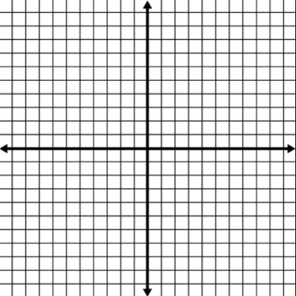

Exploration 2:

- Graph the function $f\left(x\right) = x^{2}$on the graph below.
- Subtract five from the function and write the equation here: ______________________
- Graph the new equation on the same graph below.
- What do you notice?
- What is the domain and range of the new function?
- If you wanted to shift the graph up three units, what would you do?

Practice

- The function $f\left(x\right) = x^{2} +1$ is graphed below. Translate the quadratic function up four units. Graph and write the new equation.

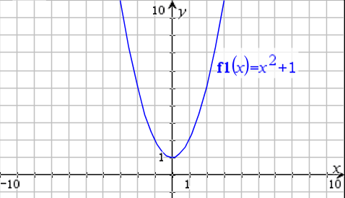

- The function $f\left(x\right) = {2x}^{2} +4$ is graphed below. Translate the quadratic function down five units. Graph and write the new equation.

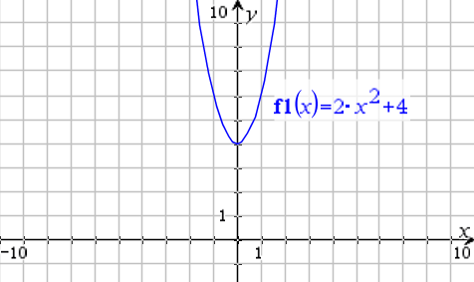

- If the function $f\left(x\right) = x^{2}-3$ is translated down four units, what is the new equation?

- A suspension bridge is suspended over a body of water. The two towers are each 150 feet tall, and the lowest part of the suspension cables fall 50 feet above the bridge. The distance between the two towers is 400 feet. Draw a labeled picture and write a quadratic function to represent this situation.

- It has been determined that the suspension bridge described in question 4 must be moved back (right) 200 feet. What will be the new quadratic function to represent the bridge?

