Mathematics Instructional Plan – Algebra I

Functions 1: Investigating Relations and Functions
Strand: Functions
Topic: Investigating relations and functions
Primary SOL: A.7 The student will investigate and analyze function (linear and quadratic) families and their characteristics both algebraically and graphically, including
- determining whether a relation is a function;
- domain and range;
e) finding the values of a function for elements in its domain; and
f ) connections between and among multiple representations of functions using verbal descriptions, tables, equations, and graphs.
Related SOL: A.1, A.4

Materials
- Function Sort Cards (attached)
- Functions activity sheet (attached)
- Scissors

Vocabulary
dependent variable, domain, function, function notation, independent variable, input, output, range, relation (A.7)

Student/Teacher Actions: What should students be doing? What should teachers be doing?
- Review domain and range from Grade 8 mathematics (SOL 8.15). Relate domain and range to independent and dependent variables as well as input and output.
- Display the following scenario: “Eleanor stayed home from school yesterday because she had a fever. The graph at right charts her temperature throughout the day.” Have students write a brief story about the course of Eleanor’s illness yesterday.
Temperature (°F)
morning noon afternoon
— Time —
- Have a few students share their stories and discuss the relationship between the time of day and Eleanor’s temperature. Direct students to identify a reasonable domain and range for this function. Remind students of the mathematics term relation (any set of ordered pairs; for each first member, there may be many second members). Ask whether Eleanor’s temperature represents a relation, and ask why or why not.
- Display the following problem. “The value of a car decreases every year that it is used. In the following table, what is the dependent variable and what is the independent variable? Is this situation a function? Why, or why not?”
Age of Car  (years) | Value of Car  (dollars)
0  1  2  3  4  5 | 15,000  11,000  8,000  6,000  5,000  4,000
- Display a mapping for the same car age-value data. Ask students which variable represents the domain and which variable represents the range.
0
1
2
3
4
5
15
11
8
6
5
4
Age of Car (years) Value of Car (thousand $)

- Tell students that both of these relations are also functions. Review the mathematics term function (a relation in which each element of the domain is matched to exactly one element in the range). Ask students whether all mathematical relations are functions. Ask for examples of relations that are not functions.
- Distribute scissors and the Function Sort Cards. Working in pairs, have students cut out the mathematical relations and place them into two groups—those that are functions and those that are not. Instruct partners to discuss and note exactly why they decided to place each relation in a certain group.
- Lead a class discussion of the relations on the Function Sort Cards. Have students explain their groupings, justifying why each relation is or is not a function. Ask whether anyone changed a representation in order to decide whether a relation was a function or not (i.e., whether anyone turned an equation or verbal situation into a graph or table).
- Explain to students that equations that represent functions can be written in function notation in which x represents domain elements and f(x) represents range elements. For example, the function y = 3x + 2 would be written as f(x) = 3x + 2 in function notation, and the function y = x² would be written as f(x) = x².
- Have students consider the function f(x) = 3x − 7. Ask them to find f(6). After discussing the solution, ask them to find f(−2) and f(0.31). Note: It is a common misunderstanding that the parentheses in function notation indicate multiplication. Be sure to bring up this matter if students do not and clarify it.
- Have students create their own function written in function notation, along with some elements of the function to find, given various domain values. Then, have students exchange functions with their partners and find solutions. Finally, have partners check the solutions.

Assessment

Questions
    - How can you determine whether a graph represents a function?
    - How can you determine whether a table of values represents a function?

Journal/Writing Prompts
    - Compare and contrast relations and functions.
    - Explain function notation to someone who does not know about it.

Other
    - Have students create their own examples and non-examples of functions for classmates to sort.

Extensions and Connections (for all students)
- Show students the vertical line test. Have them explain why it works.

Strategies for Differentiation
- Give students Function Sort Cards that have already been cut out. Have students sort the cards into function or relation.
- Have students create a chart showing characteristics of functions and characteristics of relations that are not functions.
- Provide students with a diagram or other graphic organizer with information on characteristics of functions and relations. Allow students to use this during the function sort activity.
- Cut out and organize task cards for students into categories (graph, equations, tables etc.)
- Create groups for students to work together.
- Limit the number of activities students are required to complete.
- Provide cue cards or a checklist to remind students how to identify a function and determine its domain and range.

Note: The following pages are intended for classroom use for students as a visual aid to learning.

Virginia Department of Education © 2018

Function Sort Cards
Print on card stock and cut on the dotted lines.
x y  1 –2  3 4  5 10 | A grocery store is selling peaches for $0.98 per pound.
x y  2 –1  2 –3  2 –5 |  | You visit a yard sale with your friends Pete, Sharon, and Brandon. Brandon buys 4 old CDs for $8.00, and Sharon buys 3 old CDs for $6.00. Pete talks to the seller and makes a deal to buy 4 CDs for $7.00.
 | y = 3x + 2 | x y  –2 10  0 6  2 10
y = x² | x y  5 1  6 1  7 1
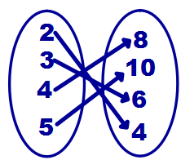 | {(2, 4), (3, 6), (4, 8)} | 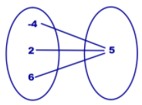
{(3, 2), (4, 1), (2, 3), (5, 1)} | 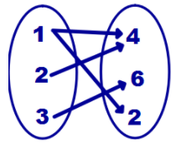 | 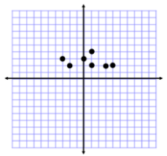

Functions

Directions: Use a die to find your numbers for your functions table and use the red/yellow coin to decide whether the numbers are negative or positive.
Function 1: f(x) = 2x – 4

x | Substitution | y

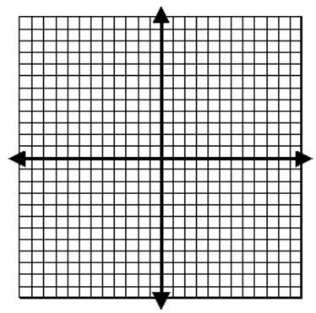

Domain:

Range:

Zero of the function:

Function 2: f(x) = - x - 8

x | Substitution | y

Domain:

Range:

Zero of the function:

Function 3: f(x) = - 2x + 1

x | Substitution | y

Domain:

Range:

Zero of the function:

Function 4: f(x) = - 3x + 4

x | Substitution | y

Domain:

Range:

Zero of the function:

