Mathematics Instructional Plan – Algebra I

Transformation Investigation
Strand: Equations and Inequalities
Topic: Investing the components of the equation of a line
Primary SOL: A.6 The student will
- graph linear equations in two variables.
Related SOL: A.6a, A.7d

Materials
- Graphing utilities
- Graph paper
- Optional Transformation Investigation Student Activity Sheet

Vocabulary
transformation, translation, reflection, slope, slope-intercept form, y-intercept (earlier grades)
x-intercept(A.6)
parent function, function families (A.7)

Student/Teacher Actions: What should students be doing? What should teachers be doing?
Note: In this activity, students will graph linear equations of the form y = mx + b and investigate transformations in the parent function y = x as m and b change.
- Distribute graph paper. On their graphing utilities, have students use an x-axis labeled from –10 to 10 and a y-axis labeled from –6 to 6. Ask students to sketch a graph of the parent function y = x. Inform students that the parent function will be used to make comparisons and generalizations throughout this investigation, so they may want to graph it on a separate sheet of graph paper and keep it to the side.
- Have students sketch a graph for each of the following equations
$y_{1}=x+1$ $y_{2}=x+4$ $y_{3}=x-1$ $y_{4}=x-3$
Direct students to record data in a table, such as the one below, and answer the following questions:
- What effect does changing b have on the parent function y = x?
- What generalizations can you make about the transformation seen when you change the y-intercept of a function?
 | y | y₁ | y₂ | y₃ | y₄
y-intercept
Slope
- Have students sketch a graph for each of the following equations:
$y_{1}=2x$ $y_{2}=\frac{1}{2}x$ $y_{3}=-5x$ $y_{4}=-\frac{2}{3}x$
Direct students to record data in a table and then answer the following questions:
- Compare the data for y₁, y₂, y₃, y₄ to the data for the parent function. What effect(s) does changing the slope have on the parent function?
- What generalizations can you make about the transformation seen in a graph when you change the slope of a function?
- Students should become familiar with describing the transformations of linear functions. The following (adapted from the 2016 VDOE Algebra I Vocabulary Word Wall Cards) generalize these transformations:
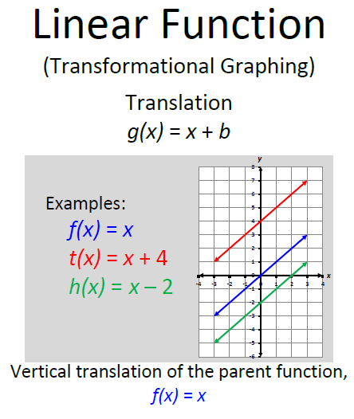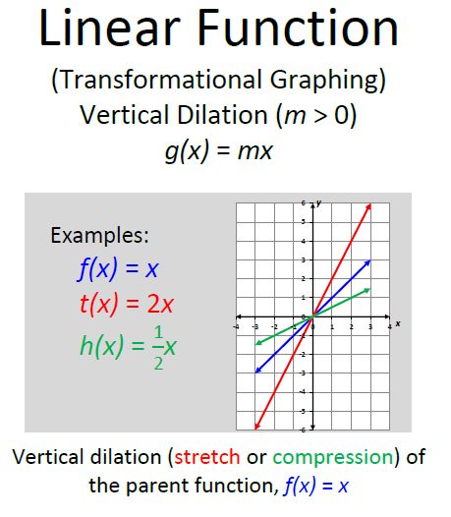
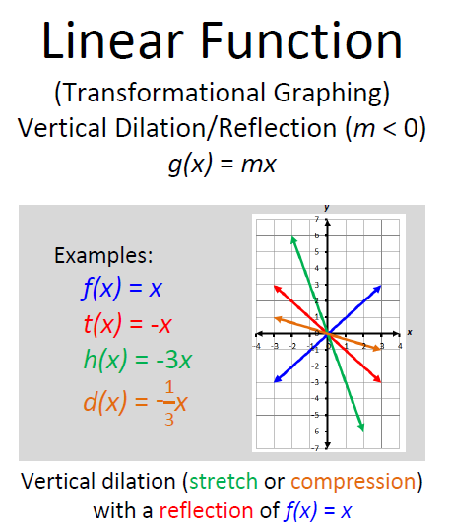
- Have students sketch a graph for each of the following equations. You can use a graphing utility such as https://www.desmos.com/calculator to graph linear equations. Students and teachers can find out more about graphing using the Desmos graphing calculator at http://learn.desmos.com/graphing .
$y_{1}=2x$ $y_{3}=-2x$ $y_{2}=\frac{2}{5}x$ $y_{4}=-\frac{2}{5}x$
Direct students to record data in a table and then answer the following questions:
- What generalizations can you make about the transformation seen when you graph functions with opposite slopes?

Assessment
  - Questions
- When the slope of a line is +1, what is the result of changing the y-intercept?
- When the slope (m) of a line is greater than 1, what is the effect on the parent function y = x?
- When the slope of a line is less than 1 but greater than zero, what is the effect on the parent function y = x?
- When the slope of a line is −1, what transformation is seen in relation to the parent function y = x?
  - Journal/Writing Prompts
    - Compare and contrast the behaviors of the functions y = x – 2 and y = –2x in relation to y = x.
  - Extensions and Connections (for all students)
    - Ask students how the graph of the parent function, y = x, would be transformed when graphing the function y = –x + 2.
Strategies for Differentiation
- Review vocabulary taught at earlier grades, if needed.
- Encourage the use of graphing calculators, graph paper, or dry-erase boards with a grid for students to see the transformations.
- Use a demonstration tool (e.g., document camera or digital display) to illustrate procedures in the graphing utility.
- Use different colors for the parent functions and comparison functions.
- Provide steps to follow if students are using a graphing utility.
- Provide copies of the table for students to use for recording information from each set of functions.
- Have students answer all generalization questions individually, in small groups, or in a large group, depending on the needs of the students.
- Have students work in groups of four, with each student graphing a separate function. Then, students can come together as a group to make comparisons between their graphs and the graph of the parent function.

Note: The following pages are intended for classroom use for students as a visual aid to learning.

Virginia Department of Education © 2018

Name: _______________________________________________________ Date: __________________
Transformation Investigation – Activity Sheet
- Sketch a graph for y = x. (consider using a regular black lead pencil)
- Sketch a graph for each of the following equations – use the graphs attached and tables with each graph. (consider using different colored pencils to create each graph)
$y_{1}=x+1 y_{2}=x+4$ $y_{3}=x-1$ $y_{4}=x-3$
- Complete the table below with the y-intercept and slopes for each equation.
 | $$y$$ | $$y_{1}$$ | $$y_{2}$$ | $$y_{3}$$ | $$y_{4}$$
y-intercept
Slope

- What effect does changing b have on the parent function y = x?
______________________________________________________________________
______________________________________________________________________
- What generalizations can you make about the transformation seen when you change the y-intercept of a function?
______________________________________________________________________
______________________________________________________________________
- Sketch a graph for each of the following equations (consider using different colored pencils) – use the graphs and attached tables:
$y_{1}=2x$ $y_{2}=\frac{1}{2}x$ $y_{3}=-5x$ $y_{4}=-\frac{2}{3}x$
Record data in the table and then answer the following questions:
 | $$y$$ | $$y_{1}$$ | $$y_{2}$$ | $$y_{3}$$ | $$y_{4}$$
y-intercept
Slope

- Compare the data for y₁, y₂, y₃, y₄ to the data for the parent function. What effect(s) does changing the slope have on the parent function?
______________________________________________________________________
______________________________________________________________________
- What generalizations can you make about the transformation seen in a graph when you change the slope of a function?
_______________________________________________________________________
_______________________________________________________________________
- Sketch a graph for each of the following equations. Go to www.desmos.com/testing to graph each linear equation. We will do this together… First graph y = x, then:
 | $$y$$ | $$y_{1}$$ | $$y_{2}$$ | $$y_{3}$$ | $$y_{4}$$
y-intercept
Slope
$y_{1}=2x$ $y_{3}=-2x$ $y_{2}=\frac{2}{5}x$ $y_{4}=-\frac{2}{5}x$

Record data in a table and then answer the following questions:

- What generalizations can you make about the transformation created when you graph two functions with opposite slopes?
________________________________________________________________________
________________________________________________________________________

Assessment
  - Questions
- When the slope of a line is +1, what is the result of changing the y-intercept?
_________________________________________________________________________
- When the slope (m) of a line is greater than 1, what is the effect on the parent function y = x?
___________________________________________________________________

- When the slope of a line is less than 1 but greater than zero, what is the effect on the parent function y = x?
_____________________________________________________________________
_____________________________________________________________________
- When the slope of a line is −1, what transformation is seen in relation to the parent function y = x?
_____________________________________________________________________
_____________________________________________________________________
    - Compare and contrast the behaviors of the functions y = x – 2 and y = –2x in relation to y = x.
______________________________________________________________________
______________________________________________________________________
    - How would the graph of the parent function, y = x, be transformed when graphing the function y = –x + 2.
______________________________________________________________________
______________________________________________________________________

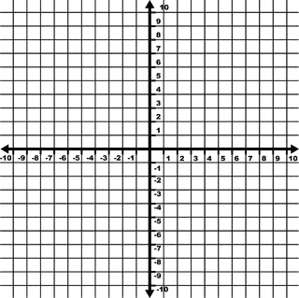

x | y
x | y

x | y

x | y

x | y
x | y

x | y

x | y

Use this graph for sketching the parent function, f(x) = x or y = x.

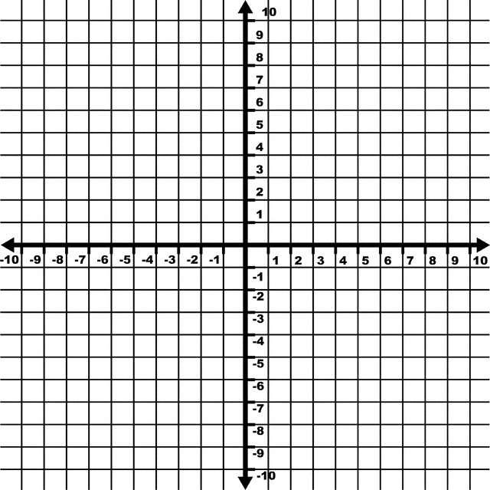
x | y

