Rate of Change of Practical Situations
Strand: Equations and Inequalities
Topic: Graphing linear equations in two variables that arise from a variety of practical situations
Primary SOL: A.6 The student will
- graph linear equations in two variables
Related SOL: A.1a, A.6a, A.7d

Materials
- Graphing utility (optional)
- Applications of Linear Equations activity sheet

Vocabulary
rate of change, slope, slope-intercept form, standard form, x-intercept, y-intercept (A.6)

Student/Teacher Actions: What should students be doing? What should teachers be doing?
Note: In this lesson, students will use skills from A.1a, translating between verbal quantitative situations and algebraic equations, to graph linear equations in two variables that arise from a variety of practical situations. Emphasize slope as a rate of change and the contextual relationship of y-intercept to the situation.
- Show students the following graph:
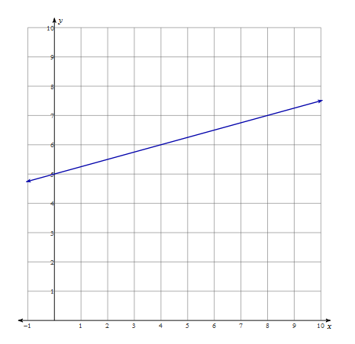
Ask them what the y-intercept and rate of change are and what the y-intercept and rate of change mean.
- Give students the following scenario and have them translate it into an algebraic equation.
“A transportation company charges a $5.00 initial fee for using their services and $0.25 for each mile you need to travel to your destination. Let c be the total cost of a trip with this car service.”
Students may create many different forms of a linear equation. The variable they use to represent “number of miles of a person’s trip” may differ. Emphasize what the rate of change means in this scenario and what the y-intercept means as it pertains to the context of the situation.
- Have students graph their linear equation from the given scenario. Identify student misconceptions. Some students may not make the connection that the scenario they were given to graph and the graph provided in (1.) are the same linear function. They may struggle with graphing a rate of change given that it is a decimal rather than a fraction. Now is the time to have students discuss in their groups or with a partner how they would go about graphing a rate of change represented by a decimal.
- If students have not made the connection that the graph they created and the graph in (1.) are the same, ask them to compare the two graphs and see whether they notice any similarities. Address misconceptions.
- Ask students to create an equation for the following scenario:
“Michelle has two jobs. In one of her jobs, she earns $10 an hour (x), and in her other job, she earns $8.00 an hour (y). At the end of the week, Michelle made $280.00.”
Once they have created the equation, ask them to graph their equation.
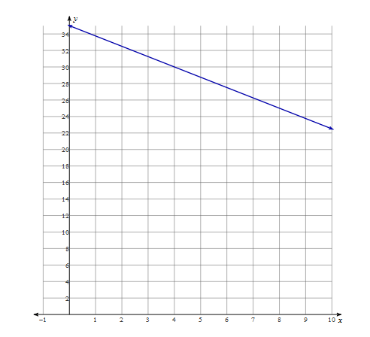
- Display the graph to the students and ask them to explain what the rate of change and y-intercept mean contextually from the graph.
- Distribute the Applications of Linear Equations activity sheet.

Assessment

Questions
  - What does slope mean as it applies to practical situations?
  - What is the y-intercept is as it applies to practical situations?
  - In what situations could rate of change be less than zero? In what situations could rate of change be greater than zero?
  - Are there any practical situations where the y-intercept would be negative? Why or why not?
  - How could you use a graph of an equation to make predictions?

Journal/writing prompts (include a minimum of two)
  - Describe step-by-step how to graph a linear equation if the equation is given in standard form.
  - Describe step-by-step how to graph a linear equation if the equation is given in slope intercept form.
  - Create two to three practical situations that could be modeled with a linear equation. Explain what the y-intercept and rate of change are and how they apply to each situation.

Extensions and Connections
- Have students research different types of investment retirement accounts and create their own linear equation and graphical model with the information they find.

Strategies for Differentiation
- Allow students to work with a partner or group and each person in the group take turns filling in each portion of the activity sheet.
- Create a graphic organizer for students who need to see the steps for graphing a linear equation in two variables in slope intercept form.
- Allow students to verify their graphs in their graphing utility.
- Provide the scale for the x- and y-axis on the graphs provided on the activity sheet.
- Teacher may manipulate the values of the numbers used in the practical situations in order to keep the x- and y- axis scale 1:1.
- Have students highlight information in each practical situation for easier identification of rate of change and the y-intercept. For example, a yellow highlighter could be used to show rate of change and green could be used to show the y-intercept. For each practical situation, the student will read the problem and highlight the slope in yellow and the y-intercept in green. Then, on the graph, highlight where the y-intercept is in green and show the slope in yellow.
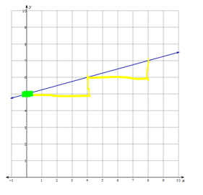
Note: The following pages are intended for classroom use for students as a visual aid to learning.

Virginia Department of Education © 2018

Applications of Linear Equations
Directions: For each practical situation, write an equation that represents the situation. Identify the y-intercept and the rate of change. Briefly describe what the y-intercept and the rate of change represent in the context of the situation. Then graph the linear equation. You will need to determine the intervals (scale) for your x- and y-axis, depending on the situation.
- You and your family need to take a taxi to get around town on your vacation. The taxi service charges $7.50 for the initial pickup of you and your family and $.25 per mile. Write and graph an equation to represent the cost of any taxi trip you take while on vacation.
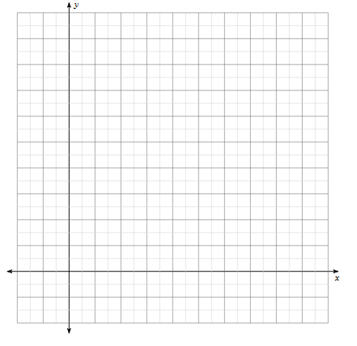
equation: ________________________________________
y- intercept: ______________________________________
_________________________________________________
rate of change (slope): ______________________________
_________________________________________________

- Each week at her job at the pet store, Maddison must empty the 180-gallon aquarium. With the hose she uses to drain the water, 25 gallons is emptied each hour. Write and graph an equation that represents the amount of water remaining in the tank over time.
equation: ________________________________________
y- intercept: ______________________________________
_________________________________________________
rate of change (slope): ______________________________
_________________________________________________

- On average, a car loses half a gallon of gas each hour it is driven. The tank holds 13 gallons of gas initially. Write and graph an equation to represent how many gallons of gas remain in the tank over time.

equation: ________________________________________
y- intercept: ______________________________________
_________________________________________________
rate of change (slope): ______________________________

- Frank is buying a laptop for $650 to use for school. He is going to purchase the computer on credit—he’ll pay $45 per month toward the balance. Write and graph an equation to represent how much money Frank owes on his laptop over time.

equation: ________________________________________
y- intercept: ______________________________________
_________________________________________________
rate of change (slope): ______________________________
_________________________________________________

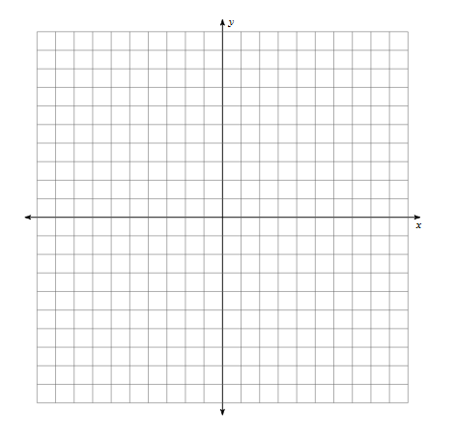
- A scuba diver is 400 feet below sea level and rising at the rate of 10 feet every minute. Write and graph an equation to represent the scuba diver’s location over time.

equation: ________________________________________
y- intercept: ______________________________________
_________________________________________________
rate of change (slope): ______________________________
_________________________________________________

- Aaliyah invests money into a retirement account. Initially, she invests $400 into the account and anticipates 8 percent annual interest in return. Write and graph an equation to represent her annual return.
equation: ________________________________________
y- intercept: ______________________________________
_________________________________________________
rate of change (slope): ______________________________
_________________________________________________

