Mathematics Instructional Plan – Algebra I

Slippery Slope
Strand: Equations and Inequalities
Topic: Modeling linear equations and finding slope through graphs
Primary SOL: A.6 The student will
- determine the slope of a line when given an equation of the line, the graph of the line, or two points on the line;
Related SOL: A.6b, c; A.7d

Materials
- Linking cubes
- Graph paper (optional)

Vocabulary
coordinate, equation of a line, rate of change, slope, y-intercept (earlier grades)
x-intercept (A.6)
dependent variable (A.7)

Student/Teacher Actions: What should students be doing? What should teachers be doing?

Part 1: Continuing a Pattern
- Display the sequence of towers as shown, and ask students to draw the next three towers.
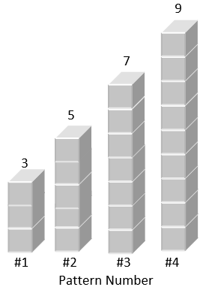

- Show students how the tower representation (below) can look like a graph. Point out the x and y axes. Explain to students that slope can be determined by finding the change in y divided by the change in x. Students can check to see whether the next three towers they drew are correct by using the change in y over the change in x formula you just presented.

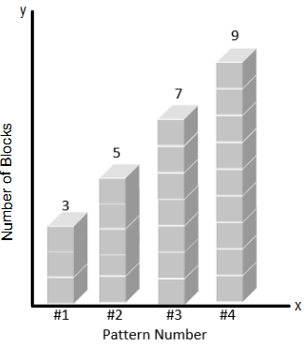
- To learn whether students can generalize this activity, ask them to figure out how many blocks would be in tower 10 without drawing the intervening towers. (Note: Some students will reason that because the number of blocks increases by two from tower to tower and because six more towers are required to get to tower 10, they just need to add 12 to the number of blocks in tower 4. Other students may notice that the number of blocks in each tower is one more than twice the pattern number for the tower.)
- Ask students how they could describe the pattern symbolically. (Note: This way of viewing the pattern does not encourage thinking about the change from one tower to the next. You need to ask questions to help students focus on building the formula on the basis of change from one to the next.)
- Ask students how many blocks would be in tower 0. Then, ask, “If you start with the blocks in tower 0, how many additional blocks would you need to build tower 3?” (Note: This focuses on the additional three sets of two blocks needed to build tower 3.)
- Ask students how many blocks would be in tower 8. (Note: Students will probably add eight sets of two blocks to the number in tower 0. This answer will help students see the 2 in 2p + 1 as a rate of change.)

- Display the sequence of towers shown below, and ask students to draw the next three towers. Ask how many blocks are in the tower 15. Ask students to draw tower 0 and describe it. (Note: Part of tower 0 is “underground” [i.e., two floors are in the basement.]) Ask, “What is the rate of change from tower to tower?”

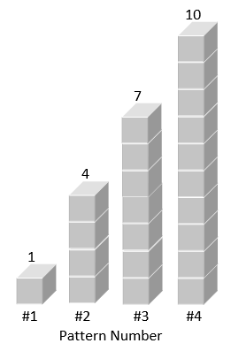
- Ask, “If you were to reverse the order of the towers, putting the 10-block tower first, then the seven-block tower, and so on, how would the new order affect the rate of change?” (If students have a hard time making this visual leap, physically rearrange the tower order momentarily.)

Part 2: Moving Toward the Cartesian Plan and the Equation of a Line
- Because students usually have difficulty giving meaning to an ordered pair, capitalize on the towers model. Display the sequence of towers shown at right, telling students that because drawing all of the blocks of these towers is cumbersome, each tower can be drawn simply as a “stick” with the number of blocks it represents written at the top. Ask, “What is the height of the tower 10?” “What is the height of the tower 25?” “What is the height of tower 0?”
12
16
20
24
#11
#21
#31
#41
Pattern Number
- Ask, “If you know the pattern number, can you write a formula that will give you the height of any tower?” Guide students to determine the rate of change in the heights of the towers to find the height of tower 0 and then put these elements together to get the formula: height of the tower 0 + (pattern # ∙ rate of change) = number of blocks in the tower. (Note: This formula, which is a symbolic representation of the pattern, grows out of student thinking about such different graphical representations as towers of blocks, sticks, and so on.)
- Have students answer the same questions about a sequence of the following towers:
11, 8, 5.

Part 3: Moving Toward a Rate of Change
Move to tasks in which students cannot figure out the rate of change by comparing the heights of consecutive towers.
35
45
#4
#8
- Display the sequence of towers shown at right, and ask, “What is the height of tower 5?” Guide students to see that the change in the height of the towers is 10, and tower 8 is four towers beyond tower 4. 10 ÷ 4 = 2.5 blocks per tower, which is the rate of change. Therefore, 35 + 2.5 = 37.5, which is the height of tower 5.
- Ask, “What is the height of tower 12?” Have students work the problem and share their solutions with a partner.

Part 4: Interpreting Points in the Cartesian Plane
#0 #1 #2 #3 #4
Pattern Number

Height of towers
20
30
50
40
10
- The next step is to interpret the towers as points on a coordinate plane. Instead of drawing sticks to represent the heights of the towers, show students how to use ordered pairs to indicate the heights and pattern numbers, as shown at right.
- Ask, “How can we discover a formula that relates the height of the tower and the pattern number?” (Note: Students may again use the strategy of first determining the change in tower height and then working back to the height of the tower 0 by
repeated addition or subtraction. We want them to move beyond repeated addition or subtraction to learn the height of tower 0. Therefore, we give them patterns in which that method is too cumbersome in order to push them toward a different strategy.)
- For example, display the coordinate plane and ordered pairs shown at right, in which the heights of towers 40 and 48 are given. Have students use this data to find the rate of change.
(152 − 128) ÷ 8 = 24 ÷ 8 = 3. Tell students that to get back to tower 0, they would have to subtract 3 40 times. Obviously, it would be much easier to subtract 3 × 40, or 120. Therefore, 128 − 120 = 8, which is the height of the tower 0.
Height of towers
(40,128)
(48,152)
40
80
120
160
#0 #8 #16 #24 #32 #40 #48
Pattern Number

Part 5: Computing Slope
- Have students look at the graphs below and compute the slope for each.
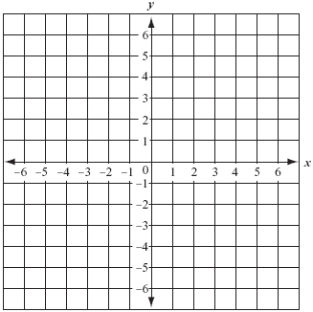

Assessment

Questions
    - Given that tower 50 is 20 feet tall and tower 75 is 145 feet tall, what is the rate of change?
    - How did you find the rate of change?
    - What is tower 120’s height, keeping the same rate of change?
    - What is tower 15’s height, keeping the same rate of change? Is this possible? Why, or why not?

Journal/Writing Prompts
    - One of your classmates was absent when we did this activity. How would you explain to the absent student how to find the rate of change?

Other Assessments
    - Give students a tower problem that has a rate of change of −5. Explain why the rate is negative and have them solve the problem.

Extensions and Connections (for all students)
- Review vocabulary from earlier grades, as needed.
- Have students discuss the changes that occur to a line when the slope changes. What happens to a line when the slope is increased? Decreased? Be sure to discuss negative slopes related to steepness.
- Have students measure the rise and run of different sets of stairs in the building and compare the rates of change from these different sets.
- Work with a career and technical education class to enable students to apply what they are learning.
- Provide students with the graph below and ask them to write a story to match that will highlight the rate of change displayed.
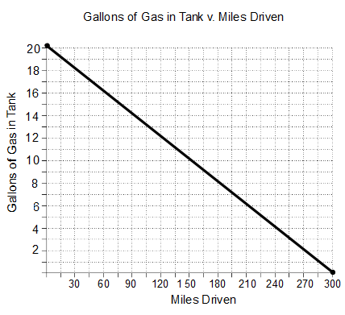

Strategies for Differentiation
- Provide students with a copy of the problems and questions to use as a visual reference.
- Allow concrete learners to benefit from making the models, using linking blocks.
- Use tape to create a coordinate grid on your classroom floor. Have students create the tower example by using students as the tower pieces. Allow students to predict how many students would be needed for tower 10. Tower 15? Tower #8? Have students at the top of each tower hold a string. Ask students whether the string looks straight when all students are holding it. If yes, then the slope was accurately found. If no, then have a discussion about why the string is not straight.
- Allow students to discuss their observations/work with a partner using the think-pair-share strategy throughout the teacher/student actions part of the lesson.
- Provide copies of the graphs in part 4 in sheet protectors so students can draw in the rates of change with dry-erase markers.
- Encourage students to create a poem or song about how to remember calculating slope.

