Mathematics Instructional Plan – Algebra I

Writing Equations of Lines
Strand: Equations and Inequalities
Topic: Writing equations of lines
Primary SOL: A.6 The student will
- determine the slope of a line when given an equation of the line, the graph of the line, or two points on the line;
- write the equation of a line when given the graph of the line, two points on the line, or the slope and a point on the line
Related SOL: A.7d

Materials
- Scissors
- Slope-Intercept Cards (attached)
- Silent Bingo Game Card (attached)
- Silent Bingo Game Problems (attached)
- Graphing calculators (optional)
- Graph paper (optional)

Vocabulary
horizontal line form, point-slope form, rate of change, slope, slope-intercept form, standard form, vertical line form, x-intercept, y-intercept (A.6)

Student/Teacher Actions: What should students be doing? What should teachers be doing?
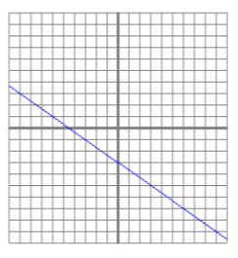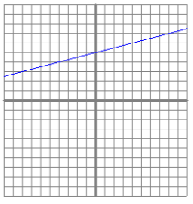

- Begin by asking students what they know about the following examples of lines on a graph. Ask: “What are the x- and y- intercepts of the line?” “What is the slope?”

- Ask students to graph coordinates on a coordinate plane, then create a line through those points and determine the x- and y- intercepts and the slopes of each line.
A. (3, 2) and (-4, 5) B. (0, 7) and (-5, 2)
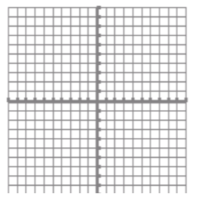
- Introduce the equation of a line in slope-intercept form (y = mx + b) and how each of the examples above could be written in slope-intercept form. Have students work together to put each example above in slope-intercept form.
- Then, use examples A and B with the points provided to show students how they could find the equation of a line with two points provided without using a coordinate plane. (this could be done using the slope formula and point-slope formula). Then ask students to put the equations in standard form.
- Finally, give students a few examples where the equation of a line is given in standard form and ask them to go from standard form to slope-intercept form, then identify the slope, x- and y- intercepts of the line, and finally, graph the line on a coordinate plane.
- Give each student a pair of scissors and a set of Slope-Intercept Cards. Have students cut the cards apart and then match the cards to make sets of five cards each—equation in standard form, equation in slope-intercept form, m, b, and graph.
- Distribute the Silent Bingo Game Card and the Silent Bingo Game Problems activity sheets. Have students play the Silent Bingo Game individually. Tell students that they may work the numbered problems in any order. Once they have completed a problem, they should search for its answer on the Bingo card and place the problem number in the small box directly above the answer. Whenever a student gets “Bingo,” check his/her game card.
- Encourage students to complete other problems once they get “Bingo.” (Note: If students work the problems in order, they will need to do most of the problems to get “Bingo.”)

Assessment

Questions
    - What is the equation of a line that has an undefined slope?
    - What is the equation of a line that has zero slope?
    - What is the equation of a line that has a negative slope and a positive y-intercept?
    - What is the equation of a line that has a positive slope and a positive x-intercept?

Journal/writing prompts
    - Explain why the graph of a horizontal line does not have an x-intercept. Describe how you know this from the equation.
    - Explain why the graph of a vertical line does not have a y-intercept. Describe how you know this from the equation.

Other Assessments
    - Have students create a design on graph paper, using at least 10 lines. Have them write the equations of the lines, including the start and stop points for each line. Alternatively, have students program their designs, using software or graphing calculators.

Strategies for Differentiation
- Encourage the use of graph paper, graphing calculators, and dry-erase boards with grids for students to see the slope and intercepts.
- Laminate the Slope-Intercept Cards so students can write on the cards with dry-erase markers.
- Have students work in pairs for both activities, as needed.
- On the Bingo activity, for questions 5–24, provide the steps necessary to complete the activity.
- Present questions one at a time from the task cards/Bingo activities.
- Limit the number of problems students are required to complete in order to demonstrate mastery.
- Have the task cards already cut out and organized into categories (i.e., equation, graphs, etc.) for students to match.
- Only have students complete one of the two provided activities.
- Allow students to respond to one of the journal/writing prompts orally instead of in writing. You may even allow them to record their oral prompts.

Note: The following pages are intended for classroom use for students as a visual aid to learning.

Virginia Department of Education © 2018

Slope-Intercept Cards
Copy on card stock and cut out.
3x + y = −1 | y = -(x – 4)
3x + 4y = 8 | 2x − y = 4
x − 2y = 6 | 2(x – 1) = y + 2
2x − y = 0 | 2y = 8

y = −3x − 1 | m = −3
b = −1
y = ⁻ $\frac{3}{4}$x + 2 | m = ⁻ $\frac{3}{4}$
b = 2

y = 2x − 4 | m = 2
b = −4
y = $\frac{1}{2}$x − 3 | m = $\frac{1}{2}$
b = −3

y = 2x | m = 2
b = 0
y = 4 | m = 0
b = 4
y = -x + 4 | m = -1
b = 4 | 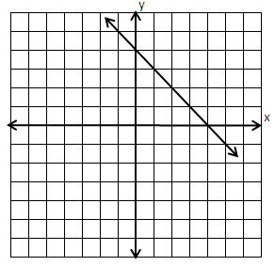
b = 1 | 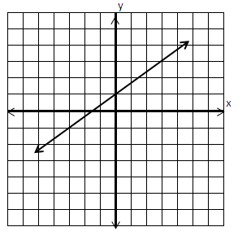
Silent Bingo Game Card
B | I | N | G | O
y = 2x + 1 | y = $\frac{1}{3}$x + 3 | y = $\frac{1}{2}$x − 1 | x = 8 | y = 3x − 5
y = $\frac{1}{2}$x + 4 | y = −$\frac{1}{3}$x | y =−5x + 11 | y = −x − 2 | x = 2
y = 3x + 2 | y = −2x + 9 | Free  Space | y = 4 | y = −2x + 3
y = $\frac{1}{2}$x + 6 | y = −$\frac{1}{3}$x + 1 | y = −2x + 1 | y = −$\frac{3}{2}$x + 3 | y = 6x − 8
y = −3 | y = 2 | y = 4x + 2 | y = $\frac{1}{2}$x + 1 | y = 3x

Silent Bingo Game Problems
Directions: Find the equation of each line in the problems below. Match the equation to the answer on your game card, and write the number of each problem in its correct answer box.
1. 2.
3. 4.
5. slope = $\frac{1}{2}$ y-intercept = 1 6. m = 4 b = 2
7. slope = 0 y-intercept = 4 8. m = undefined x-intercept = 2
9. slope = 3 y-intercept = 0 10. slope = −$\frac{1}{3}$ y-intercept = 1
11. m = 2 (1, 3) 12. m = −1 (−4, 2)
13. m = $\frac{1}{2}$ (2, 5) 14. m = 3 (0, 2)
15. m = $\frac{1}{3}$ (−3, 2) 16. (2, −3) (−3, 7)
17. (2, 4) (1, −2) 18. (0, −5) (3, 4)
19. (1, 6) (3, −4) 20. m = $\frac{1}{2}$ (−2, 5)
21. (6, −3) m = −2 22. (2, 0) (−2, 6)
23. (12, 2) (7, 2) 24. (8, 1) (8, −1)

