Mathematics Instructional Plan – Algebra I

Slope-2-Slope
Strand: Equations and Inequalities
Topic: Investigating slope of horizontal and vertical lines and graphing a line
Primary SOL: A.6 The student will
a) determine the slope of a line when given an equation of the line, the graph of the line, or two points on the line.
b) write the equation of a line when given the graph of the line, two points on the line, or the slope and point on the line.
c) graph linear equations in two variables.
Related SOL: A.7d

Materials
- Scissors
- Slope-2-Slope Squares Puzzle (attached)
- Slope-2-Slope Squares Puzzle (Solution) (attached)
- Graphing calculators (optional)
- Graph paper

Vocabulary
horizontal line form, point-slope form, rate of change, slope, slope-intercept form, standard form, vertical line form, x-intercept, y-intercept (A.6)

Student/Teacher Actions: What should students be doing? What should teachers be doing?
Note: Before engaging in this activity, students should develop an intuitive formula for finding the slope of a line (Consider having students complete the “Slippery Slope” MIP activity). The teacher should extend student definitions to a variety of plausible, contextual situations, including determining the slope of a line when given the coordinates of two points on the line, the equation of the line, or the graph of the line.
- Discuss positive and negative slope. Ask, “What effect does the slope have on the graph of the line?”
- Provide students with four linear equations graphed on a coordinate plane. Ask: “What do you notice about the direction of the line and its linear equation?” “Does the graph have the line crossing the x- and/or y-axis?” “Where does the line cross the x- and/or y- axis?” “Can you infer anything by looking at the the equation of the line and the graph of the line?”

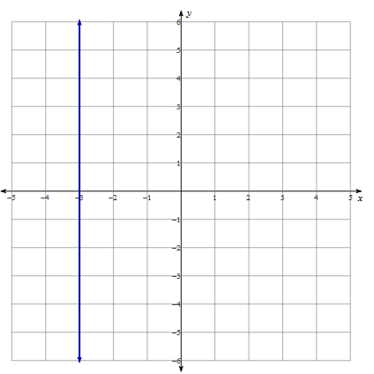  x = -3 | 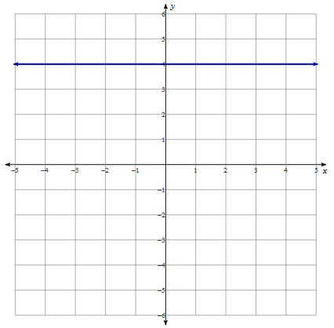  y = 3
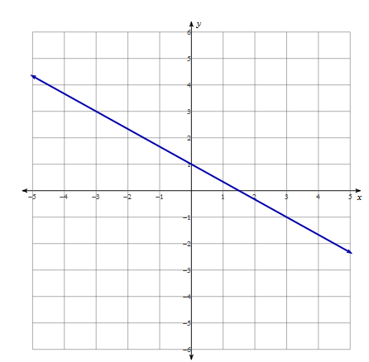  y = $\frac{-2}{3}x$ + 1 | 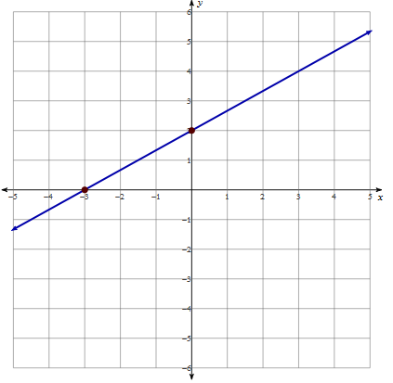  y – 2 = $\frac{2}{3}x$ + 2

- Have students experiment with the slopes of horizontal and vertical lines. You can use a graphing utility such as https://www.desmos.com/calculator to graph linear equations y = 4, y = –3, x = –7, x = 1, y – 5 = 0(x – 1), and y + x = 4 + y. Direct them to generalize their findings. Ask how they think they would graph the x- and y-axes.
- Have students graph explicit equations, and discuss the transformation(s) necessary to produce the image graph from the parent graph, y = x. Have students describe the graph in terms of the slope and the intercepts. Discuss ways to determine the slope and the intercepts when given only the equation. Reinforce the general coordinates of the intercepts (x, 0) and (0, y) by reviewing the equations of the x- and y-axes. Then, reverse the process, and demonstrate how to graph, using transformations, slope and y-intercept, and the x- and y-intercepts.
- Teachers may consider cutting out the pieces to the Slope-2-Slope Squares Puzzle ahead of time and putting them in an envelope or distributing scissors and the Slope-2-Slope Squares Puzzle, and have students cut up the pieces and then complete it individually or in small groups.

Assessment

Questions
  - How do you write the equation of a line that has an undefined slope?
  - How do you write the equation of a line that has a zero slope?
  - How do you write the equation of a line that has a negative slope and a positive y-intercept?
  - How do you write the equation of a line that has a positive slope and a positive x-intercept?
  - What is the equation for the x-axis?
  - What is the equation for the y-axis?

Journal/writing prompts
  - Explain why the graph of a horizontal line does not have an x-intercept. Describe how you know this from the equation.
  - Explain why the graph of a vertical line does not have a y-intercept. Describe how you know this from the equation.

Other Assessments
    - Have students create a design on graph paper, using at least 10 lines. Have them write the equations of the lines, including the start and stop points for each line. Alternatively, have students program their designs, using software or graphing calculators.

Extensions and Connections (for all students)
- Have students identify a given slope from a variety of lines drawn on 1-inch-grid graph paper.
- Have students work in groups to create their own 3 x 3 square with questions and answers in order to practice writing equations of lines. Have the groups exchange their 3 x 3 squares with other groups and solve.
- Have students work in groups to create a 4 x 4 square with questions and answers in order to practice writing equations of lines. Have the groups exchange their 4 x 4 squares with other groups and solve.

Strategies for Differentiation
- Encourage the use of graph paper, graphing calculators, and dry-erase boards with grids for students to see the slope and intercepts.
- Have kinesthetic learners use their arms to illustrate slopes—positive, negative, undefined, and zero. This can be extended to estimating slopes such as 2 versus $\frac{1}{4}$.
- Provide students with a graphic organizer to maintain structure in how they graph or find the equation of a line on a coordinate plane.
- Offer students an outlined format of the equations so students can organize standard form of the equations in one column and slope-intercept form in another.
- Limit the number of problems students are required to complete.
- Offer teacher-led small group instruction through the activity.
- Assign students to small groups for “learn and go” opportunities. Ensure students in each group are of varying abilities.

Note: The following pages are intended for classroom use for students as a visual aid to learning.

Virginia Department of Education © 2018

Slope-2-Slope Squares Puzzle
Standard Form and Point-Slope to Slope-intercept form…and back again!
- Cut the squares apart on the dotted lines.
- Match equations in standard form to equations in slope-intercept form by placing them adjacent to each other.
- You should get a new 3 x 3 square.
- Once a solution to the puzzle is reached, graph one equation from each square on the graph paper provided.
 | y = 3x |  |  | -2y = -4 |  |  | y – x = 4 + y
x − y = 0 | A | y = 4 | y = 2/3x − 8/3 | B | x − y = 11 | y = x − 6 | C | 2x − 3y = 8
 | x = -4 |  |  | 3y – 6 = 3(x + y) |  |  | y = ½x + 6
 | 3(y – 2) = 2(x – 6) |  |  | y = -5 |  |  | x = -2
2x + y = 4 | D | x − y = 6 | 4x − 4y = −1 | E | y = −3/4x + 5 | 4x − 3y = 27 | F | y = x
 | 4x – 2y = 2 (2x + 5) |  |  | 2y = 7x + 5 |  |  | 3y = x + 12
 | y – 8 = ½(x – 4 ) |  |  | y = 7/2x + 5 |  |  | 3x + 4y = 24
3x + 4y = 20 | G | y = 4/3x − 9 | y = 1/3x + 4 | H | y = x | y = 4 | I | 2x − y = −7
 | 3y = x + 4 |  |  | y = 2/3 x – 2 |  |  | y = 2

Slope-2-Slope Squares Puzzle (Solution)
 | y = 7/2x + 5 |  |  | y = 3x |  |  | 3x + 4y = 24
y = 1/3x + 4 | H | y = x | x − y = 0 | A | y = 4 | y = 4 | I | 2x − y = −7
 | y = 2/3 x – 2 |  |  | x = -4 |  |  | y = 2
 | 3(y – 2) = 2(x – 6) |  |  | y – x = 4 + y |  |  | -2y = -4
2x + y = 4 | D | x − y = 6 | y = x − 6 | C | 2x − 3y = 8 | y = 2/3x − 8/3 | B | x − y = 11
 | 4x – 2y = 2 (2x + 5) |  |  | y = ½x + 6 |  |  | 3y – 6 = 3(x + y)
 | y = -5 |  |  | y – 8 = ½(x – 4 ) |  |  | x = -2
4x − 4y = −1 | E | y = −3/4x + 5 | 3x + 4y = 20 | G | y = 4/3x − 9 | 4x − 3y = 27 | F | y = x
 | 2y = 7x + 5 |  |  | 3y = x + 4 |  |  | 3y = x + 12

