Mathematics Instructional Plan – Algebra I

Represent the Solution of a Linear Inequality in Two Variables Graphically Scavenger Hunt
Strand: Equations and Inequalities
Topic: Representing the solution to a linear inequality in two variables graphically
Primary SOL: A.5 The student will
- represent the solution of linear inequalities in two variables graphically;
Related SOL: A.5a

Materials
- Graphing utility
- Graphing Inequalities Scavenger Hunt Activity Sheet

Vocabulary
greater than, inequality, less than (earlier grades)
dashed line, division property of inequality, set notation, solid line (A.5a)

Student/Teacher Actions: What should students be doing? What should teachers be doing?
- Revisit graphing a linear equation and solutions to linear equations. Ask students to write the equations of the following lines and tell which coordinates represent solutions to each linear equation:
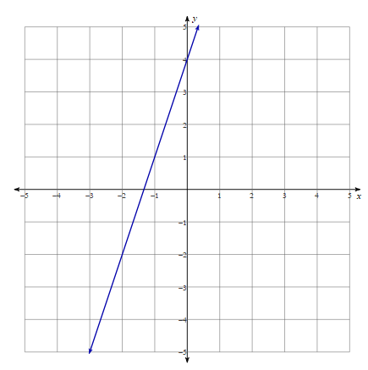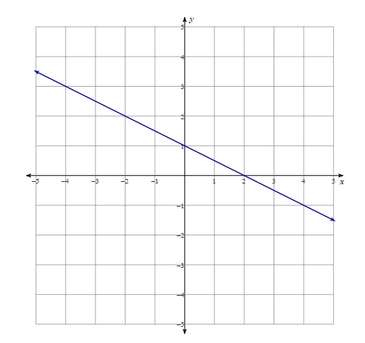

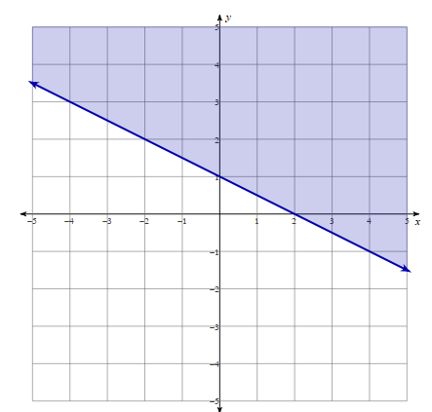
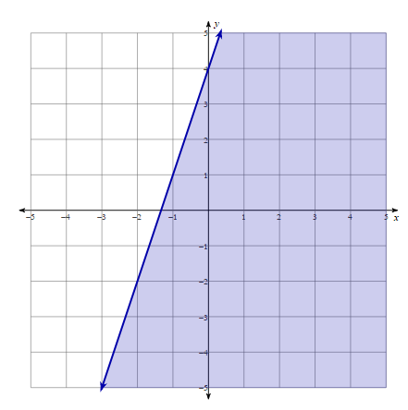
- Divide students into groups. Show students the following graphs with shading and ask them to come up with a conjecture with their group on what they think the shading represents. Then have the group share their ideas with the class.
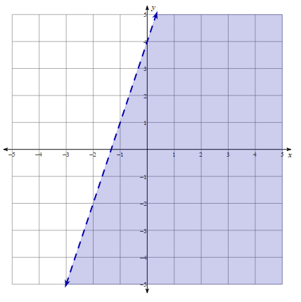
- Once the class has come up with the correct reasoning for the shading, show the next two graphs. In the picture of the first graph, ask students whether they believe (-1,1) is a solution. For the second graph, ask the students whether they believe (0,1) could be a solution. Why, or why not? Discuss similarities and differences in these two graphs and give a few more coordinates in each for students to determine which are solutions.
- Using a graphing utility, ask students to graph the solutions to the following inequalities. Students can use the Desmos graphing calculator to graph linear inequalities in one variable. Teachers and students can learn more about graphing inequalities using Desmos at http://learn.desmos.com/inequalities. Teachers may also wish to have students graph ordered pairs using Desmos to ascertain which fall within the solution set (shaded region).

A. 3y > 10 – 6x | B. y ≥ $\frac{3}{2}$x $-$1
C. 4x – y ≥ 8 | D. x < 4 - y
- Students will work together to find the graphs of solutions to linear inequalities. Cut out and tape each scavenger hunt card around the room. Put students in groups of three or four and put each group at a lettered card. Give each person (or group of students) graph paper or a graphing utility to aid in their search and an answer sheet. On the answer sheet, students will write at which lettered card their group started. At the corner of each lettered scavenger hunt card is a linear inequality. Each group must graph the solutions to the linear inequality and then look for the lettered card that corresponds to the graph of the solutions. Then graph the inequality at the bottom of the next page and continue until they arrive back at their original card.

Assessment

Questions
  - How do you know whether an ordered pair is a solution to a linear inequality in two variables?
  - How do properties of inequalities differ from properties of equality?
  - What is the difference between the dashed lines and solid lines in graphing solutions to linear inequalities?

Journal/writing prompts
  - Explain the differences between the solutions of linear inequalities in two variables to the solutions to linear equations in two variables.
  - Explain the process of representing the solution of a linear inequality in two variables graphically.
  - Explain why the division property of inequality is so important when graphing solutions of linear inequalities.

Other
  - How do you verify solution sets to linear inequalities are accurate using a graphing utility?
  - If you do not have a graphing utility, how do you verify solution sets to linear inequalities in two variables?
  - What is the difference in the graphs of solutions of a linear inequality in one variable to the graphs of solutions to linear inequalities in two variables?

Extensions and Connections (for all students)
- What are some real-world scenarios that would involve graphing linear inequalities?
- Making decisions using linear inequalities is used in everyday life and in careers such as with personal investments, computer programming, and engineering.

Strategies for Differentiation
- Encourage students to check their graphed inequality by choosing two to three different coordinates and substitute those coordinates into their original inequality to see whether the inequality is true.
- Have students make an organized flow chart or checklist of the process of representing the solutions to linear inequalities in two variables graphically, such as:
Is the linear inequality …
- in slope-intercept form (y = mx + b)?
- graphed with a solid line (≤, ≥) or dashed line(<, >)?
- greater than (shade above the line) or less than (shade below the line)?
Then have students check a coordinate on the line, above the line, and below the line to verify solutions.
- Give students a list of the inequalities from the scavenger hunt with their graphs and ask them to match the inequality to its corresponding graph.
- Provide students with the linear inequalities only and ask them to graph (with graph paper provided).
- Limit the number of inequalities they are asked to match with their graph.

Note: The following pages are intended for classroom use for students as a visual aid to learning.

Virginia Department of Education © 2018

Graphing Inequalities Scavenger Hunt Activity Sheet
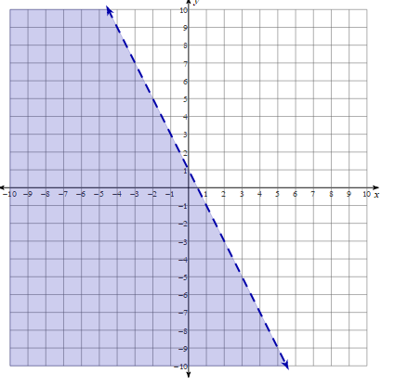
A

-x + 4 < y
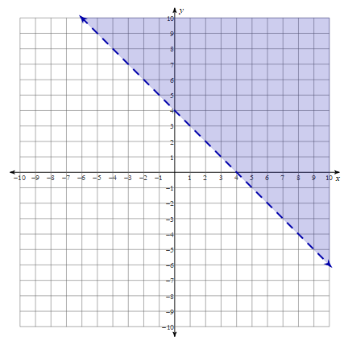
D

3x – 2y > 2

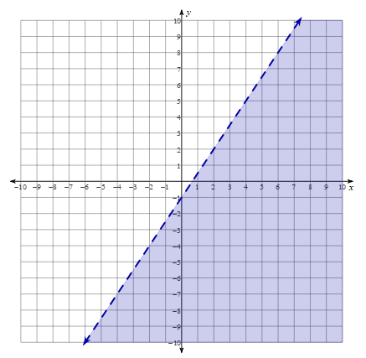
F

3y ≤ -3x + 12
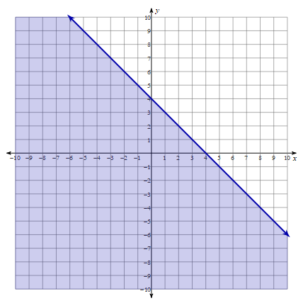
B

10x + 5y ≥ 5
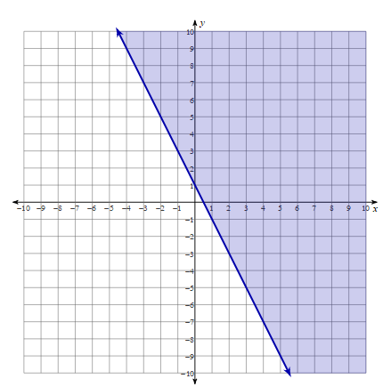
C

2y > -x ̶ 4
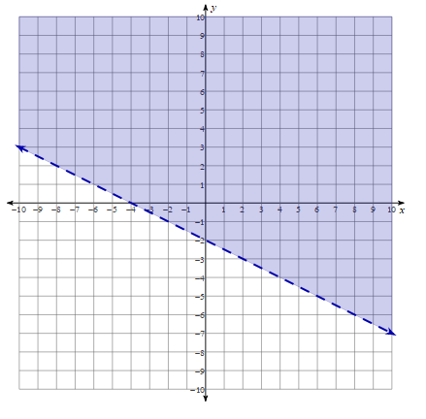
E

3 > 6x + 3y
Directions: Use the coordinate planes below to help find graphed solutions to linear inequalities in scavenger hunt.
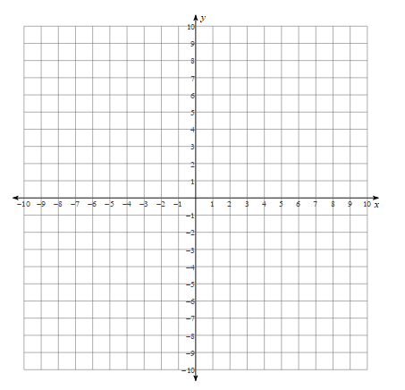

Scavenger Hunt Answer Sheet
Names:
__________________________________________________________________
__________________________________________________________________

first station (start) ______
second station ______
third station ______
fourth station ______
fifth station ______
sixth station ______

