Mathematics Instructional Plan – Algebra I

Solving Linear Inequalities in One Variable
Strand: Equations and Inequalities
Topic: Relating the graphing of a line to solving an inequality in one variable
Primary SOL: A.5 The student will
- solve multistep linear inequalities in one variable algebraically and graphically
Related SOL: A.4a

Materials
- Solving Inequalities Puzzle (attached)
- Scissors
- Glue
- Sheets of blank paper
- Error Analysis activity sheet (attached)
- Graphing calculators

Vocabulary
closed point, open point (earlier grades)
boundary, dashed line, solid line (A.5a)

Student/Teacher Actions: What should students be doing? What should teachers be doing?
- Review solving inequalities in one variable (SOL 7.15 and 8.15).
- Teachers may wish to cut out the Solving Inequalities Puzzle (attached) into pieces ahead of time and place in envelopes. Distribute the pieces of the Solving Inequalities Puzzle to students and have them work in pairs to connect the pieces by solving the multistep linear inequalities algebraically and arranging the pieces to connect to the equivalent solution set for each inequality. Teachers may wish show the puzzle pieces cut out and glued in the correct arrangement on a blank sheet of paper ahead of time to ensure that students know what the final product will be. As an alternative, teachers might wish to have students cut out the pieces and work the puzzle.
- Review graphing the solution set of an inequality in one variable on a number line.
- Compare the open and closed points used in graphing the solution of an inequality in one variable to the dashed and solid boundary lines used in graphing the solution to an inequality in two variables.
- Lead the students through error analysis of the following inequality. Then, distribute the Error Analysis activity sheet.
2(3x – 4) < 4x – 20
6x – 8 < 4x – 20
6x – 4x – 8 < 4x – 4x – 20
2x – 8 < –20
2x – 8 – 8 < –20 – 8
2x < –28
($\frac{1}{2}$)2x < –28($\frac{1}{2}$)
x < –14

Assessment

Questions
    - How is solving an inequality different from solving an equation?

Journal/Writing Prompts
    - Describe a real-world situation in which solving an inequality would be necessary.
    - Describe a way to self-assess the correctness of your graphs.

Strategies for Differentiation
- Allow students to use calculators to make simple calculations and compare findings.
- Have students use a talking calculator or a calculator with large keys and/or display.
- Demonstrate steps and procedures on an overhead calculator.
- Demonstrate key information on a demonstration tool (e.g., document camera, digital display).
- Color-code the steps in an inequality.
- Have students create a chart that compares and contrasts graphing an inequality in one variable with graphing an inequality in two variables.
- To help concrete learners, use graph paper to keep the information linear.
- Enlarge the copies of the pieces of the Solving Inequalities Puzzle to make the problems more distinct.

Note: The following pages are intended for classroom use for students as a visual aid to learning.

Virginia Department of Education © 2018

Solving Inequalities Puzzle (Solution)
Directions:
- Below is the solution to the puzzle.
- Copy and cut the pieces apart on the solid lines.
- Students should match the inequalities by placing them adjacent to each other.
- Have students complete it individually or in small groups. They should get the heart shown below.
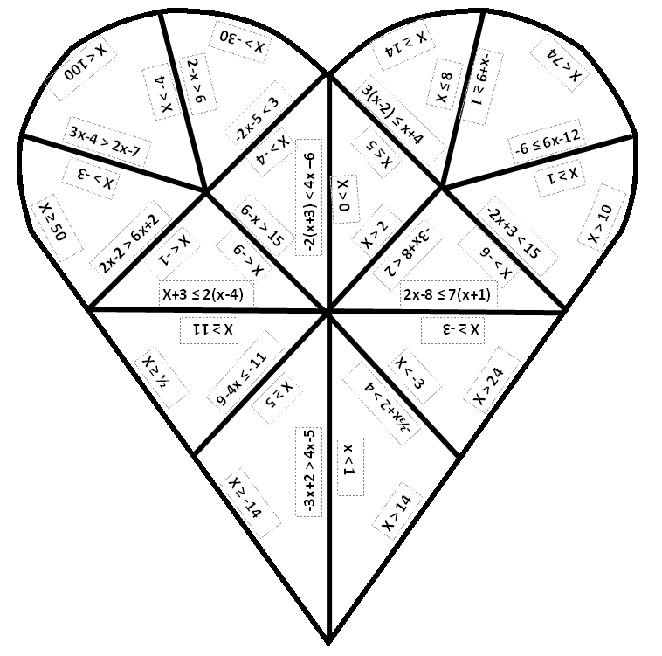
Error Analysis
Name Date
Directions: Identify the mistake in the first column and then correct it in the second. Once you make the correction and show the appropriate work, graph your solution.
Inequality | Correction | Graph
6x - 4 > –2
+2 +2
6x > –2
x > –$\frac{1}{3}$
–x – 6 ≤ 2 - (3x – 4)
–x – 6 ≤ 2 – 3x + 4
–x – 6 ≤ 6 – 3x
+x +x
–6 ≤ 6 – 2x
–6 –6
0 ≤ –2x
0 ≥ x
2(x – 4) – 7x < 37
2x – 8 – 7x < 37
+7x +7x
9x – 8 < 37
+8 < 45
9x < 45
X < 5
2x - 6 ≥ 8 + 4x
–4x ≥ –4x
–2x – 6 ≥ 8
+6 +6
–2x ≥ 14
x ≥ –7

