Mathematics Instructional Plan – Algebra I

Solving Quadratic Equations by Factoring
Strand: Equations and Inequalities
Topic: Solving quadratic equations using factoring
Primary SOL: A.4 The student will solve
- quadratic equations in one variable algebraically;
- practical problems involving equations and systems of equations
Related SOL: A.2c, A.7c

Materials
- Algebra tiles
- Graphing calculators
- Quadratic Clues to a Puzzling Situation activity sheet (attached)
- Solving Quadratic Equations by Factoring activity sheet (attached)

Vocabulary
factor, greatest common factor, linear equation, product, quadratic equation, standard form

Student/Teacher Actions: What should students be doing? What should teachers be doing?
- Quadratic expressions can be factored in different ways. Students should be given ample time to work with each of these different methods so that they can see the connections amongst them. Several examples are provided on the following pages.

Given: $x^{2}+4x+3$ | Algebra Tiles | Area Model | Grouping
Apply the substitution property as you rewrite the trinomial as a polynomial with four terms.  - With algebra tiles, the tiles should form a rectangular shape.  - In reference to the $ax^{2}+bx+c$ form, we break the $bx$ term into two terms. These two terms should have a product equivalent to $acx^{2}$ and a sum of $bx$. | 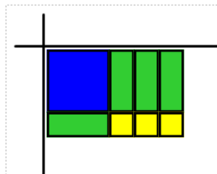 | $$x^{2}$$ $$3x$$  $$x$$ $$3$$ | $$x^{2}+3x+x+3$$
Apply the distributive property to rewrite the first two terms as a product of a monomial and a binomial.  - Factor a GCF from the first two terms, and record appropriate binomial factor to accompany it.  - Checking this work with mental multiplication is recommended. | 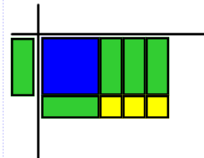  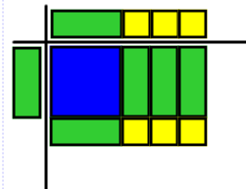 | $$x$$ $$x^{2}$$ $$3x$$  $$x$$ $$3$$  $$x$$ $$3$$  $$x$$ $$x^{2}$$ $$3x$$  $$x$$ $$3$$ | $$x\left(x+3\right)+x+3$$
Apply the distributive property to rewrite the last two terms as a product of a monomial and a binomial.  - Factor a GCF from the last two terms, and ensure that the same binomial factor would accompany it.  - Checking this work with mental multiplication is recommended. | 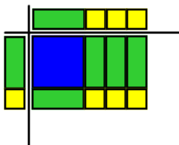 | $$x$$ $$3$$  $$x$$ $$x^{2}$$ $$3x$$  $$1$$ $$x$$ $$3$$ | $$x\left(x+3\right)+1(x+3)$$
Rewrite the quadratic trinomial as the product of two binomials.  - You can see the application of the distributive property more clearly when factoring by grouping. | $$(x+1)(x+3)$$ | $$(x+1)(x+3)$$ | $$(x+1)(x+3)$$
** Students can use guess-and-check to work backward through any of these methods.

Given:${-2x}^{2}+x+1$ | Algebra Tiles | Area Model | Grouping
Apply the substitution property as you rewrite the trinomial as a polynomial with four terms.  - With algebra tiles the tiles should form a rectangular shape.  - In reference to the $ax^{2}+bx+c$ form, we break the $bx$ term into two terms. These two terms should have a product equivalent to $acx^{2}$ and a sum of $bx$. | 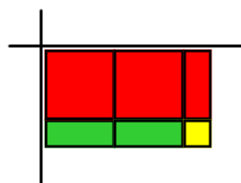 | $${-2x}^{2}$$ $$-x$$  $$2x$$ $$1$$ | $$-2x^{2}-x+2x+1$$
Apply the distributive property to rewrite the first two terms as a product of a monomial and a binomial.  - Factor a GCF from the first two terms, and record appropriate binomial factor to accompany it.  - Checking this work with mental multiplication is recommended. | 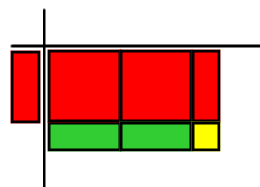  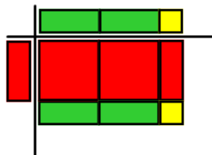 | $$-x$$ $${-2x}^{2}$$ $$-x$$  2$x$ $$1$$  $$2x$$ $$1$$  $$-x$$ $${-2x}^{2}$$ $$-x$$  $$2x$$ $$1$$ | $$-x\left(2x+1\right)+2x+1$$
Apply the distributive property to rewrite the last two terms as a product of a monomial and a binomial.  - Factor a GCF from the last two terms, and ensure that the same binomial factor would accompany it.  - Checking this work with mental multiplication is recommended. | 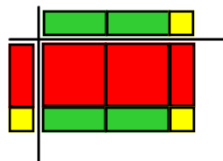 | $$2x$$ $$1$$  $$-x$$ $${-2x}^{2}$$ $$-x$$  $$1$$ $$2x$$ $$1$$ | $$-x\left(2x+1\right)+1(2x+1)$$
Rewrite the quadratic trinomial as the product of two binomials.  - You can see the application of the Distributive Property more clearly when factoring by grouping. | $$(-x+1)(2x+1)$$ | $$(-x+1)(2x+1)$$ | $$(-x+1)(2x+1)$$
** Students can use guess-and-check to work backward through any of these methods.

- One method to solve a quadratic equation involves factoring. Facilitate instruction to unwrap the content presented below:
When solving a quadratic equation by factoring, students should:
- Rearrange the equation, if needed, so that it is in standard form ($ax^{2}+bx+c=0$).
- Factor the quadratic expression ($ax^{2}+bx+c$). If a constant can be factored from the quadratic expression, that should happen before applying any of the other methods for factoring a quadratic expression.
- Apply the zero-product property, which states that, when two factors multiply to give a product of zero, at least one of the two factors must be equal to zero.
- Determine the solution(s) from the linear equations that were recorded in step 3.
- Use a graphing calculator to check solutions for accuracy.

Example: Solve by factoring: $3x^{2}+2x=8$
$$3x^{2}+2x-8=0$$
$$\left(3x-4\right)\left(x+2\right)=0$$
$$3x-4=0 x+2=0$$
$x=\frac{4}{3}$ $x=-2$
$3{\left(\frac{4}{3}\right)}^{2}+2\left(\frac{4}{3}\right)=8$ and $3{(-2)}^{2}+2\left(-2\right)=8$
The solution set is $\left\{-2, \frac{4}{3}\right\}$.

- Distribute the Quadratic Clues to a Puzzling Situation activity sheet, and have students work with a partner to complete the puzzle. While students are working, circulate around the room to answer questions and spot-check for accuracy. Students may need to be reminded to rewrite equations in standard form and/or factor out a constant GCF before factoring the quadratic expression. They may also need reminders regarding the process for factoring a difference of squares.
- Next, lead students through instruction that relates to practical applications. When solving practical problems, students will need to decide not only whether both answers are accurate but whether both answers are realistic. This instruction should highlight problems similar to the one listed below:
Example: A ball is thrown straight up, from 3 meters above the ground, with a velocity of 14 meters per second. The ball’s path approximately follows the curve of the function $h=-5t^{2}+14t+3,$ where h represents the height of the ball above the ground, in meters, and t represents the time, in seconds. After how many seconds does the ball hit the ground?

$-5t^{2}+14t+3=0$
$-\left(5t+1\right)\left(t-3\right)=0$
$5t+1=0$ $t-3=0$
$t=-0.2$ $t=3$
The ball could not hit the ground after a negative number of seconds, so the only solution is 3 seconds.
- Distribute the Solving Quadratic Equations by Factoring activity sheet so that students can practice applying this content to practical situations. Students should work with a partner or in small groups. Circulate around the classroom to answer questions and provide assistance as needed.

Assessment

Questions
  - Algebraically, what would a quadratic equation with only one solution look like? Give an example to clarify your comments.
  - Matt has checked his solutions, and they do not seem accurate. Can you explain where he has made an error in his work?

$$\begin{matrix}\begin{matrix}\begin{matrix}2x^{2}=x+15 \\ 2x^{2}-x-15=0 \\ \left(2x-5\right)\left(x+3\right)=0\end{matrix} \\ 2x-5=0 x+3=0\end{matrix} \\ x=2.5 x=-3\end{matrix}$$

{-3, 2.5}

Journal/writing prompts
  - Describe the zero-product property and how it is applied when solving a quadratic equation by factoring.
  - Compare and contrast factoring using an area model with factoring by grouping.

Other Assessments
  - Students can solve quadratic equations on whiteboards so that the teacher can assess student mastery with a quick glance.

Extensions and Connections (for all students)
- Students will connect their solutions with the zeroes of a quadratic function.
- Students should learn to move in the reverse direction, from the solutions for a quadratic equation back to the equation itself.
- This content can be applied to many physics questions dealing with topics such as forces and energy.

Strategies for Differentiation
- Allow students to use multiple strategies for factoring.
- Provide flow charts outlining the steps used to solve a quadratic equation by factoring.
- Edit equations to provide a level of rigor that is appropriate for individual students.
- Demonstrate the use of the quadratic formula (see the Solving Quadratic Equations Using Square Roots and the Quadratic Formula activity sheet) for solving quadratic equations as another method for solving. A dry-erase marker and board can be used to “erase and replace” values of a, b, and c in the quadratic formula.
- On Quadratic Clues to a Puzzling Situation activity, allow students to choose one problem from each lettered box to show mastery.

Note: The following pages are intended for classroom use for students as a visual aid to learning.

Virginia Department of Education © 2018

Quadratic Clues to a Puzzling Situation
Name Date
Directions: Solve each equation by factoring and place the positive integer answer from each in the indicated cell of the puzzle.
A 3  $$2x^{2}=9x+5$$ | A 6  $$x^{2}-16=0$$
B 5  $$3x^{2}+2=7x$$ | C 1  $$x^{2}-5x=36$$
C 5  $$2x^{2}-10x-12=0$$ | D 9  $$3x^{2}=20x+7$$
When finished, solve the remaining Sudoku puzzle. Remember, each row, column, and 3x3 square should show the numbers 1 through 9 without repetition.
 | A | B | C | D | E | F | G | H | I
1 |  |  |  |  | 8 |  |  | 3 | 5
2 |  | 4 |  |  | 7 | 5 | 1 |  | 9
3 |  |  |  |  |  | 1 |  | 2
4 | 9 | 8 |  | 5 | 2 | 7 | 6
5 | 7 |  |  | 8 |  |  |  | 9
6 |  | 3 | 5 | 1 | 6 |  | 2
7 | 1 |  | 7 |  | 3 | 2 | 4 |  | 6
8 |  |  | 2 |  |  |  |  | 5 | 7
9 | 8 |  | 4 |  |  | 6 |  |  | 2

E 5  $$x^{2}-x-12=0$$ | E 9  $$3x+10=x^{2}$$ | F 6  $$4x^{2}-39x+27=0$$
F 8  $$2x^{2}+8=17x$$ | G 5  $$3x^{2}-7x=40$$ | H 4  $$3x^{2}-9x-12=0$$
H 7  $$2x^{2}-19x+24=0$$ | H 9  $$21=x^{2}+20x$$ | I 4  $$x^{2}-9=0$$

Solving Quadratic Equations by Factoring
Name Date
Directions: Solve each of the following by factoring. Show all work in the space provided.

1. A penny is thrown into the air from the top of a building. The penny’s height, above the ground, after t seconds can be modeled by the equation $h=-16t^{2}+48t+64$, where h is height in feet. After how many seconds does the penny hit the ground?

https://www.scienceabc.com/wp-content/uploads/2015/09/Untitled-design.jpg

2. On a given dive, a platform diver’s body follows a path that can be modeled by the equation $d=-4t^{2}+2t+6$, where d represents the diver’s distance above the water after t seconds. Use this information to determine how long it will take a diver to reach the water’s surface.

Algebra tile example
http://www.allthingsclipart.com/06/platform.diving.02.jpg

3. The observed bunny rabbit population on an island is given by the function
$p(t)=-4t^{2}+80t+1,200$ , where t is the time, in years, since the researchers began observing the rabbits. According to this quadratic function, when will the rabbit population disappear from the island?

https://www.tumblr.com/search/okunoshima%20rabbit%20island

