Mathematics Instructional Plan – Algebra I

Simplifying Numerical Expressions
with Square and Cube Roots
Strand: Expressions and Operations
Topic: Simplifying numerical expressions involving square and cube roots
Primary SOL: A.3 The student will simplify
- numerical expressions containing square or cube roots
Related SOL: 8.14b, A.3a, b

Materials
- Graphing calculators
- Preparing for Renovations activity sheet (attached)

Vocabulary
cube root, difference, index, product, radical expression, radicand, square root, sum

Student/Teacher Actions: What should students be doing? What should teachers be doing?
- Post several algebraic expressions for the students to simplify. These expressions should resemble the following: $3x+5x$, $-4m+m$, $9y-5y$, and $-3k-2k.$
- After students have simplified each expression, they should be given a radical expression to substitute into both the original expression and the sum/difference. For example, if $x=\sqrt{7}$, then the student would revise his/her work that states
$3x+5x=8x$ and record $3\sqrt{7}+5\sqrt{7}=8\sqrt{7}$. Or, if $k=\sqrt[3]{5}$, then the student would adapt their work that states $-3k-2k=-5k$ and record $-3\sqrt[3]{5}-2\sqrt[3]{5}=-5\sqrt[3]{5}$.
- At this point, the students should turn and talk with a partner to generalize what happens when you add or subtract two radical expressions with the same radicand/index.
- Afterward, students should have an opportunity to share their generalizations with the class. The teacher should extend this discussion to include the fact that we cannot combine radical expressions by addition/subtraction with different radicands/indexes just as we cannot add or subtract unlike terms in an algebraic expression.
- Next, the teacher can scaffold the instruction regarding multiplying radical expressions. The progression might resemble the following: The students should be given an opportunity to anticipate what each product might be before using the graphing calculator to check their predictions. Between each example, the teacher should allow students to summarize their thinking on the previous example and share their thoughts regarding the next product.
- The teacher should follow this discussion up with a few cube root examples, such as and Then, he/she can follow up with the fact that we will not find the product of a square root and a cube root.
- Students should also be familiar with simplifying expressions that have numeric radicands, but may include variable coefficients. Generalize that if , then . Making a link between combining like terms when working with radical expressions can be made by using an example such as . Students should recognize that 9x² and -3x² are like terms and that 4x and 11x are like terms to obtain .
- Distribute the Simplifying Numerical Expressions with Square and Cube Roots activity sheet for students to complete.
- When you feel like the students have a grasp on the processes involved in determining the sum, difference, and product of numerical expressions involving square roots and cube roots, students should work with a partner or small group to complete the Preparing for Renovations activity sheet, or you can use it as an extension activity.

Assessment

Questions
  - Explain how simplifying the radical expression $7\sqrt{5}+\sqrt{5}$ is similar to simplifying the algebraic expression $7x+x$.
  - Express the volume of the rectangular prism below as a simplified radical expression:
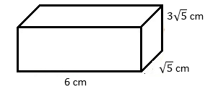

  - Express the volume of the rectangular prism below as a simplified radical expression:
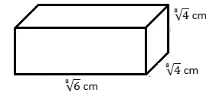

Journal/writing prompts
  - Although we learned that two numerical expressions involving square roots must have the same whole-number radicand in order to calculate a sum/difference, a trusted mathematician argues that you can add $\sqrt{8}$ and $3\sqrt{2}$. Use your knowledge regarding simplifying radical expressions to explain this mathematician’s thought process.
  - Compare and contrast the processes involved when finding the product of two square root expressions versus finding the product of two cube root expressions.

Other Assessments
  - Students can work through additional practice problems on whiteboards so that the teacher can spot-check for accuracy.
  - Students can work with a partner to create and check radical expressions with a given sum, difference, or product. For example, the students could be asked to each create an addition sentence that has a sum of $6\sqrt{3}$. Then, they can trade papers and verify the sum for the expression on their partner’s paper.

Extensions and Connections
- Students could encounter addition and/or multiplication of radical expressions when working with concepts like the Pythagorean Theorem in Geometry.

Strategies for Differentiation
- When determining the product of two square root or cube root expressions, students might create factor trees to help them with the simplification of the product.
For example, the multiplication $3\sqrt{5}∙2\sqrt{10}$ might lead a student to the product $6\sqrt{50}$. However, this product can be simplified. A student might start simplifying the square root of 50 by creating a factor tree that starts with the factors of 5 and 10.
- Use the Preparing for Renovations activity sheet as an extension for students exceeding mastery of the standard.

Note: The following pages are intended for classroom use for students as a visual aid to learning.

Virginia Department of Education © 2018

Simplifying Numerical Expressions with Square and Cube Roots
Name Date
I. Determine each sum/difference.
1.) $3\sqrt{5}-2\sqrt{5}$ = 2.) $8\sqrt{11}+3\sqrt{11}$ =

3.) $\sqrt[3]{9}+4\sqrt[3]{9}$ = 4.) $25\sqrt[3]{3}-7\sqrt[3]{3}$ =

5.) $-7\sqrt[3]{5}+\sqrt[3]{27}+4\sqrt[3]{5}$ = 6.) $\sqrt{18}-5\sqrt{2}+7$=

7.) $2x\sqrt{5}-8x\sqrt{2}+2$= 8.) $13a^{2}\sqrt{3}-2a\sqrt{3}+5a\sqrt{27}-4a^{2}\sqrt{3}$=

II. Determine each product. Make sure that your answer is in simplest radical form.
9.) $(4\sqrt{5})(2\sqrt{3})$ = 10.) $(-2\sqrt[3]{4})(7\sqrt[3]{-3})$ =

11.) $(-3\sqrt{8})(-5\sqrt{2})$ = 12.) $(5\sqrt[3]{4})(9\sqrt[3]{4})$ =

III. Use the concept of the product of radicals.
13.) What are possible values of a and b, if $\sqrt{ab}=5\sqrt{6}$ ?

14.) What are possible values of x and y, if $2\sqrt[3]{3xy}=-4\sqrt[3]{18}$ ?

III. For 13 – 16, use the diagram to the right.
A
B
15.) Determine the area of region A.

16.) Determine the area of region B.

17.) Determine the total area of the rectangle.

18.) Determine the perimeter of the entire figure.

Preparing for Renovations
Name Date
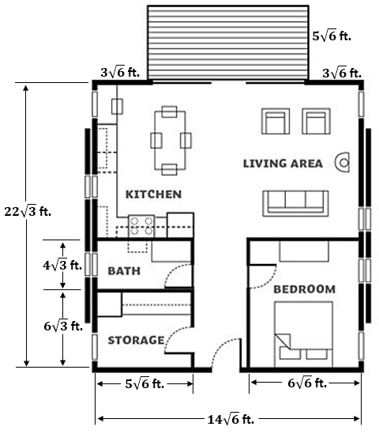
A couple recently purchased a new home. The floor plan can be seen below. The couple wants to put new carpet in the bedroom and new hardwood flooring in the kitchen, living area, and center hallway. They also plan to put a fresh coat of stain on the deck.

Show all calculations as you determine each measurement requested.

1. Find the length of the bedroom.

2. Determine the minimum square
footage of carpeting that the couple
will need to purchase.

3. Calculate the dimensions for both
the kitchen/living area and the
center hallway.

Kitchen/living area:
- Add the lengths of the bath and storage.
- Find the length of the kitchen/living area by subtracting your sum in part a from the total length of the house.

Center hallway (length was determined in part a above):
- Add the width of the bedroom and storage.
- Find the width of the center hallway by subtracting your sum in part c from the total width of the house.

Kitchen/living area: __________ x __________
Center hallway __________ x __________
4. Determine the minimum square footage of hardwood flooring that will need to be
purchased.

- Determine the square footage needed to cover the kitchen/living area.

- Determine the square footage needed to cover the center hallway.

- Determine the total square footage of hardwood flooring needed.

5. Find the width of the deck.

- Add the two measurements of $3\sqrt{6}$ feet.

- Subtract the sum determined in part a from the total width of the house.

6. Determine the square footage for the deck that the couple will need to cover with stain.

7. If stain costs $0.55, on the average,
to cover each square foot of decking,
how much should the couple expect
to pay for the stain?

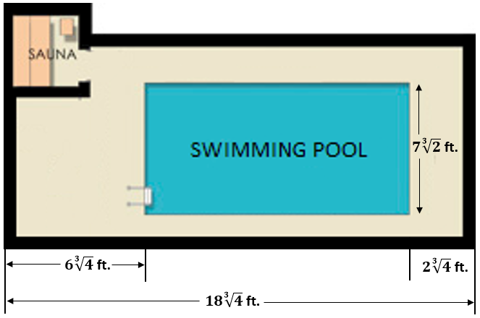
The couple also plans to add a pool and sauna outside the house in the near future. A sketch of their plan is provided.

- Determine the length of the swimming pool.

- Add the lengths of $6\sqrt[3]{4}$ ft and $2\sqrt[3]{4}$ ft.

- Subtract your sum from part a from the total of $18\sqrt[3]{4}$ ft.

9. How many square feet is the couple planning to allot for a swimming pool?

- Extension: The couple could add decorative tiling around the perimeter of the pool.
If they do decide to follow through with the tiling, how many feet of tile
will they need?

