Mathematics Instructional Plan – Algebra I

Multiplying Polynomials Using Algebra Tiles
Strand: Expressions and Operations
Topic: Multiplying polynomials
Primary SOL: A.2 The student will perform operations on polynomials, including
- adding, subtracting, multiplying, and dividing polynomials.
Related SOL: 4.4b, A.2a

Materials
- Multiplying Polynomials Using Algebra Tiles activity sheet (attached)
- Multiplying Polynomials: Connecting Algebra Tiles to the Area Model for Multiplication activity sheet (attached)
- Algebra tiles

Vocabulary
base, binomial, coefficient, constant, degree, exponent, factors, monomial, partial products, polynomial, product, term, trinomial

Student/Teacher Actions: What should students be doing? What should teachers be doing?
- Launch the lesson with a discussion of multiple strategies to determine the product: 11 x 16.
If, during this brainstorm, students do not come up with the methods demonstrated below, refresh their memories before moving on to step 2.
 | 10 | 6
10 | 100 | 60
1 | 10 | 6
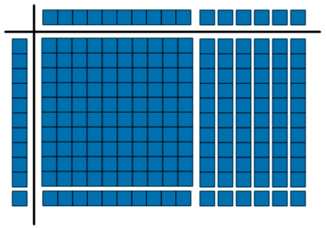
or

- Demonstrate multiplying polynomials using algebra tiles, as shown below:
(x + 1)(x + 6) = x² + 7x + 6
- Distribute algebra tiles and the Multiplying Polynomials Using Algebra Tiles activity sheet. Instruct students to model each expression with the tiles, draw the model, simplify the expression, and write the simplified answer.
- Distribute the Multiplying Polynomials: Connecting Algebra Tiles to the Area Model for Multiplication activity sheet. Instruct students to use the area model to help them determine all of the partial products and then the simplified polynomial that represents the product. This work should be recorded algebraically as well.

Assessment

Questions
- Draw a model of the multiplication of two binomials. Simplify your expression.
- Explain why $\left(2x\right)\left(3x\right)={6x}^{2}$and not 6x.

Journal/Writing Prompts
- One of your classmates was absent when we discussed how to multiply polynomials using algebra tiles. Write a paragraph explaining this procedure.
- Describe how to multiply polynomials without using algebra tiles.

Strategies for Differentiation
- Encourage the use of algebra tiles, drawings, and mathematical notation simultaneously to reinforce the concepts in this lesson.
- Have students use colored pencils for drawing algebra tile models.
- Label the two lines provided (sum of partial products, simplified expression) for each question on the Multiplying Polynomials: Connecting Algebra Tiles to the Area Model for Multiplication activity sheet.

Note: The following pages are intended for classroom use for students as a visual aid to learning.

Virginia Department of Education ©2018

Multiplying Polynomials Using Algebra Tiles
Name Date
Use algebra tiles to model each multiplication problem and find the product. Draw your model in the mat. Then, in the space provided, write the product as a polynomial in its simplest form.

1. x(x + 1) 2. 2x(x – 2)

Product:_______________ Product:_______________

3. x(2x + 2) 4. −x(x − 3)

Product:_______________ Product:_______________
5. (2x+ 1)(x + 1) 6. (−3x + 2)(−x − 2)

Product:_______________ Product:_______________

7. (2x + 1)(x − 4) 8. (−2x − 3)(2x − 1)

Product:_______________ Product:_______________

Multiplying Polynomials: Connecting Algebra Tiles
to the Area Model for Multiplication

Name Date
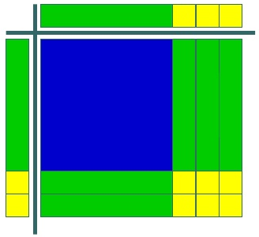
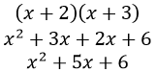
 | x | 3
x | $$x^{2}$$ | 3x
2 | 2x | 6

Use the area model to find the product of each set of polynomials. Record partial products in square/rectangle, and record the coinciding algebraic steps on the lines provided.

1. $(-x+1)(2x+3)$
__________________
__________________

2. $(2x-5)(3x+4)$
__________________
__________________

3. $(x+9)(x^{2}-x+2)$
__________________
__________________

4. $(x-3)({2x}^{2}+5x+1)$
__________________
__________________

5. $(2x-3)(x^{2}-7x-4)$
__________________
__________________

