Mathematics Instructional Plan – Algebra I

Adding and Subtracting Polynomials Using Algebra Tiles
Strand: Expressions and Operations
Topic: Adding and subtracting polynomials
Primary SOL: A.2 The student will perform operations on polynomials, including
- adding, subtracting, multiplying, and dividing polynomials;

Materials
- Adding and Subtracting Polynomials Using Algebra Tiles activity sheet (attached)
- Algebra tiles

Vocabulary
monomial, binomial, trinomial, polynomial, term, degree, base, exponent, coefficient

Student/Teacher Actions: What should students be doing? What should teachers be doing?
- Demonstrate adding and subtracting polynomials using algebra tiles.
- Distribute algebra tiles and the Adding and Subtracting Polynomials Using Algebra Tiles activity sheet. Instruct students to model each expression with the tiles, draw the model, simplify the expression, and write the simplified answer.

Assessment

Questions
    - Draw a model of the addition of two trinomials. Simplify your expression.
    - Explain why x and x² cannot be combined into one term.

Journal/Writing Prompts
    - One of your classmates was absent when we discussed how to subtract polynomials using algebra tiles. Write a paragraph explaining this procedure.
    - Describe how to add and subtract polynomials without using algebra tiles.
    - Explain the difference between “like terms” and “unlike terms.” Give examples.

Strategies for Differentiation
- Encourage the use of algebra tiles, drawings, and mathematical notation simultaneously to reinforce the concepts in this lesson.
- Have students use colored pencils for drawing algebra tile models.
- Provide algebra tiles for student exploration.
- In the Adding and Subtracting Polynomials Using Algebra Tiles activity, provide students with a completed example to use as a model.
- Struggling students could stop working after question 4 on the Adding and Subtracting Polynomials Using Algebra Tiles activity sheet.
- Allow students to work with a partner to complete questions 7–9 on the Adding and Subtracting Polynomials Using Algebra Tiles activity sheet.

Note: The following pages are intended for classroom use for students as a visual aid to learning.

Virginia Department of Education ©2018

Adding and Subtracting Polynomials
Directions: Use the example below to help you simplify the remaining polynomials. Both of your answers should match.
Algebra Tiles | Algebraically
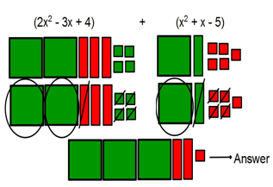  3x² – 2x - 1 | 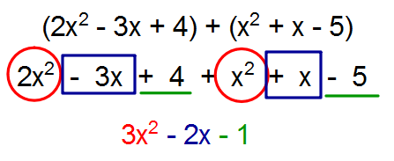  In the example above, we must combine like terms by adding them together. For example, 2x² and x² are like terms. If we add their coefficients together (2 and 1), we get a sum of 3.  Note: you cannot combine 2x² with x because they are unlike terms. In other words, they do not have the same variable and exponent.
1. | - (x² – 2x + 3) + (-2x² – x – 5)
2. | - (-x² – 2x + 2) – (-x² + x + 4) The model to the left was created after distributing the subtraction.

Adding and Subtracting Polynomials Using Algebra Tiles
Name Date
Use algebra tiles to model each addition and subtraction problem and find the sum or difference. Draw your model of each problem below the problem. Cancel zero pairs by writing an X on the tiles that cancel. Write your simplified answer in the space provided.
1. (2x² − 7x + 6) + (−3x² + 7x) 2. (−2x² + 3x) + (−7x − 2)

Answer:_______________ Answer:_______________

3. (x² − 4x) − (3x² + 2x) 4. (3x² − 5x − 2) − (x² − x + 1)

Answer:_______________ Answer:_______________

5. (4x² + 5x − 9) − (7x² + 5x) + (3x² – 8x + 6)

Answer:_______________

6. (5x² − 7x − 1) − (6x² + x + 1) + (3x² + 4x – 3) – (2x² + 5x – 7)

Answer:_______________

Is each statement below true or false? Justify your answer with a drawing. Write “True” or “False” in the space provided.
?
7. (3x² + 2x − 4) + (−x² + 2x − 3) = 2x² + 4x − 7 ___________________

?
8. (x² − 2x) − (−3x² + 4x − 3) = −2x² − 6x − 3 ____________________

9. (5x² – x + 6) − (6x² – 5x − 1) – (-x² – 3x + 9) = − x − 2____________________

Extend your learning and thinking by drawing, simplifying, and solving the following problem.
(−x² − 3x − 1) − (x² − 3x −1) + (2x² − x + 1) − (x² − x − 1) + (x² + x + 1)

