Mathematics Instructional Plan – Algebra I

Evaluating Expressions Using Algebra Tiles
Strand: Expressions and Operations
Topic: Evaluating algebraic expressions
Primary SOL: A.1 The student will
- represent verbal quantitative situations algebraically; and
- evaluate algebraic expressions for given replacement values of the variables
Related SOL: A.4c

Materials
- Algebra tiles (or similar manipulative)
- Evaluating Expressions, Using Algebra Tiles activity sheet (attached)

Vocabulary
addition/subtraction property of equality, algebraic expression, associative property of addition/multiplication, commutative property of addition/multiplication, distributive property (A.1a, b), inverse property of addition/multiplication, multiplication/division property of equality, reflexive property of equality, replacement set, substitution property, symmetric property of equality, transitive property of equality, variable

Student/Teacher Actions: What should students be doing? What should teachers be doing?
Note: Algebra tiles help students make connections between the abstract and the concrete. This activity encourages modeling and drawing. The Concrete-Representational-Abstract (CRA) Model is important in order for students to develop conceptual understanding of substitution and simplifying expressions. Some students who have had exposure to the use of manipulatives in previous mathematics courses and may be ready to move to the representational and abstract levels faster than other students.
- Use algebra tiles to model substitution when simplifying algebraic expressions. Demonstrate representing an expression with tiles and then replacing each rectangle with the appropriate tile value and combining like terms (e.g., 3 + 2x, when x = –4, as follows:
3 + 2x, when x = –4

Replace each with
Show zero pairs by placing additive inverses side-by-side.

Therefore, when $x = -4, 3 +2x = -5.$
- Show that the distributive property can be represented using algebra tiles as well. For example, demonstrate $3\left(x-2\right)$ as “x – 2” three times: Remind students that this is the same as 3 times x minus 3 times 2.
3(x – 2), when x = 2

Replace each with

Show zero pairs.
Therefore, when $x =2, 3\left(x -2\right) =0.$
- Distribute the Simplifying Expressions, Using Algebra Tiles activity sheet. Instruct students to set up each original expression with the appropriate tiles and replace, or substitute, each rectangle with its tile value. Encourage students to use the language of the properties when simplifying these expressions and show zero pairs.

Assessment

Questions
    - Draw a model of the expression $2x +4$. Assign a value to x, and replace x with your selected value. Simplify the expression. Make a drawing of your procedures. What is the simplified answer?
    - Write an expression that uses x. Draw a model of your expression. Replace x with −3. Simplify the expression. Make a drawing of your procedures. What is the simplified answer?
    - How would you show the division and multiplication property of equality using algebra tiles?
    - How would you show that the commutative property of addition/multiplication is true using algebra tiles?

Journal/Writing Prompts
    - One of your classmates was absent when we practiced simplifying expressions, using algebra tiles. Write a detailed explanation of how to use algebra tiles and substitution to simplify an expression.

Other Assessments
    - Have students create a poster illustrating the procedures discussed in this activity.
    - Ask students to write out the algebraic expressions with words from the in-class examples. Have them do the same for the expressions given on the activity sheet.

Extensions and Connections (for all students)
    - How can you change an expression to an equation using algebra tiles?

Strategies for Differentiation
- Encourage ELL students to write the description of procedures in their native languages.
- Have students use the algebra tiles in conjunction with drawing the representations of the tiles using colored pencils.
- Have students write keywords instead of writing the entire list of procedures.
- Allow students to use actual algebra tiles as templates for tracing.
- Ask students to create their own expressions and replacement values for x.
- Create a large-scale reusable copy of the modeling frame and allow students to use as needed.
- Provide scaffolded examples in questions 1 and 2 on the Evaluating Expressions, Using Algebra Tiles activity.

Note: The following pages are intended for classroom use for students as a visual aid to learning.

Virginia Department of Education © 2018

Evaluating Expressions, Using Algebra Tiles
Name____________________________________ Date____________________
Model each expression with algebra tiles, and make a drawing of your tile model. Then, replace each rectangle with the appropriate tile value and draw this model. Simplify the expression by combining like terms and canceling out zero pairs, where necessary. Write the simplified answer.
1. 2 + x, when x = 4
Model of the Expression | Expression with the  Rectangle(s) Replaced | Simplified Answer

2. –3 + 2x, when x = –4
Model of the Expression | Expression with the  Rectangle(s) Replaced | Simplified Answer

3. The sum of two times x and –3, when x = 4
Model of the Expression | Expression with the  Rectangle(s) Replaced | Simplified Answer

4. One less than one half of x, when x = 6
Model of the Expression | Expression with the  Rectangle(s) Replaced | Simplified Answer

5. 2(1 – x), when x = –2
Model of the Expression | Expression with the  Rectangle(s) Replaced | Simplified Answer

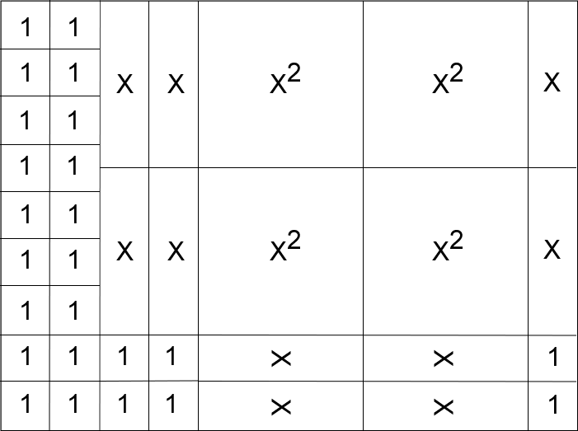
Model of the Expression | Expression with the  Rectangle(s) Replaced | Simplified Answer

