Bicycling in Virginia - Plan Your Trip!!
Grades: Upper Elementary - 4-6
Content: English Standards of Learning 4.1, 4.2, 4.6, 4.7, 4.8, 4.9,5.1, 5.2, 5.6, 5.7, 5.8, 5.9, 6.1, 6.2,6.6, 6.7, 6.8, 6.9 (nonfiction reading, composing, editing, research, oral presentations)
Resources:
- Virginia Department of Transportation - bike map
- Virginia Tourism Corporation
- Virginia Department of Conservation and Recreation (State Parks)
- List of Trails in Virginia
This cross-curricular, group research project will require several class periods and may be modified to fit any schedule or class. The project works best with cooperative groups that have been previously assigned, and students who are familiar with working in groups. Each group or student should be provided a copy of the Virginia Department of Transportation Bike Map to use as a reference. Each part of the project should be graded separately using a rubric; additionally, the entire project could receive an overall grade.

Divide the class into 8 small groups for the research project. Assign or let each group choose one of the following areas for their bike trip.

High Bridge Trail State Park
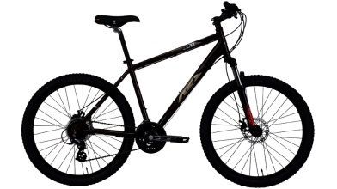
Virginia Capital Trail
Virginia Creeper Trail
U.S. Bicycle Route 76 & Blue Ridge Parkway
New River Trail State Park
Northern Virginia Trail Network
Heart of Appalachia Bike Route
Tobacco Heritage Trail

Explain that each bike trip research project group will turn in the following:

- A detailed map of the planned route – minimum of 30 mile trip
- Itinerary of each day and how many miles traveled - 3 day minimum
- Areas of interest each day - include pictures and description of any areas of interest
- A narrative journal entry of 2 paragraphs per day for each of the 3 days describing sites and chronicling the day and stops
- Geographic description of the route including elevation, terrain, weather, state of the trail/roads, towns or locations along the way, unique features of your trail
- Color brochure advertising the trail you took, persuading your classmates that your trail was the best choice
- Bibliography page including any sources used
- A list explaining which group members were responsible for which parts of the project
- Oral presentation - Each group will present their bike trip to the class

