WHERE ARE THE SHAPES?

Kindergarten, One or Two

Objective: The student will be able to identify the various shapes found on objects and then specifically on a bicycle.

Virginia Science Standards: K.1, K.4, 1.1, 1.2, 2.1
Background Information:
Share with your students the following information related to the Richmond 2015 UCI Championships.
In September, the 2015 Road World Championships (Worlds) will be held in Richmond, the Capital of Virginia. (Have students identify Richmond on a map and discuss the distance from their city.) Approximately 1,000 men and women from among the world’s top cyclists, representing about 75 countries, will compete in the 12 championship races. It is a rare opportunity for the athletes to compete for their country, just as they do during the Olympic Games. The athletes will compete in three different events including the traditional Road Race, the Individual Time Trial and the recently introduced Team Time Trial. World Champions are crowned in each event. This is truly a great global sporting event which will be broadcast live to a global audience of more than 300 million people.

Why Teach Shapes:
Children who learn about shapes are building skills that will help them with reading, writing, science, and mathematics. Learning about shapes also can help them understand other signs and symbols. For example, when children learn to discern the similarities and differences between shapes, they are using the same skills they need to recognize the differences between letters and numerals. This concept provides them with a basic process that they will be able to use in observing, comparing and discussing all they see and encounter. Using observation skills, students can identify the various shapes found on a bicycle, from the obvious ones like wheels that are circular to less obvious shapes such as the triangular parts of the frame and the rectangular shape of the pedals.

Activity Plan
Materials:
- Copies of the “Shape Hunt” worksheet attached (one for each student team)
- Large chart paper to create a shape graph divided into four columns with each labeled for a shape (circle, square, triangle, rectangle)
- Book: Marvin K. Mooney Will You Please Go Now!, Dr. Seuss
- Bicycle for observation
- Pictures of different kinds of bicycles (You can print the pictures attached to this lesson or you can search on the web using the key words “bicycle designs.”)
- White construction paper (at least 8 ½ X 11)
- Cut out shapes in various colors (or templates of shapes for students to trace and cut out). For primary grades, the focus is on the shapes: circle, square, triangle, and rectangle.
- Glue
- Scissors
- Pencils

Activity #1:
- Discuss with the class that they will be “shape detectives and engineers” today. Discuss what the words “detective” and “engineer” mean. As “shape detectives and engineers,” they will search for shapes all around them and will use those shapes to design and build things.
- Divide the class into teams of two. Give each team a “Shape Hunt” page. Tell the students that they will have ten minutes as a team to find as many shapes in the classroom as they can. They need to indicate on their sheet where they found each shape.
- At the end of the Shape Search time, gather the class as a large group. Using the large chart paper you prepared with the four columns, let groups tell you where they found their shapes. If a group identifies a shape already noted by a previous group, just put a hash tag beside it since the object is to find as many different locations of the shapes.
- Discuss what the graph you have created shows about the number of shapes in your classroom.

Activity #2:
- Gather the class. Remind them that they are still “shape detectives and engineers.”
- Read aloud the Dr. Seuss book Marvin K. Mooney Will You Please Go Now!. As you read the story, allow time for the students to identify shapes they see in the book. Also have them identify the many varied vehicles and ways that Marvin K. Mooney could leave.
- When you have finished with the book, bring out the bicycle to share with the students.
- Relate that two of the ways that Marvin K. Mooney could leave was by a bike or even a Zike Bike. Tell them that they will need to now be very accurate (define this word for them) detectives and engineers as they observe the bicycle.
- Have the class identify all the shapes they see on the bicycle. Make sure that they use positional words (above/below, in front of/behind, etc.) to describe where they see each of the identified shapes.
- Share with the students the various pictures of different “kinds” and “designs” of bicycles. Discuss how they are different from the bicycle in the room. Discuss with the class how changing how things are made many times improves things from the original design. Discuss whether or not they think each various bicycle design would be a good design.
- Tell the students that they are going to now become “bicycle engineers.” They are going to construct another type of bicycle (but not a Zike Bike) for Marvin K. Mooney to use to leave. Tell them that they will have various shapes to use to construct a model of their bicycle on a piece of construction paper.
- Tell the students to name their bicycles (like Dr. Seuss called his design the Zike Bike).
- They need to write a sentence that describes their bicycle and how it will be a good bicycle for Marvin K. Mooney to use to leave.
- They need to be able to identify all the shapes in their bicycle design.
- Allow time for students to share their designs with the class.

Shape Hunt Team Member Names:

Circle | Square | Triangle | Rectangle

Pictures of Various Bicycle Designs

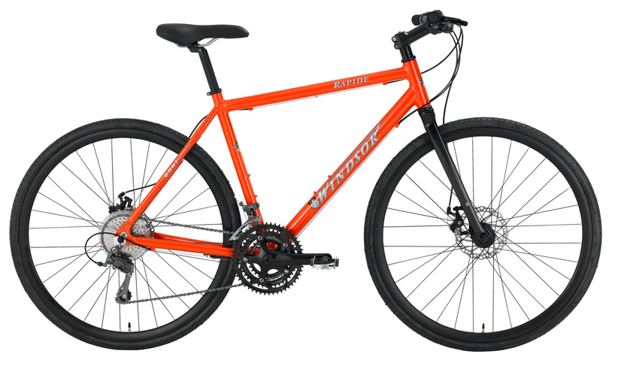
www.bikesdirect.com

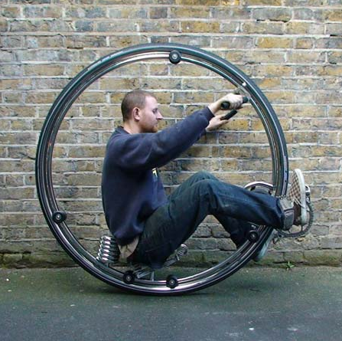
http://www.dezeen.com/2010/06/30/dezeens-top-ten-bikes/

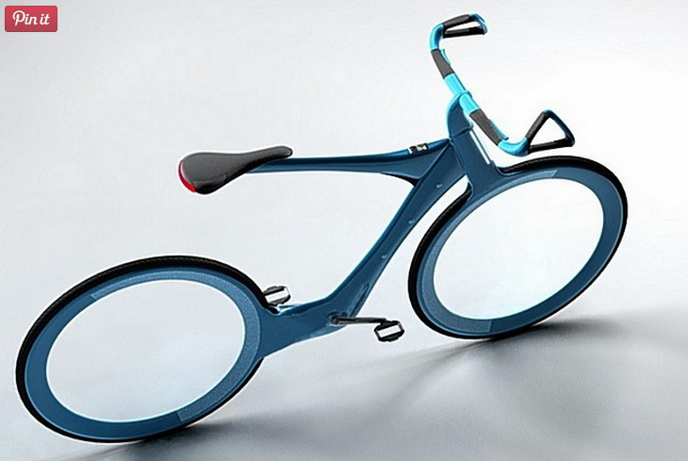
http://www.designrulz.com/product-design/gadgets/2011/01/ultimate-cool-bike-designs/

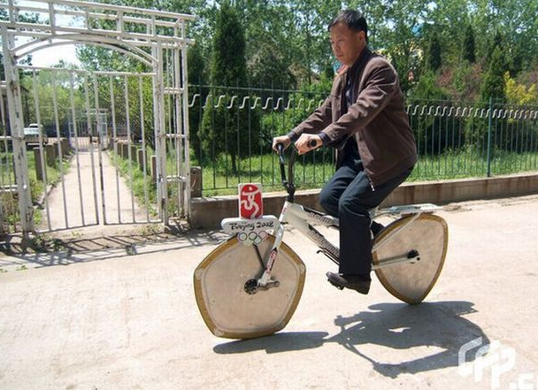
https://endless-sphere.com/sphere/threads/reuleaux-polygon-bicycle-uses-triangular-pentagonal-wheels.10617/

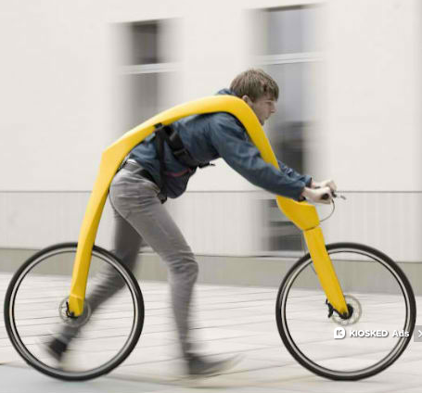
Momtastic Web Ecoist
http://webecoist.momtastic.com/2012/09/17/this-aint-no-huffy-15-bold-futuristic-bike-designs/

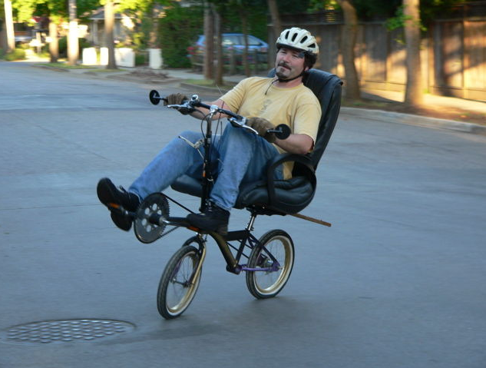
Office Chair Bicycle
http://www.bikeroute.com/Recumbents/News/Archives/000157.html

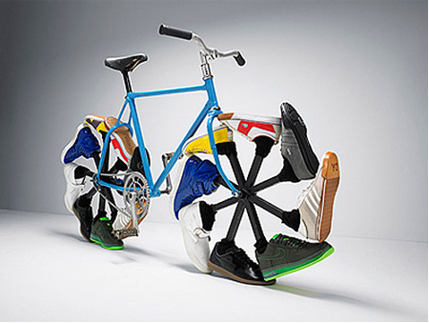
http://www.toxel.com/inspiration/2008/11/25/creative-and-unusual-bike-designs/

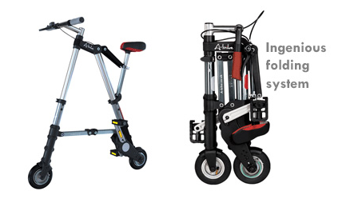
http://www.toxel.com/inspiration/2008/11/25/creative-and-unusual-bike-designs/

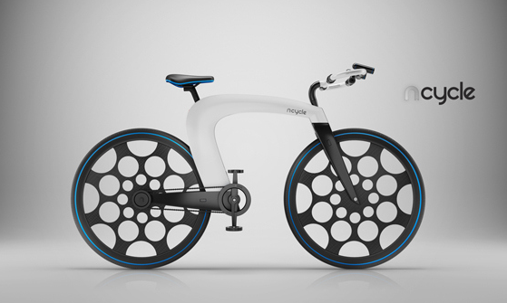
http://www.core77designawards.com/2013/recipients/ncycle/

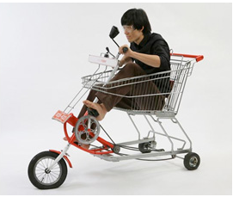
http://www.toxel.com/tech/2011/01/13/12-unique-and-creative-bicycles/

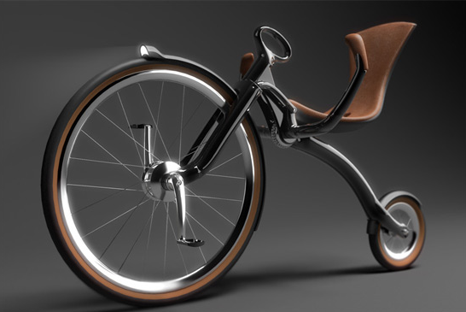
http://bicycledesign.net/2010/06/two-very-different- penny-farthings-and-a-foil-car/

https://www.pinterest.com/pin/530298924843246211/

