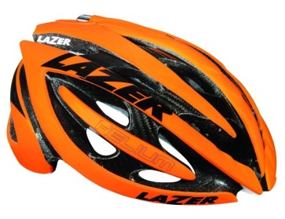
Helmet Safety

Kindergarten, First, Second

Objective: The student will develop an understanding of the importance of wearing a bicycle helmet and be able to demonstrate the 2-2-2 rule for wearing a helmet.

Virginia Standards:
Health Kindergarten
K.1.j. - Recognize ways to be safe (e.g., tying shoes, wearing a helmet, using a car safety.3.i seat and seat belt).
K.2.k - Identify safe choices when walking, riding in a car and bus, and riding a bike.
K.3.i - Describe how safety choices can prevent injuries (e.g., wearing helmets, tying shoelaces, using seat belts and safety seats, and sitting in the back seat of vehicles with airbags).
Health First Grade
1.1.e – Describe behaviors that promote personal safety, to include bus and automobile safety, pedestrian safety, playground safety, fire safety, water safety, Internet safety, and safety when biking and using other recreational equipment.
1.2.i - Explain ways to stay safe when riding a bicycle, inline skating, riding a skateboard or scooter, and using other self-propelled vehicles
1.3.f - Explain how protective gear reduces injuries.

Materials: Pre-Assessment Worksheet, bicycle helmets, helmet fit task cards
Background Information:
Share with your students the following information related to the Richmond 2015 UCI Championships.

The Road World Championships (Worlds) is held annually in a city chosen by the Union Cycliste Internationale (UCI). In September 2015, this nine-day event will be held in Richmond, the Capital of Virginia. (Have students identify Richmond on a map and discuss the distance from their city.) Approximately 1,000 men and women from among the world’s top cyclists, representing 75 countries will compete in the 12 championship races. This is an opportunity for these athletes to compete for their country, just as they do during the Olympic Games. The athletes will compete in three different events including the traditional Road Race, the Individual Time Trial and the recently introduced Team Time Trial. World Champions are crowned for each event, and they are entitled to wear the rainbow jersey until the next Championships. It is estimated that this exciting global sporting event will be broadcast live to 300 million people.

Pre-Assessment for Helmet Safety:
Today we will be learning how a properly fitted bicycle helmet works and how it helps protect your brain. Brain injuries can leave individuals with permanent impairments so wearing a helmet is important to your safety.
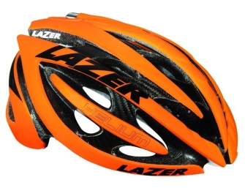
NAME: ________________________________
DATE: ________________________________

Helmet Safety Check

Select the best answer for each question below.

- What is the purpose of wearing a helmet while riding a bike?
  - A helmet keeps your head cool when riding.
  - A helmet reduces the risk of brain injury.
  - A helmet protects your eyes.
  - A helmet keeps your ears warm.

- How does a bicycle helmet protect your head if you are in an accident?
  - A helmet provides a barrier between your head and the ground.
  - A helmet has vents to keep your head cool.
  - A helmet absorbs the crash forces instead of your brain.
  - A helmet really does not protect your head when you crash.
- When should you wear a bicycle helmet?
  - You should wear a helmet only if you are riding in traffic.
  - You do not need to wear a helmet if you always obey the safety rules.
  - You only need to wear a bicycle helmet if your parents tell you to do so.
  - You should ALWAYS wear a bicycle helmet when riding your bike.

Activity: Helmet Fit 101
Explain and demonstrate the 2-2-2 rule. 2 finger width between eyebrow and helmet (child’s fingers); 2 straps make the “V” under and slightly in front of each earlobe; 2 fingers between the chin and chinstrap.
Q. What are the most important things to do when fitting your helmet?
A. Helmet should fit snug and level on your head
A. There should be 2 fingers width between eyebrow and helmet
A. Snug straps so the helmet doesn’t rock back & forth... straps for the letter “V”
A. Snug chinstrap... no more than 2 fingers between chin and chinstrap

- Place students in small groups and have them practice demonstrating how to adjust and wear a helmet.
- Take photos of the students wearing a helmet correctly and incorrectly. Using the photos, create task cards that students can use to sort and identify properly fitting helmets from unsafe fittings. This activity can be used as a continuous relay designed to increase student heart rates.
Fun Fact
Fred A. Birchmore, 25, circled the globe by bicycle in 1935. The entire trip, through Europe, Asia, and the United States, covered forty thousand miles. He pedaled about 25,000 miles and wore out seven sets of tires. He traveled the rest of the way by boat.
Bonus Activity:
- Encourage students to share the 2-2-2 rule with other family members and the importance of wearing a bicycle helmet every time they ride a bike.

- Provide all students with Parts of the Helmet Worksheet. Students can label the different parts of the helmet (e.g., front of the helmet, back of the helmet, shell, foam, straps, etc.). When they have completed the worksheet, they can color it and return it to the teacher so that they can be displayed.

