Skills: Locomotor Travel, General Knowledge of Bicycle Parts, Teamwork, Cooperation

Fitness Target: Aerobic Capacity, Muscular Endurance, Muscular Strength

Virginia Standards: Health - K.1j, 1.1e, 1.2i, 2.2e, 3.1e, 3.2h, 4.2i, 5.2f
PE - K.1a&f, K.4a&b, 1.1a&h, 1.3b, 1.4c, 2.1d&e, 2.3d, 2.4c, 3.2a, 3.3d, 3.4c, 4.1a, 4.3, 4.4a, 5.1.a

National Standards: Physical Education Standard S1.E1.K-4, S1.E2.2a, S2.E1.Ka, S2.E1.1-3, S2.E1.4a
Equipment: Cones to mark the playing area, polyspots to mark “home” for each pair of students, Bike Parts Task Cards

Activity:
Before the activity begins, the teacher will discuss or review the basic parts of a bike with the class (see attached diagram).

Primary Grades (K-2) | Intermediate Grades (3-5)
Frame | Top Tube
Wheels | Down Tube
Saddle | Seat Tube
Tire | Head Tube
Spokes | Seat Post
Handle Bar | Seat Stay
Grips | Chain Stay
Pedal | Cassette
Wheel | Chain Rings
Brake | Pedal
Chain | Crank
 | Tire
 | Fork
 | Saddle
 | Brake
 | Brake Lever
 | Rim
 | Spokes

After the review or discussion, students will find a partner and stand behind a polyspot on one end of the playing area. On the other end of the playing area, the teacher will place the bike part task cards (see the attached task card list). Each pair of students will receive a Bike Label Task Sheet.

When the activity begins, one of the two partners will travel across the playing area and collect one bike part task card. When the partner returns, he/she will place the bike part in the correct location using the Bike Label Task Sheet. The new partner will then repeat the task collecting a new bike part. The task will continue until all of the bike parts have been collected and placed in the correct order. When the task is complete, the pair will raise their hands and the teacher will check the progress of the students. If the students were able to complete the task correctly, they can replace their cards and attempt the activity again using a more challenging Bike Label Task Sheet or travel using a different locomotor pattern while completing the task again.

Teaching Tips:
- Have students travel in a different locomotor pattern each time they travel to collect a task card during the activity.
- Increase physical activity by having the waiting partner perform a fitness task while they wait.
- Integrate sports skills while partners are waiting (i.e., – basketball dribble, soccer juggle, toss and catch with a ball, etc.).
- Provide students with a Bike Part Key when they have completed the task to check their work.
- If students are making common errors during the activity, take time to provide feedback to correct the issue.
- Use a visual to help students learn the parts of the bike (i.e., – label a real bike or a poster size version of the Bike Part Key)

FRAME
Primary
WHEEL
Primary
HANDLEBAR
Primary
SADDLE
Primary
TIRE
Primary
SPOKES
Primary
GRIPS
Primary
PEDAL
Primary
CHAIN
Primary
BRAKE
Primary
SEAT POST
Intermediate
FORK
Intermediate
HANDLEBAR
Intermediate
SADDLE
Intermediate
TIRE
Intermediate
SPOKES
Intermediate
GRIPS
Intermediate
PEDAL
Intermediate
WHEEL
Intermediate
BRAKE
Intermediate
BRAKE LEVER
Intermediate
TOP TUBE
Intermediate
DOWN TUBE
Intermediate
HEAD TUBE
Intermediate
SEAT TUBE
Intermediate
CHAIN STAY
Intermediate
SEAT STAY
Intermediate
REAR DERAILLEUR
Intermediate
FRONT DERAILLEUR
Intermediate
RIM
Intermediate
CHAIN RINGS
Intermediate
CASSETTE
Intermediate
CRANK
Intermediate

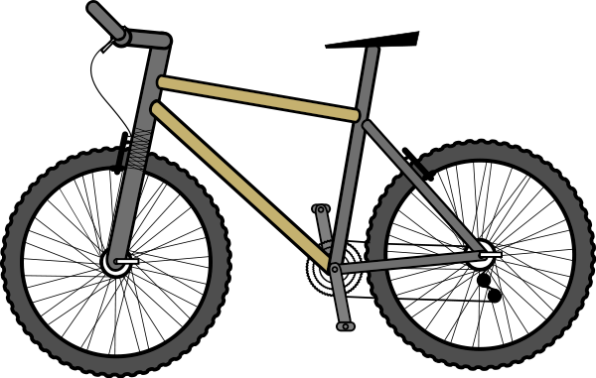
Bike Label Task Sheet
Intermediate
Bike Label Task Sheet
Primary

