Skills: Teamwork, Road Sign Identification, Locomotor Movement, Sport Skills

Fitness Target: Aerobic Capacity

Virginia Standards: Health 1.2b, 1.3h,1.6a, 2.5b, 3.1c, 3.5b, 4.4e, 4.6a, 5.5c
PE 1.2a, 1.3, 1.5a, 2.2a, 2.3c, 2.4, 3.2a, 3.3, 3.4c, 4.3, 4.4a, 5.5b

National Standards: Physical Education Standard 1, 4, and 5
Equipment: Cones to mark the playing area, street sign cutouts (attached), team markers (polyspots, cones)

Activity:
Before the activity begins, the teacher will show and explain the meaning of essential traffic signs and signals (stop, one way, yield, wrong way, red light, green light, yellow light, right turn signal, etc.,) and describe how the cyclist should respond to each sign.

With a partner, students will stand together at a marker (polyspot) to start the activity. Street signs will be placed face down inside the activity area. When the activity begins, the students will move into different parts of the playing area and place their hands on one sign and face their partner. On the count of three, the students will lift their sign like they are taking a “snap shot” with a camera and show the sign they selected to their partner. If the two signs match, the partners will take the signs back to their team marker before going out to collect more signs. If the signs do not match, the partners must return to the team marker without the signs before they can continue trying to find signs that match. The objective of this activity is to find as many pairs of matching signs as possible.
Teaching Tips:

- Have students travel using different locomotor patterns when searching for matching signs.
- If covering a sport skill unit, add the basic traveling skill, such as dribbling for basketball when students are searching for matching signs.
- Have students perform a fitness activity, such as push-up plank shoulder tap, knee curl-ups, etc., before flipping the sign.
- When partners find matching signs, they must be able to explain the meaning of the sign to the teacher before they can take it back to their team marker.
- Provide many cutout copies of each sign or signal to encourage more activity time and better recognition of the signs and signals.
- Use this activity for other matching challenges.

* Concept from Susan Flynn, College of Charleston.

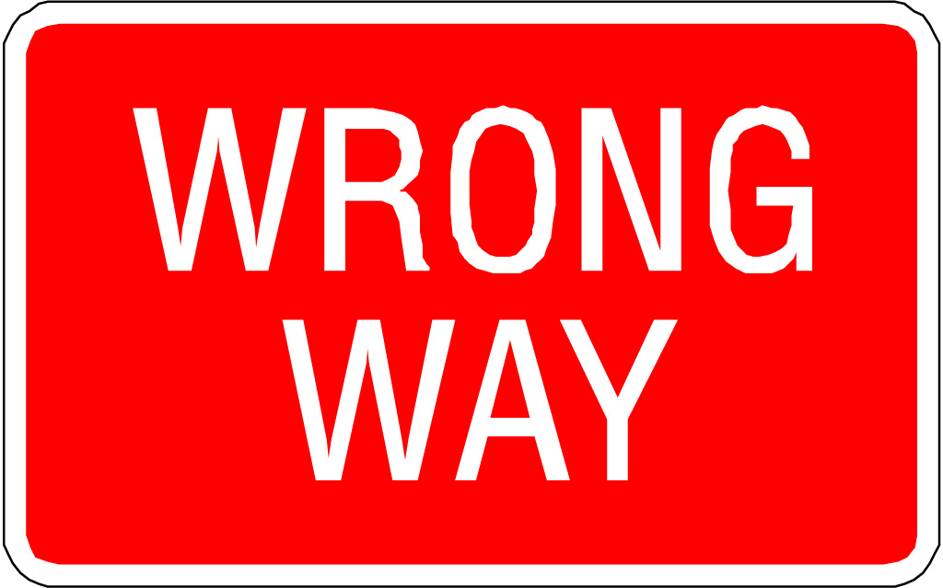
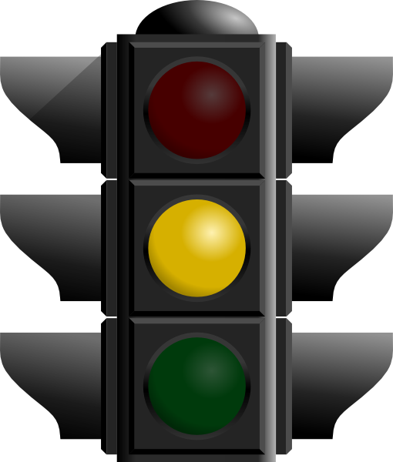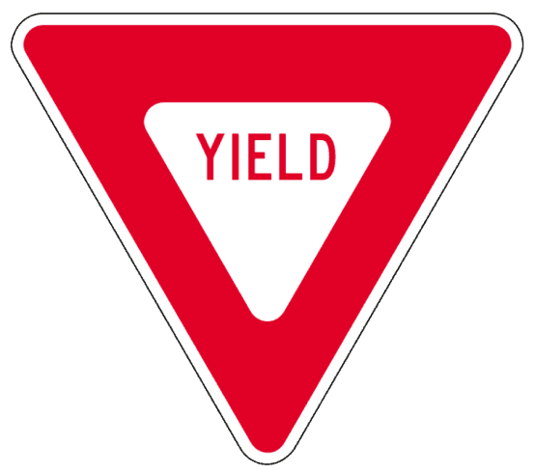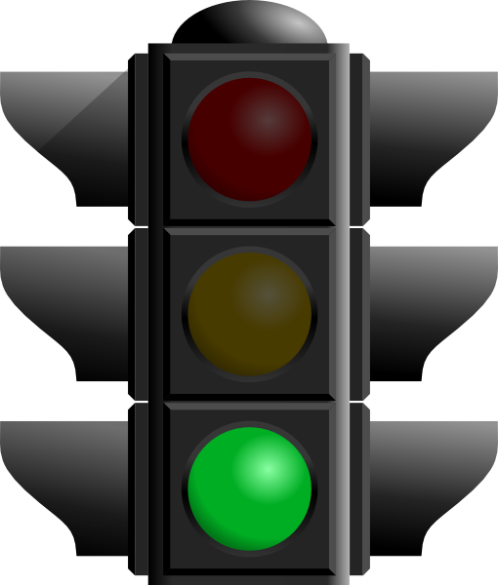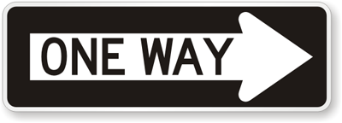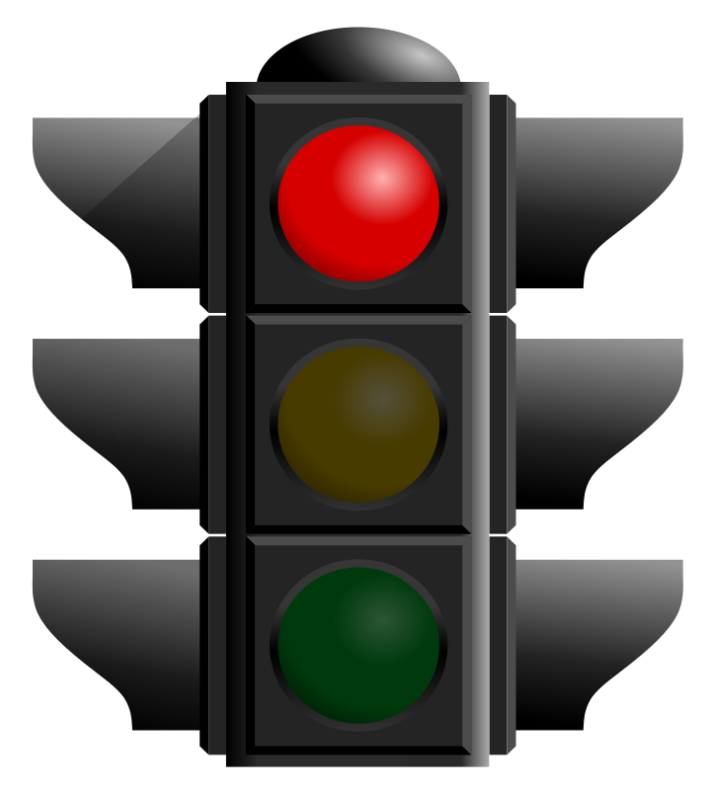
YELLOW
GREEN
RED

