Attachment A

Superintendent’s Memo #326-20

December 18, 2020
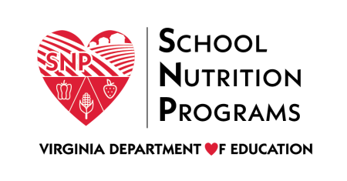

School Nutrition Programs FPAR Schedule 2020-2021
Division/School Food Authority Name | Program Review
Department of Juvenile Justice | FPAR
Phillips School at Annadale | FPAR
Tyler Village of ChildHelp | FPAR
United Methodist Family Services | FPAR
Youth for Tomorrow | FPAR
Culpeper County | SSO
Frederick County | SSO
Augusta County | SSO
Eastern Mennonite HS | SSO
Fairlawn Christian Academy | SSO

