Attachment A
Superintendent’s Memo No. 308-20
November 20, 2020

VIRGINIA DEPARTMENT OF EDUCATION

Individuals with Disabilities Education Act (IDEA)
Maintenance of Effort (MOE) Guidance Document

Overview

The Virginia Department of Education (VDOE) is required by federal regulation to ensure all school divisions in Virginia comply with §300.203(b) of the Individuals with Disabilities Education Act (IDEA), which mandates that school divisions meet a maintenance of effort (MOE) obligation. This regulation requires school divisions to spend at least the same amount of local or local plus state dollars for a current school year on the delivery of special education and related services, as were spent from the same source in the last fiscal year the LEA met IDEA MOE.
On April 28, 2015, the U. S. Department of Education (USED) published final regulations concerning local educational agencies (LEAs) MOE. These changes in the revised regulations include: (1) Clarification of the compliance standard; (2) Explanation of the Subsequent Years rule; and (3) Specification of the consequences for an LEA's failure to maintain effort. The VDOE shared this guidance with the LEAs on August 18, 2015, and were implemented during state fiscal year (SFY) 2015-2016 data collections. Divisions must ensure accuracy of its IDEA MOE expenditure data and the calculation methodology used to be consistent from year to year. Any deviation from its methodology will affect the division’s local determination matrix and will trigger a review.
The following guidance has been provided to assist divisions with computing its special education and related services expenditures. Additionally, this document further clarifies the four tests that will be used to determine compliance and the allowable exceptions and/or provisions available for divisions to consider.

IDEA MOE Expenditures

The expenditures entered in the application must include all costs associated with providing special education and related services to children and youth with disabilities that are above and beyond the costs of providing regular education programs to nondisabled students. Costs associated with capital outlay or regular education programs and services should be excluded from this expenditure calculation.

Expenditures for special education and related services must be reported by source of funds (state and local). Federal expenditures are not used to determine whether the division has met its MOE requirement. Each entry must represent actual expenditures and be consistent with federal and state definitions of special education and related services. “Related services” are defined in §22.1-213, Code of Virginia:

“Related services” means transportation and such developmental, corrective, and other
supportive services as are required to assist a disabled child to benefit from special
education, including speech pathology and audiology, psychological services, physical

Attachment A
Superintendent’s Memo No. 308-20
November 20, 2020

and occupational therapy, recreation, early identified and assessment of disabilities in
children, counseling services and medical services for diagnostic or evaluation purposes.
The term also includes school health services, social work services in schools, and parent
counseling and training.

The primary requisite for reporting expenditures for purposes of determining compliance with IDEA’s MOE requirements is that divisions will only report those expenditures made for students with disabilities for whom the division is legally responsible. In the state fiscal year (SFY) 2019-2020 Annual School Report (ASR), divisions reported expenditures for students with disabilities served by the division. As such, expenditures entered in the IDEAMOE Application will likely differ from special education expenditures reflected on Schedule A of the Annual School Report Financial Section (ASRFIN) since they reflect a different reporting type.

As noted above, divisions should report only those expenditures that are related to the provision of special education and related services for students with disabilities for whom the division is legally responsible. These expenditures should include any local or state dollars expended for:

- direct instruction/provision of special education service through an Individualized Education Program (IEP);
- costs such as salaries and benefits (full and prorated costs) of staff who provide special education and related services;
- costs associated with special transportation as called for in an IEP;
- prorated proportionate costs of certain equipment purchases or certain construction costs;
- costs associated with the provision of special education and related services for divisions responsible for the education program in a regional or local jail;
- costs for providing special education and related services through a homebound or home-based model; and
- tuition paid to another division.

The following costs should not be included in the division’s reported expenditures:

- tuition received from another school division
- general capital outlay
- general transportation costs
- Comprehensive Services Act (CSA) local match
- any expenditure that apply to all students (i.e., general education costs that applies to students with disabilities as well)

NOTE: Tuition received by the serving school division for a student the serving division is not legally responsible for should be used to reduce the serving division’s expenditures by the amount of tuition received.
Once the division has identified its special education and related services expenditures, the division will enter its expenditure data into the online IDEAMOE Application (Refer to Attachment B for detailed instructions). The information below is provided to help divisions understand the process through which the VDOE will determine compliance, utilizing the four ‘tests’ and various allowable exceptions or provisions available.
Attachment A
Superintendent’s Memo No. 308-20
November 20, 2020

IDEA MOE Tests

As specified in §300.203b of the IDEA regulations, the compliance standard is an expenditure test to determine whether an LEA, in fact, met the requirement to maintain effort in a particular fiscal year. The compliance standard prohibits LEAs from reducing the level of expenditures from local, or state and local funds, for the education of children with disabilities below the level of those expenditures made by the LEA for that purpose from the same source for the preceding fiscal year, except as provided in §§300.204 and 300.205. In other words, a school division must maintain (or increase) the amount of local, or state and local funds, it spends for the education of children with disabilities when compared to the last fiscal year the LEA met IDEA MOE.

There are four methods or ‘tests’ a school division can use to meet its maintenance of effort compliance requirement, to spend at least the same total amount of:

- either local dollars,
- local plus state dollars,
- local per capita amount of dollars, or
- local plus state per capita amount of dollars.

These expenditures were for the education of children with disabilities that the school division spent from the same source for that purpose in the previous year, subject to the subsequent years rule. Also, the December 1 Child Count used for the per capita calculation should exclude students the division received funding through the CSA.

The table below provides an illustration of the four ‘tests’ available and the application of the subsequent years rule for state fiscal years (SFYs) 2017-2018, 2018-2019, and 2019-2020. The table also provides an illustration of the required levels of effort for SFY 2020-2021.

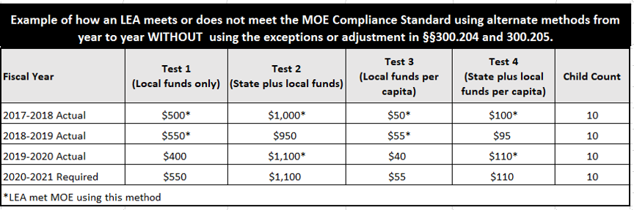

In this example, the division met the IDEA MOE compliance standard in SFY 2017-2018 using all four tests (i.e., Tests 1, 2, 3, and 4). In SFY 2018-2019, the division met IDEA MOE using two tests (i.e., Tests 1 and 3). In SFY 2019-2020, the division met IDEA MOE using two tests (i.e., Tests 2 and 4). For SFY 2020-2021, the required levels of effort the division must maintain would be $550 for Test 1-local funds only; $1,100 for Test 2-State plus local funds, $55 for Test 3-local funds per capita; or $110 for Test 4-State plus local funds per capita. The LEA can meet its IDEA MOE requirement by passing one of the four tests, subject to the subsequent years rule.

Attachment A
Superintendent’s Memo No. 308-20
November 20, 2020

Once the school division enters its current year’s (i.e., SFY2019-2020) expenditures for local and combination of state plus local information into the IDEAMOE Application, preliminary tests designed within the automated IDEAMOE Application will indicate if a division meets or does not meet its IDEA MOE requirement using the subsequent years rule. The school division can change methods or tests to establish compliance from one year to the next as long as it is using the same method for comparing the expenditures in the comparison year to the expenditures in the year for which it is establishing compliance. The school division should ensure auditable data are maintained to support its compliance with meeting the IDEA MOE requirement. The division can meet its IDEA MOE compliance requirement by meeting any of the four tests available.

There is no flexibility in the IDEA for any waiver or variance to a school division’s MOE requirement.

If a division does not pass at least one or more of the tests listed above, the division can also use the web-based application to enter allowable exceptions and/or provision that the VDOE will review to make a final determination of compliance with the division’s IDEA MOE requirement. Under certain conditions specified in the IDEA regulations (described below), a school division may reduce the expenditures needed to meet its MOE requirement. The IDEAMOE Application has been enhanced to allow the division to select one of four options for a possible starting amount to allow school divisions the flexibility to meet IDEA MOE requirement using alternate methods for one year to the next. Please refer to Attachment B for screenshots and detailed instructions. An overview of the allowable exceptions and the provision available to school divisions will be reviewed below.

IDEA MOE Allowable Exceptions and Adjustment to Expenditures

The allowable exceptions and adjustment specified in IDEA §300.204(a), §300.204(b), §300.204(c), §300.204(d), and §300.205 and the criteria the VDOE will use in considering them in addressing any school division’s failed initial MOE test are listed below. To be considered as allowable exceptions, the expenditures must be for the current fiscal year (2019-2020) and not prior year’s expenditures. Also the division must maintain documentation to demonstrate that the division properly took the exceptions.

- §300.204(a)

“…The voluntary departure, by retirement or otherwise, or departure for just cause of special education or related services personnel (e.g., special education teachers, speech pathologists, paraprofessionals or related services providers assigned to work with children with disabilities).”

This possible exception is determined by the school division identifying which personnel or contractor, over the course of the previous school year, left school division employment through their own choice. The division then identifies the costs associated with each departure. This may be done in two ways.

Attachment A
Superintendent’s Memo No. 308-20
November 20, 2020

- The departure was for a position that was not filled during the year. The full cost associated with that departure can be counted for the exception.

- The position was filled and the new staff member was hired at a lower level on the division’s pay scale and the difference between the two costs associated with the position can be counted for the exception.

Any considerations for exceptions under this section apply only to positions that are paid for with local or state funds.

Any departures that were the result of a Reduction in Force (RIF), or through layoffs or through any other division directed decision does not constitute a voluntary departure.

Departure for just cause means employment was terminated following some legitimate disciplinary action taken by the division.

Note: An additional guidance addressing options for using the §300.204(a) allowable exception for service providers or contractors who voluntarily left the division can be accessed at the U.S. Department of Education’s Office of Special Education Programs website: Letter to Michael Lovato.

- §300.204(b)

“…A decrease in the enrollment of children with disabilities.”

If the school division experiences a decrease in the enrollment of students with disabilities in comparing its current year December 1 Special Education Child Count total to the previous year’s December 1 special education child count total, the per capita cost of local expenditures or local plus state expenditures may be multiplied by the decrease in the enrollment to produce a dollar amount that may be an allowable exception under this section.

If this exception is applicable to a division, the IDEAMOE web application will calculate the exception for the division.

- §300.204(c)

“…The termination of the obligation of the agency, consistent with this part, to provide a program of special education to a particular child with a disability that is an exceptionally costly program, as determined to be two to three times more than the average per pupil cost, because the child….”

- Has left the jurisdiction of the agency;

Attachment A
Superintendent’s Memo No. 308-20
November 20, 2020

- Has reached the age at which the obligation of the agency to provide FAPE to the child has terminated; or

- No longer needs the program of special education.

An exceptionally costly program means an individual program for an individual child that is at least two to three times more than the average cost for providing special education and related services in a school division. Any possible exception generated by this section will be considered on an individual, case by case basis, using the information submitted through the IDEAMOE application, and reviewed by VDOE prior to approval.

- §300.204(d)

“…The termination of costly expenditures for long-term purchases, such as the acquisition of equipment or the construction of school facilities.”

Allowable exceptions under this section may include costs for construction projects that have ended or for equipment previously purchased for which there is no need for an additional purchase. Construction costs related to special education would generally be prorated based on the percentage of special education related costs as a percentage of the cost of the project. These possible exceptions would be considered on an individual, case-by-case basis.

- §300.205

“…Adjustment to local fiscal efforts in certain fiscal years.”

The MOE flexibility provision specifies that for any fiscal year for which the 611 flow-through federal allocation received by a school division exceeds the amount the division received the previous fiscal year, the division may reduce the level of expenditures otherwise required by not more than 50 percent of the amount of that excess. This provision cannot be used by any division that has been identified as having significant disproportionality and is required to reserve 15 percent of their federal Part B award for Coordinated Early Intervening Services (CEIS). However, if a division voluntarily chooses to set aside up to, but not to exceed, 15 percent of its federal Part B grant award, the amount the division chooses to set aside is reduced by the amount taken for the allowable exception under this provision.
If the division exercises its authority to use this provision, the division must spend an amount of local funds equal to the reduction taken to carry out activities that could be supported with the Every Student Succeeds Act of 2015 (ESSA) funds regardless of whether the division is using the ESSA funds for those activities. The funds must be used to supplement and not supplant for these activities and must be spent on the year the reduction is taken.
Only divisions that receive “Meets Requirement” on the annual determination are eligible for this provision.
Attachment A
Superintendent’s Memo No. 308-20
November 20, 2020

Illustration of IDEA MOE Allowable Exceptions and Adjustment to Expenditures

The following table illustrates how an LEA may meet the compliance standard using alternate methods or tests from year to year using the allowable exceptions and adjustments in §300.204 and §300.205.

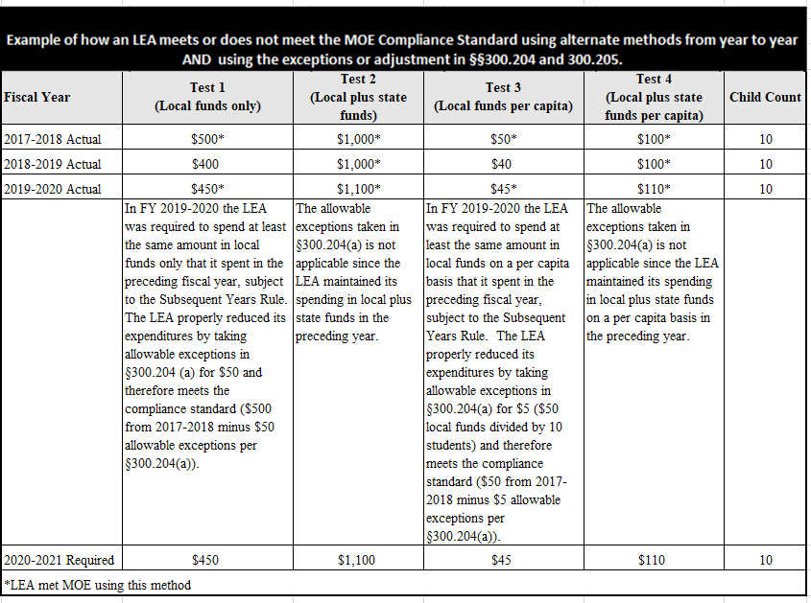

In this example, it demonstrates a division meeting all four MOE tests (i.e., Tests 1, 2, 3, and 4) in SFY 2017-2018. In SFY 2018-2019, the division did not maintain its expenditures in local funds and local funds per capita basis, but maintained its expenditures for its local plus state funds and the local plus state funds on a per capita basis and therefore met its MOE compliance standard. In SFY 2019-2020, the division spent $450 in local funds only and properly took the allowable exceptions in §300.204(a) for $50 and therefore meets the compliance standard of $450 (i.e., $500 in 2017-2018 minus $50 allowable exceptions in §300.204(a)). The required level of effort the division must make in SFY 2020-2021 would be $450 for local funds only, $1,100 for local plus state funds, $45 for local funds on a per capita basis, or $110 for local plus state funds on a per capita basis.
Attachment A
Superintendent’s Memo No. 308-20
November 20, 2020

Final IDEA MOE Decision

Once the current year’s (i.e., SFY2019-2020) expenditures for local and combination of local plus state information is entered by the school division into the IDEAMOE application, preliminary tests designed within the automated IDEA MOE application will indicate if a division meets or does not meet its IDEA MOE requirement using the new rule (i.e., subsequent years rule). If not met, the automated system can be used to identify possible allowable exceptions, which if approved, could result in the division meeting its IDEA MOE requirement.

After VDOE has reviewed the division information entered into the web application specific to possible allowable exceptions, the VDOE will make a final determination whether or not a division has met its MOE requirement. Final notification of the division’s IDEA MOE status will be included in the summary of the initial MOE tests and any approved allowable exceptions. It will also specify the expected level of effort (the MOE “target”) for the next fiscal year.

If the final status for a division is failure to meet their MOE requirement, the VDOE will be required to pay the amount of the division’s shortfall or the amount of division’s Part B sub grant, whichever is lower (§300.203d), to the U.S. Department of Education. The VDOE will then establish a payment plan for the division to reimburse VDOE. Federal funds cannot be used to make this payment.
Please refer to Attachment B for assistance with using the web-based IDEAMOE Application.

