# Attachment C

# Superintendent’s Memo #156-20

# June 26, 2020



## **Addendum to the Annual Agreement**

## **Community Eligibility Provision (CEP) – School Year 2020-2021**

**School Division:** Click to add school division name.

**Division Number:** Click to add school division number.

**The above school division is applying for:**

Divisionwide Community Eligibility Provision (CEP) **or**

CEP for designated sites/groups as listed in the CEP Schedule and site applications in the SNPWeb Application Packet, beginning in school year 2020-2021.

This agreement is between the Virginia Department of Education (VDOE) and the above school food authority (SFA) and covers the period of four years beginning July 1, 2020, and ending June 30, 2024. The participating SFA may stop participating in CEP for one or more schools during the four year cycle by notifying the VDOE no later than June 30 of the school year prior to the school year the school(s) will return to traditional claiming procedures.

The undersigned have the authority to enter into this Agreement to Participate in the CEP as authorized by Section 11(a)(1) of the Richard B. Russell National School Lunch Act.

1. It is mutually agreed between the VDOE and the SFA that the SFA:
2. has an identified student percentage of enrolled students as of June 1 of the year prior to participation in CEP that is greater than or equal to 40 percent and maintains all documentation to support this number;
3. agrees to serve all children in the participating school(s) breakfast and lunch, at no cost, for four successive school years;
4. agrees to pay, from sources other than federal funds, any costs of serving breakfasts and lunches that are in excess of the federal assistance received, including federal cash reimbursements;
5. agrees not to collect free and reduced-price meal applications from households in participating schools during the period of participation in CEP;
6. agrees to maintain a total count of breakfasts and lunches served daily; and
7. agrees to abide by all requirements for applying and administering CEP as stated in Section 104(a) of the Healthy, Hunger-Free Kids Act of 2010, as amended, and Section 11(a)(1) of the Richard B. Russell National School Lunch Act (42.U.S.C. 1759s(a)(1).
8. General Conditions
9. This agreement is non-transferable.
10. Neither the VDOE nor the SFA has an obligation to renew this agreement.

**Required Signatures:**



**Name:** Click to add name.

**Title:** Click to add title.

**Date:** Click to add date.



**Name:** Click to add name.

**Title:** Click to add title.

**Date:** Click to add date.



**Date:** Click to add date.

### **Instructions to Submit as Attachment in SNPWeb Application Packet**

1. Complete the required fields in Attachment B, *CEP Addendum to the Annual Agreement*. Print and obtain the signatures of the SNP director/supervisor/contact person and the division superintendent. Scan the signed form and save it to your computer.
2. To submit the CEP Addendum to the Agreement as an attachment in SNPWeb, go to School Year 2020-2021>Applications>Application Packet:

SNPWeb Application Menu
Screenshot of SNPWeb Applications menu with Application Packet highlighted. 

1. On the dashboard, scroll down to *Attachment List*. Click on the ***Details*** button to the left:

Application Packet Dashboard 
Screenshot of SNPWeb Application Packet Dashboard.

1. Click on the red ***Add Attachment*** button:

Add Attachment
Screenshot of SNPWeb Attachment List and Add Attachment button.

1. Click on ***Browse*** to view files on your computer. Select the file that is the scanned CEP Addendum, signed by the superintendent. Write a comment if you wish. Click ***Save***:

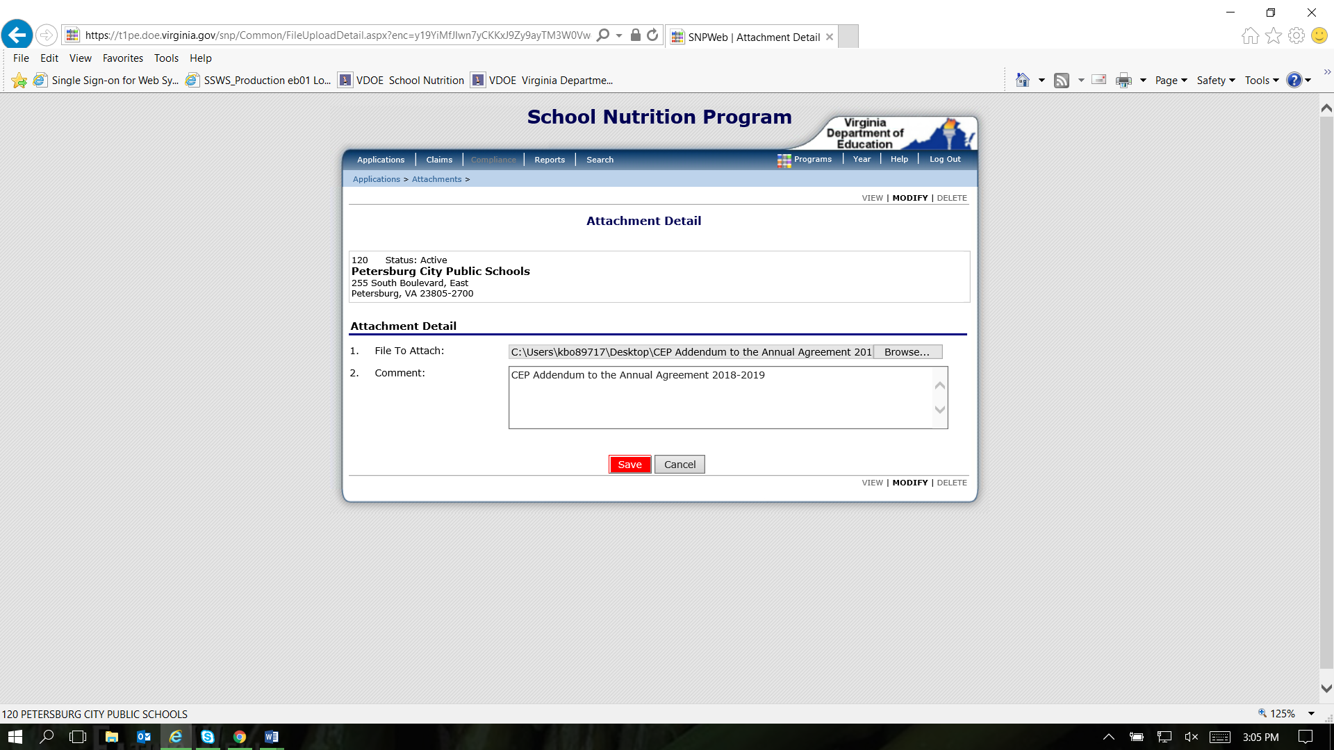

1. Click ***Finish*** and return to *Attachments* where you should see the FFVP Addendum added to the list of attachments uploaded to your Application Packet.

Attachment Detail Processed
Screenshot of SNPWeb Attachment Detail processed message.

Completed Attachment Upload
Screenshot of SNPWeb Attachment completed.