Attachment B to Supts. Memo No. 128-18
May 11, 2018

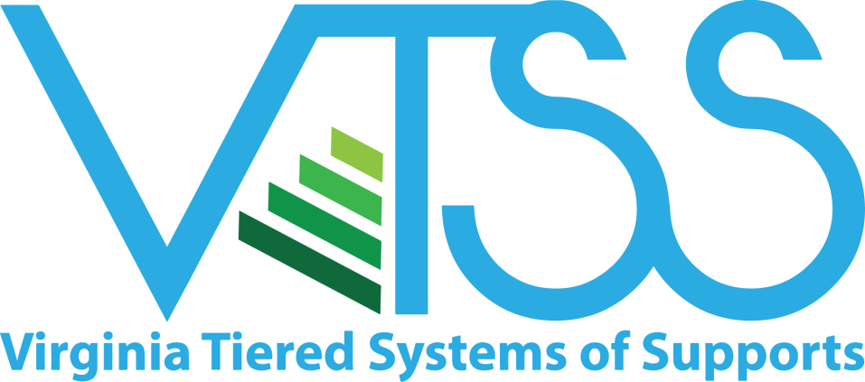
2018 Application
Virginia Tiered System of Supports (VTSS)
Cohort 5

School Division:

Primary Contact Name:

Phone:

E-mail:

Please return by June 13, 2018 to:
Maribel Saimre
Maribel.Saimre@doe.virginia.gov
Virginia Department of Education
P.O. Box 2120
Richmond, Virginia 23218-2120

Attachment B to Supts. Memo No. 128-18
May 11, 2018

Application Checklist

Section A: Documentation of Division Exploration Activities
Complete the VTSS Division Exploration Guide and attach to this application. This guide is available on the VTSS website at link: https://vtss-ric.org/professional-learning/division-exploration-webinar-series/ as a companion to the VTSS Readiness Webinar series, and as attachment C to the Superintendent’s Memo. These webinars provide guidance on completing VTSS division exploration activities.

Section B: VTSS Commitment for Success Agreement and Signature Page
Division Superintendent (or designee) will read and initial the VTSS requirements. Division executive leaders review the application and complete the VTSS Application Signature page.

Section C: Letters of Support (optional)
Possible examples include: local school board, business partners, external technical assistance providers, and school improvement consultants.

Attachment B to Supts. Memo No. 128-18
May 11, 2018

VTSS Commitment for Success Agreement

Please read and initial to indicate that you understand and agree. Initial
(Division) will:

Identify VTSS as one of the top division goals. Efforts will be made to align
separate initiatives under this framework.

Allocate funding and resources to support the VTSS framework. Participants in
VTSS Cohort 5 are eligible for implementation start-up support through a state
grant (FY18). The division should investigate ways in which to sustain
implementation beyond the state grant period.

Form a Division Leadership Team (DLT) that is representative of the division
and community (e.g. Superintendent, executive staff, instruction, special
education, student services, family members, etc.).

- DLT will meet monthly.
- DLT commits to attending three state-wide professional learning opportunities
(these may be offered centrally, regionally or on-site in specific circumstances)
per academic year.
- DLT commits to sending at least 2 representatives to VDOE-sponsored
professional learning events for their school-based teams.
- Should the Superintendent not be able to actively participate in the leadership
team, a representative will be assigned and regular communication with the Superintendent established and documented.

From the division leadership team, appoint a Division Coordinator and at least one
other member to serve as VTSS Division Systems Coaches.

- Division Systems Coaches commit to attending monthly school-based VTSS
team meetings, facilitating action planning and supporting implementation at
all three tiers.
- Division Systems Coaches attend Systems Coaching Institutes offered yearly
and other coaching specific training opportunities as available.

Allocate time in the school calendar for school based teams, school coaches and administrators to access VDOE-sponsored professional learning opportunities.

- Division team and/or Division Systems Coaches commit to providing coaching
and/or follow-up support following professional learning opportunities.

Attachment B to Supts. Memo No. 18-18
May 11, 2018

Commit to engaging family, youth and community in planning, implementation
and evaluation of the VTSS framework.

Develop and progress monitors a VTSS implementation action plan, which addresses
all three tiers and is aligned with academics, school improvement and/or strategic
goals and plans.

- Team commits to utilizing data to guide decision making within the implementation plan.
- Team commits to utilizing the implementation plan to build division capacity to
support schools in the implementation of VTSS with fidelity.

Participate in all evaluation activities as outlined by project evaluators contracted by VDOE.

DLT will support the collection of evaluation data required of the schools.

DLT will commit to providing school-based teams timely access to academic and
behavior data.

Attachment B to Supts. Memo No. 128-18
May 11, 2018

VTSS Application Signature Page

VTSS Division Coordinator
Name: Position:
Phone: E-mail:

Printed Name: Signature: Date:
Division Superintendent

Printed Name: Signature: Date:

Assistant Superintendent of Instruction

Printed Name: Signature: Date:

Director of Special Education

Printed Name: Signature: Date:

Director of Student Support Services

Printed Name: Signature: Date:

