Attachment A, Memo No. 111-18

May 4, 2018

# **SNPWeb Community Eligibility Provision Schedule**

A School Food Authority (SFA) that is interested in participating in the Community Eligibility Provision must complete the Community Eligibility Provision Schedule in the annual Application Packet.

1. The Community Eligibility Provision Schedule is automatically added to the Application Packet screen when the SFA answers “Yes” to Question 25 in the Eligibility Information section of the SFA Application, “Will any of your sites be participating in the Community Eligibility Provision (CEP) for the National School Lunch Program?”

If the division will participate in CEP divisionwide, “Yes” must be selected in the second part of Question 25.

**Figure 1: SFA Application Question 25**

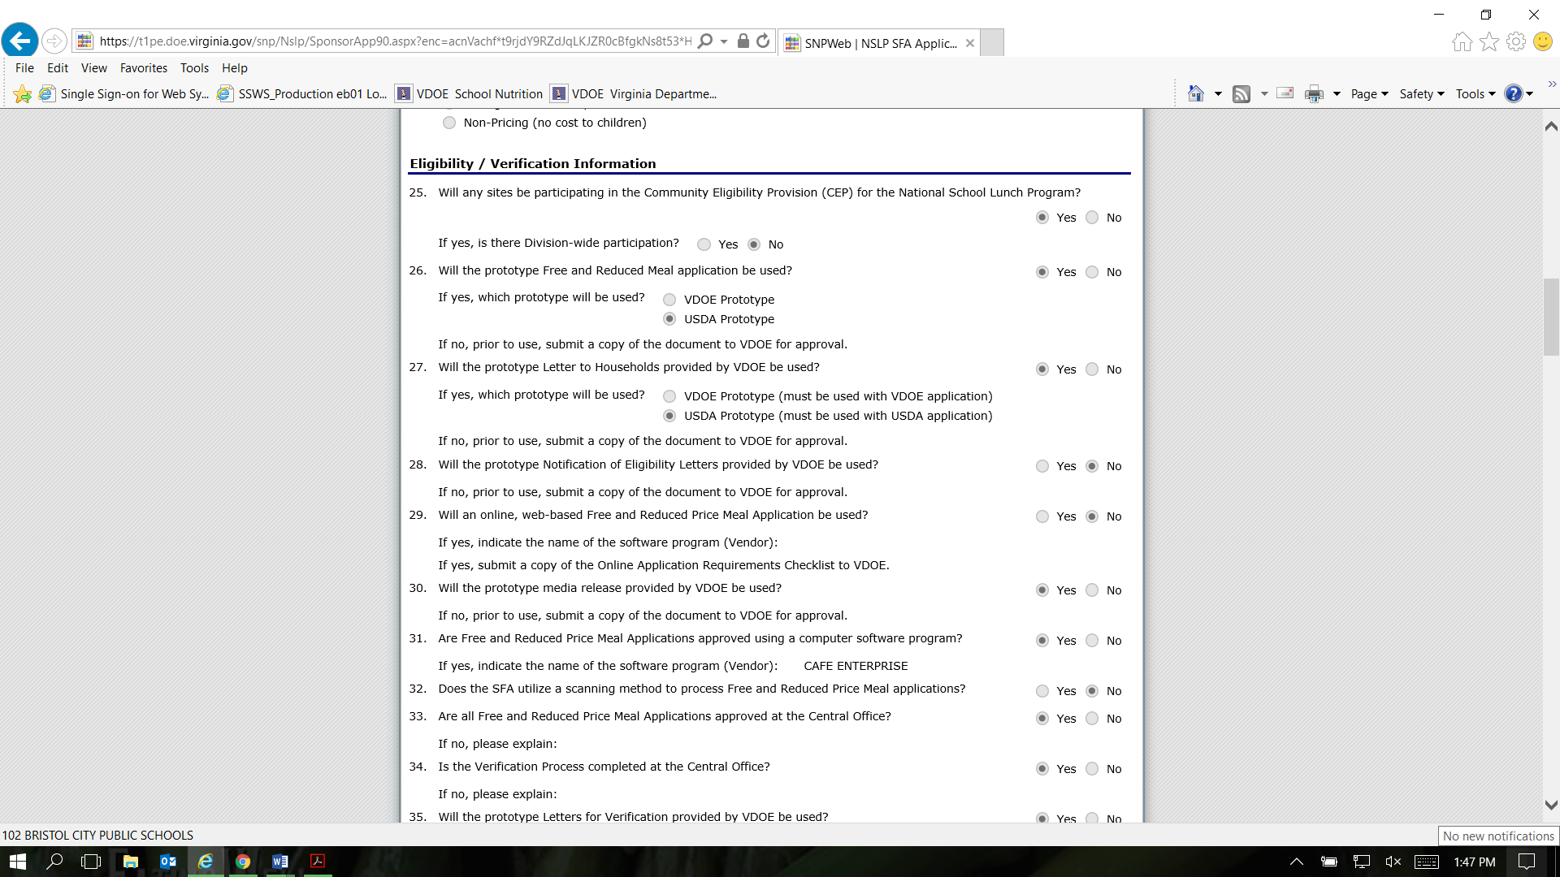

**Please Note:** The Community Eligibility Provision Schedule will ONLY display sites that have “Non-Pricing-CEP” selected as the response to Question 3, “Pricing Information” in the Site Application of the SNPWeb Application Packet.

**Figure 2: Site Application Question 3**

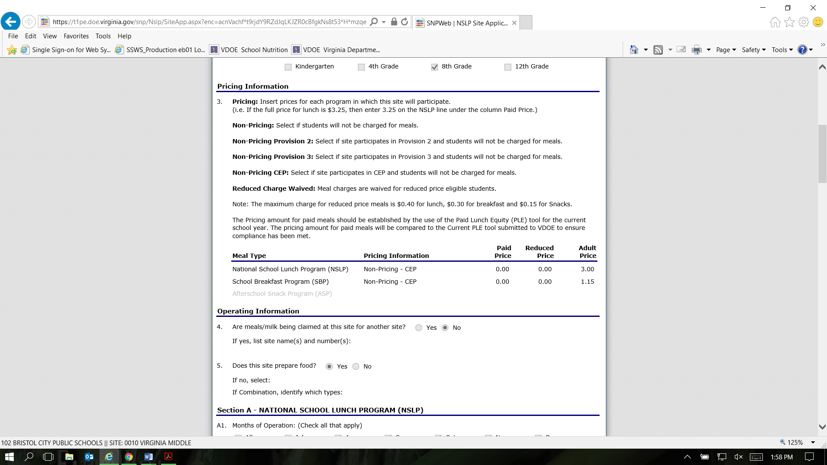

# **Access the Community Eligibility Provision Schedule in the Application Packet**

1. On the blue toolbar, select **Applications** to access the menu screen.

2. Select **Application Packet**. The **Application Packet** screen will display.

3. Select **Add** next to the **Community Eligibility Provision (CEP) Schedule**. The **Community Eligibility Provision (CEP Schedule** screen displays).

**Figure 3: Application Packet Screen – Add CEP Schedule**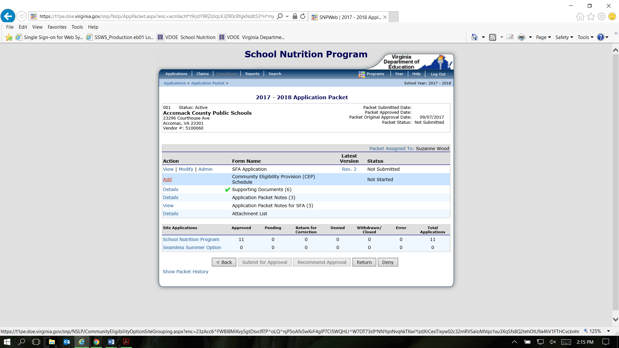

**Figure 4: CEP Schedule Screen**

Screenshot of CEP Schedule Screen in SNPWeb.

# **Define a CEP Schedule**

1. On the blue toolbar, select **Applications** to access the menu screen.
2. On the menu, select **Application Packet**. The **Application Packet** screen displays.
3. Select **Add** to begin or **Modify** (if the schedule was previously accessed)next to **Community Eligibility Provision Schedule**. The **Community Eligibility Provision (CEP) Schedule** screen displays.

**Please Note:** The Community Eligibility Provision Schedule will ONLY display sites that have “Non-Pricing-CEP” selected as the response to Question 3, “Pricing Information” in the Site Application of the SNPWeb Application Packet.

Next to each Site ID under the Grouping heading, the Number of Identified Students, Enrollment, and ISP data is retrieved from the Community Eligibility Provision Site Eligibility Report data for April 1 of the Year Prior to First Year (YPFY) as submitted by the SFA. (i.e., the April 1, 2018, data reported by the SFA will display in the CEP Schedule for the CEP cycle beginning in 2018-2019)

* Cycle Year 1 for 2018-2019: The student data displayed is the site’s/group’s prior year April 1, 2018, data.

1. For each site, under the **Group** column, select whether the site will participate based on its own site data by selecting “**Individual**” or if the site will participate by being grouped with other sites by selecting the group number. If the SFA is participating as divisionwide, all sites must be assigned to “Group 1.”
2. Once all sites have been either identified as “Individual” or assigned to a group, select **Save**.

# **Adding a Site to an Existing Community Eligibility Provision Schedule**

1. On the blue toolbar, select **Applications** to display the menu screen.
2. On the menu, select **Application Packet**. The **Application Packet** screen displays.
3. Select **Modify** next to **Community Eligibility Provision Schedule**. The **Community Eligibility Provision (CEP) Schedule** screen displays.
4. The new site will be identified as “**Unassigned**” under the **Group** column. Select the **group** to which the site should be associated or select “**Individual**” if the site qualifies based on its own student data.
5. Select **Save** to receive a confirmation. Select **Edit** to return to the **Community Eligibility Provision (CEP) Schedule** screen or select Finish to return to the Application Packet screen.