

Promoting Environmental Literacy: Professional Development for Science Leaders and Administrators

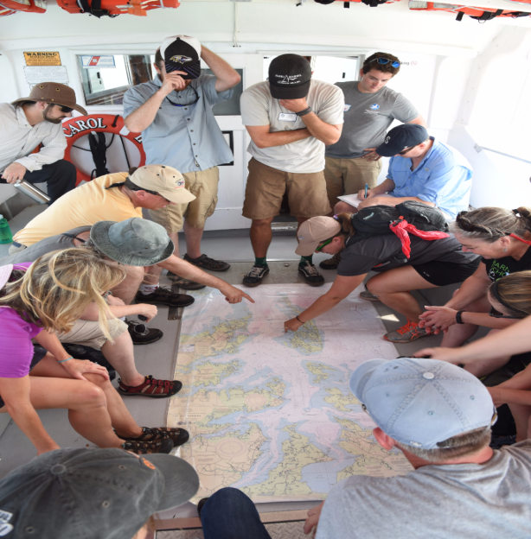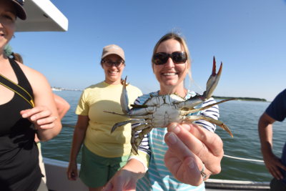School leaders across the watershed are using the environment to integrate powerful learning techniques in their school communities. Facilitated by the Chesapeake Bay Foundation this experience will be five exciting days of networking, sharing ideas, and immersion in the fundamentals of environmental education so that you will be able to provide your faculty and staff the support that they need to integrate Meaningful Watershed Educational Experiences into your school community.

NOAA CHESAPEAKE BAY LOGO

**Where:** Five days/two days at New Kent Forestry Center and 3 at Chesapeake Bay Foundation’s Port Isobel Environmental Education Center

**When**: June 25-29, 2018; Sessions will be held from 8:30 a.m.-5 p.m. each day with a 45 minute lunch at approximately noon.

**Questions?** Contact Cindy Duncan at [cduncan@cbf.org](mailto:cduncan@cbf.org) or Anne Petersen at [Anne.Petersen@doe.virginia.gov](mailto:Anne.Petersen@doe.virginia.gov)