**Investigating an Aquatic Mountain Ecosystem**

Join the Virginia Departments of Forestry and Game and Inland Fisheries for an investigation of a mountain watershed at Mathews State Forest in Galax, VA. Teachers will engage in active forest and aquatic field investigations that can easily be duplicated on their school grounds or at a local natural area for conducting and assessing their Meaningful Watershed Education Experience. All activities and investigations will integrate the 5 C’s of 21st Century Skills in Education. Participants will receive a bucket of field investigation equipment, field guides, and the Aquatic WILD and Project Learning Tree cross-curricular guides.

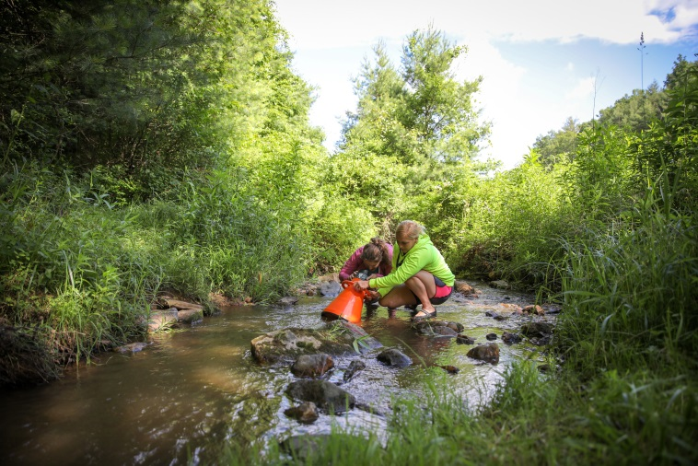

Lodging and meals will be provided.

Dates: June 25 – June 28, 2018.

Time: June 25 10 a.m.-5 p.m.; June 26 8:30 a.m.-5 p.m.;

June 27 8:30 a.m.-5 p.m.; June 28 8:30 a.m.-2 p.m.;

Lunch will be at approximately noon-12:45 p.m. each day.

For more information contact:

Suzie Gilley, [suzie.gilley@dgif.virginia.gov](mailto:suzie.gilley@dgif.virginia.gov)

Page Hutchinson, [page.hutchinson@dof.virginia.gov](mailto:page.hutchinson@dof.virginia.gov)

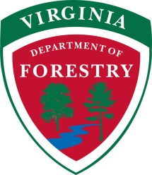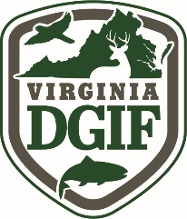Anne Petersen, [anne.petersen@doe.virginia.gov](mailto:anne.petersen@doe.virginia.gov)