Sample Science Course Pathways
(Note: School divisions must follow the Standards of Accreditation and Board Approved Course list when developing pathways. Other course pathways are available based on school division course guides, prerequisites, academic and career interests.)

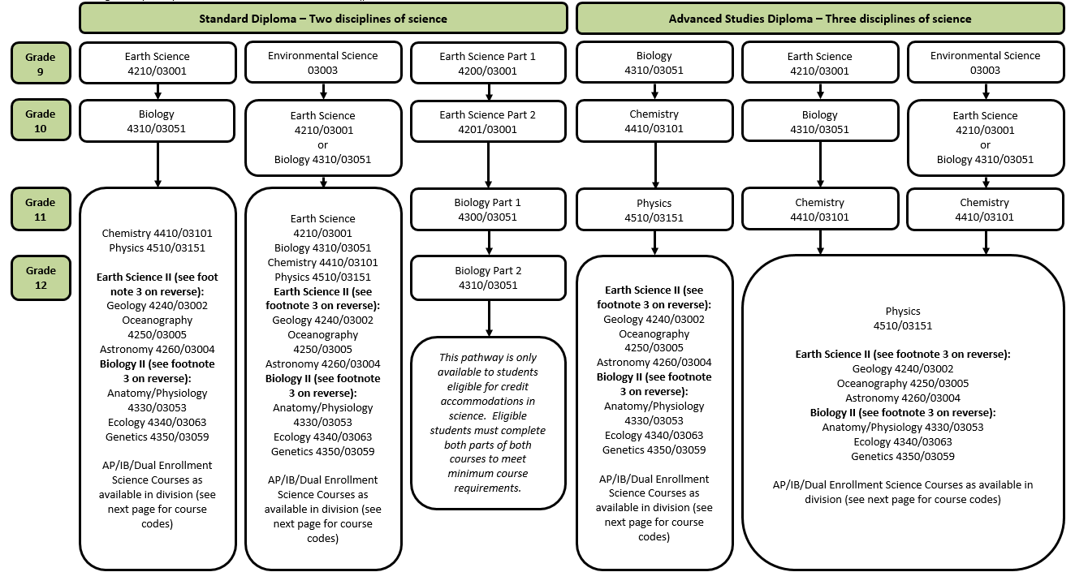

Courses in Science
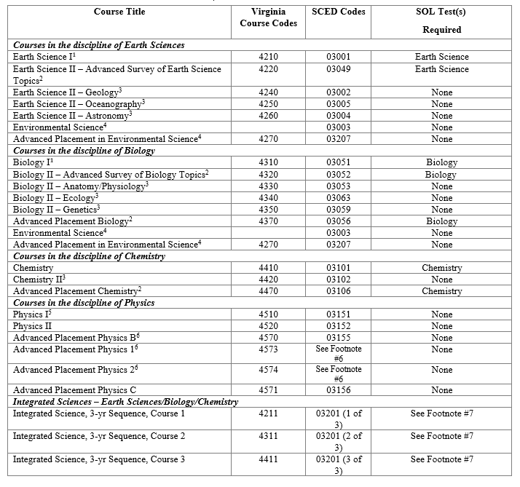
¹The Board of Education’s Guidelines on Credit Accommodations allow students with disabilities who are eligible for credit accommodations in science to use each part of Earth Science, Parts I and II, and Biology, Parts I and II, to earn a standard credit towards the three science credits required for the Standard Diploma only. A student who chooses to earn standard credits by taking both Earth Science and Biology in two parts must complete both parts of both courses to meet the minimum course requirements, and would earn three standard credits in science plus one additional elective credit. Two-part courses may also be combined with full-year courses in other Board- approved science courses to meet the requirements.
²Students who have not taken the first level course in this discipline are required to take the corresponding SOL test.
³The prerequisite content for this course is the first-level SOL core course in this discipline.
⁴Advanced Placement Environmental Science and Environmental Science may count as either Biology or Earth Science credit. It is highly recommended that students planning to apply or attend college take four science courses to include Biology, Chemistry, and Physics
⁵The sequence of Principles of Technology I [9811/10153 (1 of 2)] and Principles of Technology II [9812/10153 (2 of 2)] will satisfy one (1) standard unit of credit in laboratory science for physics and one (1) elective credit. Students who enroll in Principles of Technology courses for a physics credit must have completed Algebra I and two (2) other laboratory science courses as specified by the Standards of Accreditation prior to enrolling in Principles of Technology. There is no SOL test associated with Principles of Technology I and II.
⁶Advanced Placement Physics 1 and 2 will begin to be offered in the 2014-2015 academic year, and Advanced Placement Physics B will be discontinued following the 2013-2014 academic year. SCED codes have not yet been determined for AP Physics 1 and 2.
⁷Students will take the Earth Science, Biology, and Chemistry test(s) when they have completed the appropriate SOL content, as determined by the local school division.

