Attachment A
Superintendent’s Memo No. 252-19
October 18, 2019

Virginia Department of Education

Individuals with Disabilities Education Act (IDEA)
Proportionate Set-Aside Guidance Document

Overview

Each local education agency (LEA) must spend a proportionate amount of its Sections 611 and 619 allocations on providing special education and related services (including direct services) to home-schooled or parentally-placed private school children with disabilities. Section 300.133 of the Individuals with Disabilities Education Act (IDEA) specifies a formula that an LEA is required to use to determine the proportionate amount the LEA is to make available or spend to meet the requirements of § 300.132(a).
§ 300.132 (a)
“… To the extent consistent with the number and location of children with disabilities who are enrolled by their parents in private, including religious, elementary schools and secondary schools located in the school district served by the LEA, provision is made for the participation of those children in the program assisted or carried out under Part B of the Act by providing them with special education and related services, including direct services determined in accordance with § 300.137....”

The Division of Special Education and Student Services (SESS) will continue to utilize the web-based application to collect school divisions’ proportionate share calculations for the fiscal year 2019-2020 grant period. This application will be made available through the Virginia Department of Education’s (VDOE) Single Sign-On for Web Systems (SSWS) portal.

Background
This information is taken directly from the IDEA federal regulations § 300.133 and Appendix B to Part 300 – Proportionate Share Calculation. Each LEA must expend, during the grant period, on the provision of special education and related services for the parentally-placed private school children with disabilities enrolled in private elementary schools and secondary schools located in the LEA an amount that is equal to:

- A proportionate share of the LEA’s sub grant under section 611(f) of the Act for children with disabilities aged 3 through 21. This is an amount that is the same proportion of the LEA’s total sub grant under section 611(f) of the Act as the number of parentally-placed private school children with disabilities aged 3 through 21 enrolled in private elementary schools and secondary schools located in the LEA is to the total number of children with disabilities enrolled in public and private elementary schools and secondary schools located in the LEA aged 3 through 21; and
- A proportionate share of the LEA’s sub grant under section 619(g) of the Act for children with disabilities aged 3 through 5. This is an amount that is the same proportion of the LEA’s total sub grant under section 619(g) of the Act as the total number of parentally-placed private school children

Attachment A
Superintendent’s Memo No. 252-19
October 18, 2019

with disabilities aged 3 through 5 enrolled in private elementary schools located in the LEA is to the total number of children with disabilities enrolled in public and private elementary schools located in the LEA aged 3 through 5.
- As described in paragraph (2) of this section, children aged 3 through 5 are considered to be parentally-placed private school children with disabilities enrolled by their parents in private, including religious, elementary schools, if they are enrolled in a private school that meets the definition of elementary school.
- If an LEA has not expended for equitable services all of the funds described in paragraphs 1 and 2 by the end of the fiscal year for which it was appropriated, the LEA must obligate the remaining funds for special education and related services (including direct services) to parentally-placed private school children with disabilities during the carry-over period of one additional year.
- In calculating the proportionate amount of the IDEA Part B funds that must be expended, the LEA, after a timely and meaningful consultation with a representative, must conduct a thorough and complete child find process to determine the number of parentally-placed children with disabilities attending a private school located in the district. To determine the number of parentally-placed students with disabilities attending private schools, the LEA must conduct an annual count and ensure that the count is done on any date between October 1 and December 1, inclusive, of each year. The count must be used to determine the proportionate share the LEA must spend in providing education to students with disabilities parentally-placed in private schools in the next subsequent fiscal year.
- State and local funds may supplement and in no case supplant the proportionate amount of federal funds required to be expended for parentally-placed students with disabilities under this part.
- The proportionate share of IDEA funds must be determined before designating funds for any Coordinated Early Intervening Services (CEIS), as specified in section § 300.226 of the IDEA regulations.
- Dollar amounts must be calculated for both sections 611 and 619 funds. The combined amounts for ages 3 through 5 and ages 3 through 21 represent the total amount that must be set-aside. The total required amount can be spent out of section 611 funds.
The following outlines how the proportionate share is calculated.
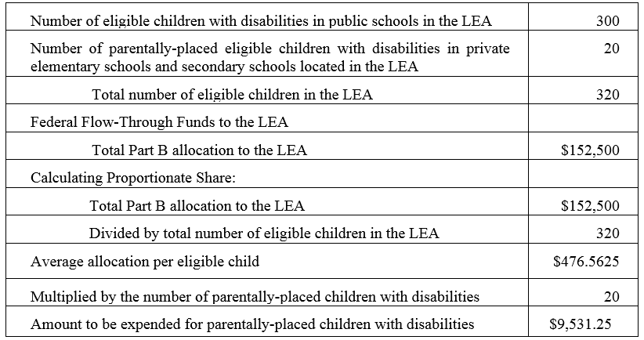
Attachment A
Superintendent’s Memo No. 252-19
October 18, 2019

Steps in Using the Proportionate Set-Aside (Speced-PSA) Application

General Information
The process for completing the Virginia Department of Education’s (VDOE’s) Proportionate Set-Aside (Speced-PSA) web-based application is provided to guide users with entering information and to determine the proportionate share of the LEA’s total Part B subgrants in providing services to home-schooled or parentally-placed private school children aged 3 through 21. The calculated amount will be the school division’s basis when requesting reimbursement through the VDOE’s Online Management of Education Grant Awards (OMEGA) system.
Proportionate share costs are not limited to direct services but can include consultative services, equipment or materials for eligible home-schooled or parentally-placed students with disabilities, or training for private school teachers and other private school personnel.
The LEAs are prohibited from using the set-aside amount for administrative costs, the costs of child find and evaluation process of home-schooled or parentally-placed private school students.

Accessing and Using the Application

The application can be accessed through the VDOE’s SSWS portal. If the Speced-PSA application is not available within the user’s menu page, the user must contact the school division’s local SSWS Administrator to obtain access rights. A login ID and password will be provided by the local SSWS Administrator once access right is granted. The following link can be used to access the VDOE home page.

- To access the SSWS portal, click the “SSWS Login” located at the lower right side of VDOE’s home page as shown in Figure 1.

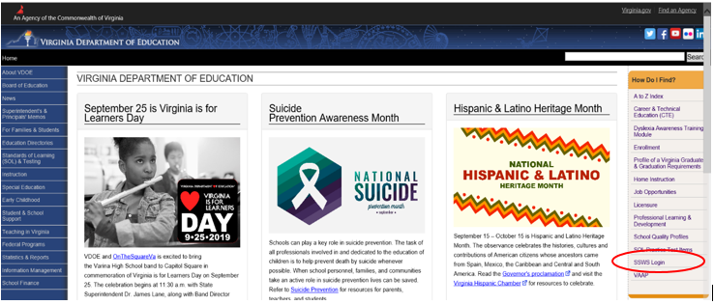
Figure -1-

Attachment A
Superintendent’s Memo No. 252-19
October 18, 2019

- Figure 2 displays the SSWS login screen. The person responsible for entering the information will need a login ID and password to access the web-based application. The local SSWS Administrator should be contacted to obtain the SSWS login ID and password.

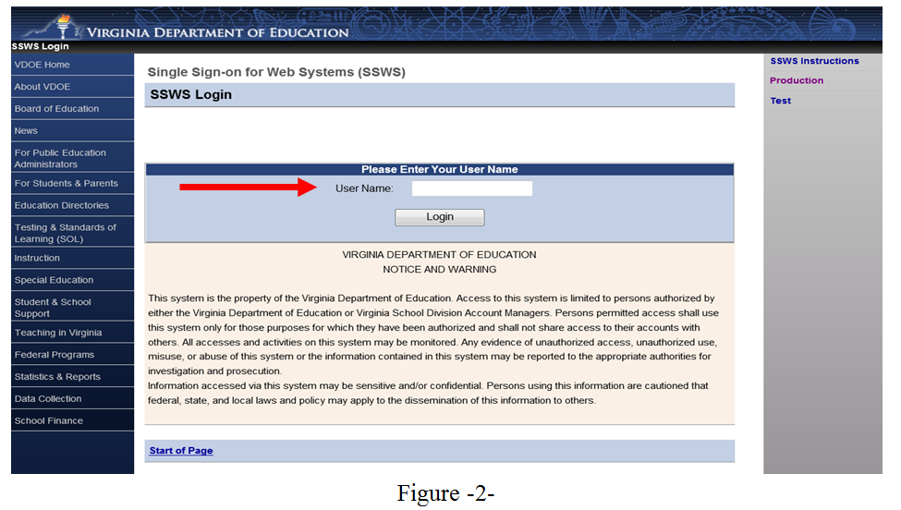
- Figure 3 displays the password screen. The user must have the SSWS login ID and password to access the web-based application.

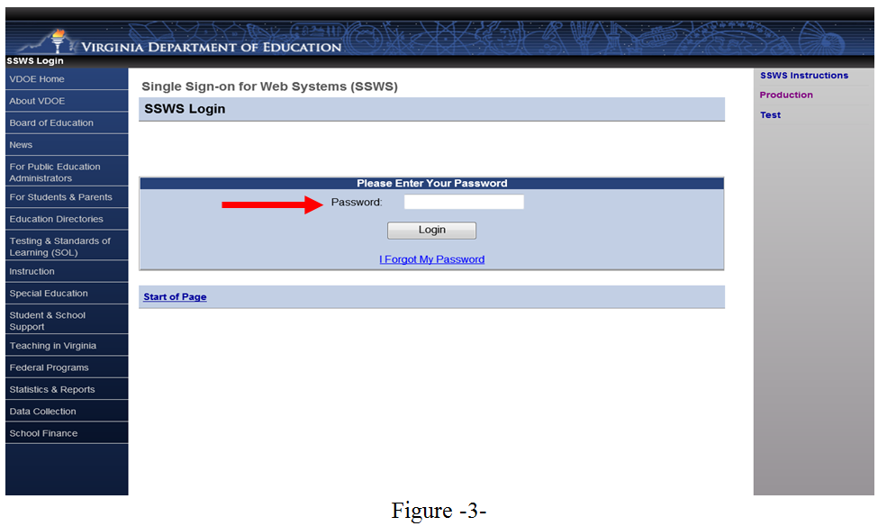

Attachment A
Superintendent’s Memo No. 252-19
October 18, 2019

- After a successful login, the application menu will display as shown in Figure 4. Select “Special Education Proportionate Set-Aside (Speced-PSA)” from among the applications listed in the user’s menu. If it is not available in the user’s menu, the user must contact their local SSWS Administrator to obtain full access rights.

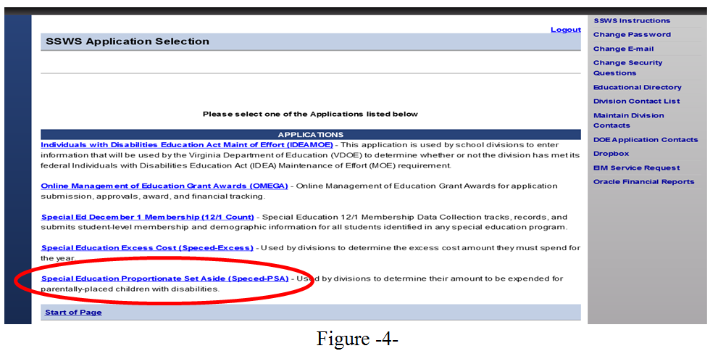
- Figure 5 displays the screen after the Speced-PSA application is clicked. The collection window must be open for the current fiscal year in order enter information and for the data to be saved and processed. There are two (2) available options on the upper right side of the page for the user to select.
Worksheet – Selecting this option will display the screen where users can enter the information to determine the division’s proportionate share. Line details are described in subsequent pages.

Reports – Selecting this option will display the screen where the Verification Report can be viewed or printed. The recent upgrade to the PSA application eliminates paper verification. As such, verification reports is now approved in electronic form and LEAs are no longer required to submit signed copies of verification reports to VDOE.

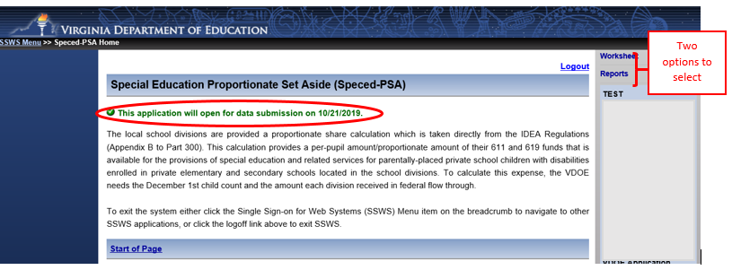
Figure -5-
Attachment A
Superintendent’s Memo No. 252-19
October 18, 2019

- Figure 6 displays after selecting the “Worksheet” option from the menu on the upper right side of the screen. This is the screen where data are entered to calculate the division’s proportionate share. The worksheet is composed of lines 1 to 7 but only line 3 is open for entry. All other lines are auto-generated and auto-calculated. The user should use the “tab” key after an entry for the application to calculate the set aside amount correctly. Also, refrain from using the “back” button when navigating the application as it will cause the application to function incorrectly. Instead, use the options available on the top of the screen. The sample print screen in Figure 6 displays “0” in Line 3. The user must enter information related to the number of home-schooled or parentally placed students found eligible during the child find process but not receiving services during the school year. The number entered in Line 3, if any, is not reported in the December 1 child count so the LEA’s total number of eligible children in Line 4 may not equal the actual December 1 child count. Refer to instructions and illustrations starting at page 7.

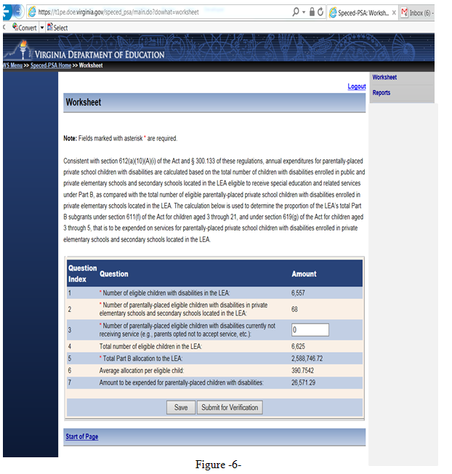

Attachment A
Superintendent’s Memo No. 252-19
October 18, 2019
The following example is for illustration purposes only:

There are 6,530 eligible children with disabilities enrolled in the LEA, 33 are eligible parentally-placed children with disabilities currently enrolled and being served in private elementary schools and secondary schools located in the LEA. The division has identified 10 students as eligible parentally-placed children with disabilities not currently receiving service because the parent decided not to accept services from the division or these were students previously receiving services but left the division. The total number of eligible public and private school children with disabilities is 6,573. Note: Proportionate share for parentally-placed private school children is based on total children eligible, not children served. The number of eligible parentally-placed private school children with disabilities (43) divided by the total number of eligible public and private school children with disabilities (6,573) indicates that 0.6542 percent of the LEA’s subgrant must be set aside for the group of eligible parentally-placed children with disabilities enrolled in private elementary schools and secondary schools located in the LEA. The LEA receives a total $2,351,819.16 in Federal flow-through funds for 611 and 619. Therefore, the LEA must set aside $15,385.40 of special education or related services funds to the group of parentally-placed private school children with disabilities enrolled in private elementary schools and secondary schools located in the LEA.

- An illustration of the above example is shown in Figure 7 and the details of questions 1 to 7 are described in pages 8 and 9.

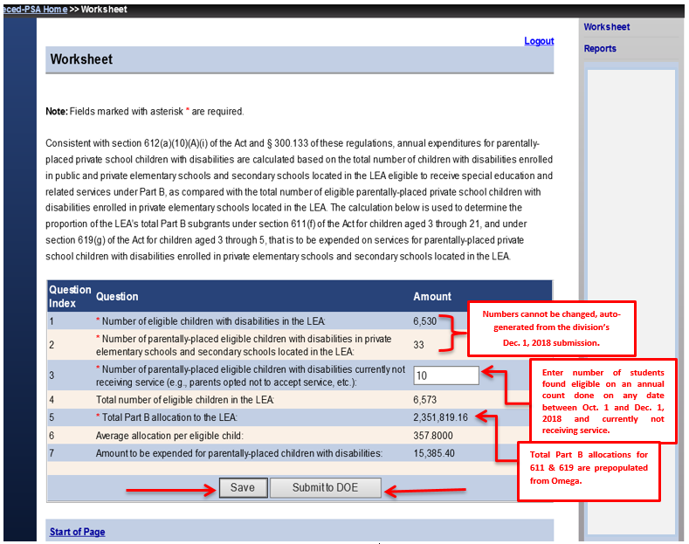
Figure -7-

Attachment A
Superintendent’s Memo No. 252-19
October 18, 2019

- Line 1 – The number of eligible students will be automatically populated from the system using the auto-generated December 1 child count submission when the collection window is open. In the example at Figure 7, line 1 indicates 6,530 students. This number excludes private school and home-schooled children eligible and served. Eligible students are students who have been evaluated and determined eligible for special education and related services by the division. Served students are students who are receiving special education and related services within the division. Note: The number of eligible students cannot be changed since it is auto generated from the division’s December 1, 2018, child count submission, duly certified by the division’s superintendent and reported to the U.S. Department of Education (USED).

- Line 2 – The number of home-schooled or parentally-placed eligible students will be populated from the system using the auto-generated December 1 child count. In the example at Figure 7, line 2 indicates 33 students. This represents the number of children with disabilities parentally-placed in private school or home schooled in the LEA after conducting a thorough and complete child-find process and ensuring that the count was performed between December 2 of the preceding year to December 1 of the current year (e.g., December 1, 2017 – December 1, 2018) and reported in the December 1, 2018, child count report. Note: The number of home-schooled or parentally-placed eligible children with disabilities in private schools cannot be changed since it is auto generated from the division’s December 1, 2018, child count submission, duly certified by the division’s superintendent and reported to the U.S. Department of Education (USED). Divisions who are serving parentally placed or homeschooled students that were not reported in their December 1 child count report must contact the VDOE for additional guidance in reporting these students.

- Line 3 – Enter the number of home-schooled or parentally-placed students identified during the child-find process as being eligible for services (i.e., December 1, 2018), but are not receiving services due to various reasons (e.g., parent has opted not to accept services). The count must be between December 2nd of the preceding year to December 1 of the current year. The child count is not reported in the December 1 child count report so the total eligible children may not equal the LEA’s actual December 1 child count. The division is required to set-aside a proportionate amount for the students’ future use. The illustration above indicates 10 students in Line 3. Enter “0” if there is none. Note: The division should not include students that were found eligible after December 1, 2018 and those that are receiving services through an Individualized Education Program (IEP).

- Line 4 – Auto-generated and represents the total number of students with disabilities in public and private schools and home schooled. Based on the illustration, line 4 shows a total of 6,573 students (sum of lines 1, 2, and 3). Note: The line total may be more than the actual December 1 child count if there are students reported in Line 3.
- Line 5 – The total SFY 2019-2020 Part B 611 and 619 allocations of the division will be automatically populated from the Online Management Education Grant Awards (OMEGA). In the illustration above, line 5 indicates $2,351,819.16 as the actual total Part B funds received. This amount constitutes the sum of Sections 611 and 619 funds.

Attachment A
Superintendent’s Memo No. 252-19
October 18, 2019

- Line 6 – Auto-generated average allocation per eligible child. This amount represents the proportionate share of the division’s per eligible child. In the illustration in Figure 7, line 6 shows $357.80 (line 5 divided by line 4).

- Line 7 – Auto-generated amount to be expended for home-schooled or parentally-placed children with disabilities. This amount represents the total amount of federal funds that must be set-aside for home-schooled or parentally-placed children with disabilities. In the illustration of Figure 7, line 7 shows a total amount of $15,385.40 (line 6 multiplied by the sum of lines 2 and 3).
Note: Any funds not spent or obligated by June 30, 2020, for special education and related services (including direct services), must be carried forward for one additional year (i.e., July 1, 2020 - June 30, 2021). Any unspent funds after the one year carry-over period can be used on other special education and related services. State and local funds may supplement and NOT supplant the proportionate amount of federal funds required to be expended for parentally-placed students with disabilities.

If the user is ready to submit the worksheet, first click the “Save” button for accurate calculation then click the “Submit for Verification” button. Submitting the worksheet without saving it first will calculate the set aside amount incorrectly. If the user is not ready to submit, click the “Save” button and the worksheet will remain open for edits. Once the worksheet is submitted, the collection window will automatically lock for edits and the application will notify the Superintendent to review and approve the submission. If a revision is needed after the worksheet is submitted but before approval, the user must notify its Superintendent to disapprove the submission to unlock the collection window. If a revision is needed after the submission is already approved, the user must contact VDOE to re-open the collection window. NOTE: If a revision is needed after the due date but before approval, the user must contact VDOE via email to re-open the collection window.
- Figure 8 displays the screen after the worksheet is submitted. The recent upgrades to the PSA application eliminates paper verification report. As such, Superintendents or Designees are required to sign the certification reports in electronic form using the Superintendent Data Collection Approvals (SDCA) Application (see Figure 10, page 11)). Copies of verification reports are no longer required to be submitted to VDOE.
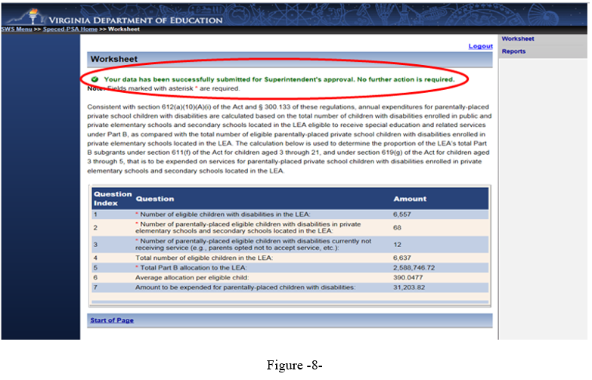
Attachment A
Superintendent’s Memo No. 252-19
October 18, 2019
- Figure 9 illustrates the screen for SDCA after the Superintendent or Designee has successfully logged in to SSWS. A user’s ID and password are required to access the SDCA which can be obtained through the division’s local Administrator if the application is not available in the Superintendent’s or Designee’s menu.

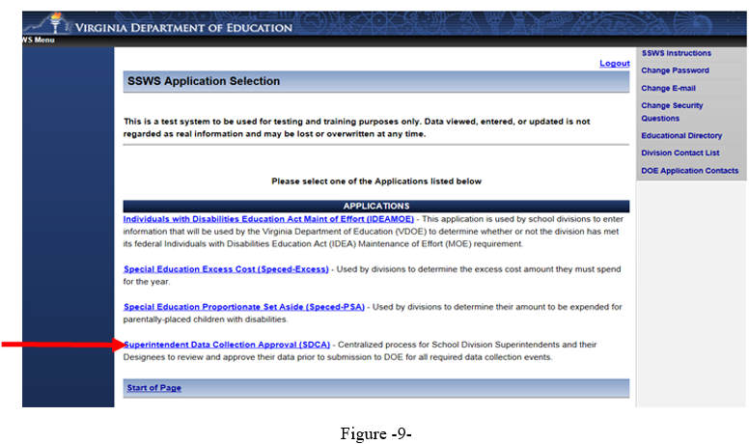

- Figure 10 displays the screen after the SDCA menu is clicked. The Superintendent or Designee must select the “Proportionate Set Aside Verification Report” in the list of report names for approval to access the verification report.
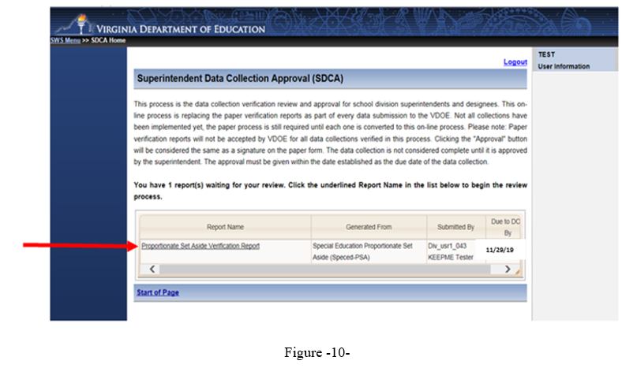
Attachment A
Superintendent’s Memo No. 252-19
October18, 2019
- Figure 11 displays the new version of the PSA Verification Report with two functions added, the “Approve” and “Disapprove” buttons. The Superintendent or Designee must choose one function after review of the submitted data to proceed to the next screen. If the “Approve” function is selected, the submission is completed and the collection window will close (see Figure 13). If the “Disapprove” function is selected, the collection window is re-opened and resubmission is required (see Figure 14). A data note is required for disapproved submissions.

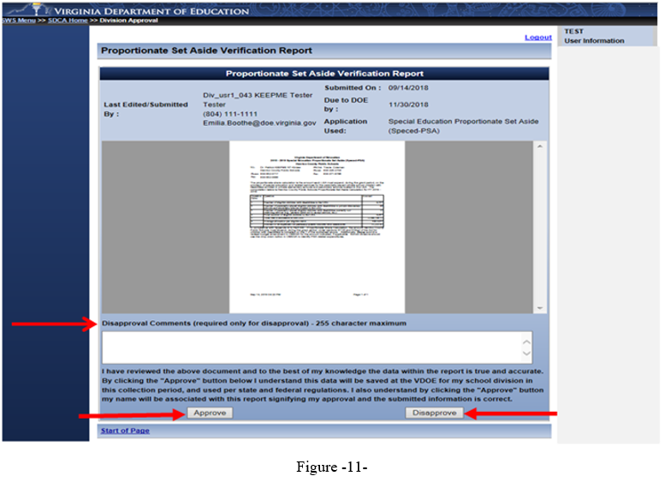

- Figure 12 displays the screen after the approve button is clicked. The approval of the verification report represents the Superintendent’s or Designee’s electronic signature and indicating accuracy and completeness of the submitted data. If a revision is needed after the approval is completed, or if the Superintendent did not electronically sign the verification report after the due date, the division must contact VDOE to re-open the collection window to complete submission.

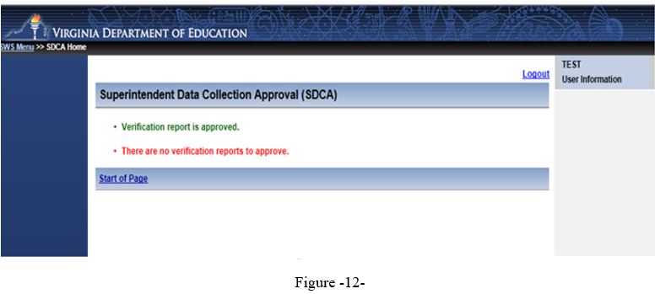
Attachment A
Superintendent’s Memo No. 252-19
October 18, 2019
- Figure 13 displays the screen after the disapprove button clicked. All disapproved submissions requires a data note in the comments box so the system can process the request. Once the disapproved submission is processed, the collection window will automatically re-open and edits are permitted. If the Superintendent did not electronically sign the verification report after the due date, the division must contact VDOE to re-open the collection window and complete submission.

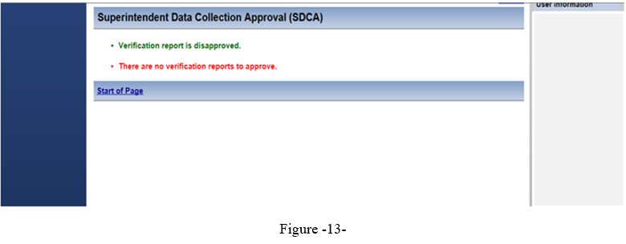

- Figure 14 displays the screen after the verification report is approved and completed. The online approval is replacing the paper verification report so divisions are no longer required to submit copies of paper verification reports. Also, approval must be made with in the established due date of the data collection for the submission to be considered complete. Unsigned verification reports after due date will be tagged as late submission.

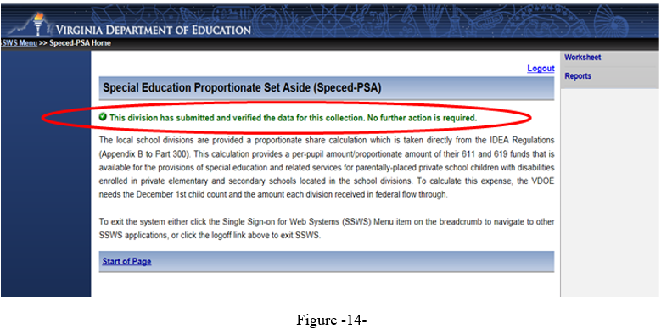

Please note the collection window will open on October 21, 2019, and closes on November 29, 2019. Divisions not submitting the Speced-PSA calculation will be contacted individually and will be required to follow a protocol to reopen the collection window. This protocol will be shared with those specific school divisions. Late submissions and inaccurate reporting of information will affect the school division’s local determination matrix and will trigger a review.

