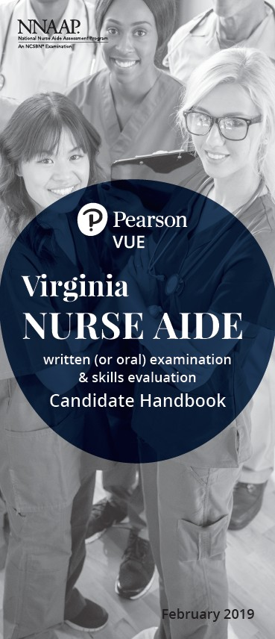

Pearson VUE invites VA Nurse Aide Faculty and Instructors, attending the Virginia Health and Medical Sciences Educators Association Summer Conference, to a presentation on the National Nurse Aide Assessment Program (NNAAP).

Topics will include:

- Review of the NNAAP Skills Evaluation

- Candidate Preparation Expectations/ Experience

- Most Missed Skills and Steps

