Attachment A, Superintendent’s Memo #088-19
April 12, 2019

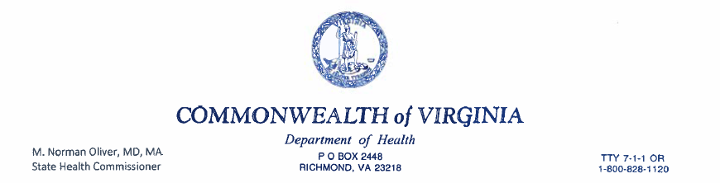March 4, 2019
Dear Parents of Rising Sixth Graders:
The 2007 General Assembly passed legislation that requires sixth grade girls to receive the Human Papillomavirus (HPV) vaccine series. The law also requires the Virginia Department of Health (VDH) to provide parents/guardians of rising sixth-graders with information about the vaccine. In 2011, the Centers for Disease Control and Prevention (CDC) made an additional recommendation that boys of the same age routinely receive HPV vaccine.
Healthcare providers diagnose about 40,000 new cases of cancer related to HPV each year. As State Health Commissioner, I know that you make many decisions to protect your child from disease. We share this goal. The HPV vaccine can help protect your child from the nine strains of HPV most associated with cancer. This includes cervical cancer in women and cancers found in the mouth and back of the throat in men. The HPV vaccine works best when it is given to a child prior to exposure to the virus. Just as having your child buckle up when riding in the car or wear a helmet when biking protects their health, the HPV vaccine protects children from HPV-associated cancer that may develop later in life.
Please review the information provided with this letter. The HPV vaccine is safe and can help protect your child from cancer. After reading this information, as the parent or guardian you may choose for your child not to receive the HPV vaccine. VDH strongly recommends that children be vaccinated per CDC recommendations. Please contact your health care provider to determine when your child can receive the vaccine series and discuss any questions you have. HPV vaccine is available from your healthcare provider, local health departments or at military clinics. Please provide documentation to your child’s school in order to update your child’s school immunization record.
Should you have any questions please contact Janaye Oliver, Adolescent Immunization Coordinator at the Virginia Department of Health, by telephone at (804) 864-8073 or by email at Janaye.Oliver@vdh.virginia.gov. You may also contact Tracy White, School Health Nurse Specialist at the Virginia Department of Education, by telephone at (804) 786-8571, or by email at Tracy.White@doe.virginia.gov.
Sincerely,
M. Norman Oliver, MD, MA State Health Commissioner
www.vdh.state.va.us

