Kindness Week Classroom Resources

Kindness Videos for Kindergarten through Second Grade
Title of Video | Discussion Questions
Color your World with Kindness (Cartoon)  2.14 minutes | - Why did kindness create color?  - If kindness was a color what color would it be?  - How can you make our world a better place?
Kid President: 20 Things People Should Say More Often  3.5 minutes  Follow-up with more ideas | - Which was your favorite? Why?  - What do you think should be on our class list of 20 things people should say more often?
Kind Hearted Hands 2 minutes  Music video with real kids performing kind actions in a school setting! | - What examples of kind actions did you see in this video?  - Has anyone ever done one of the examples of kind actions for you at Swift Creek?  - How did it make you feel?
Rude Cakes Read-Aloud Hilarious read-aloud story about a rude cake who learns a timely lesson about kindness!  5 minutes | - How was the rude cake unkind at the beginning of the video?  - Why did the giant cyclops decide to let the rude cake go?  - Do you think the rude cake will change his ways?
Easy Ways to Make Your School A Kinder Place  Real kids sharing their ideas for making their school a kinder place. Inspirational and accessible.  2 minutes | - What ideas are your favorite?  - Can you think of anything the video left out?
Lifevest Video: Shows how one kindness leads to more!  5.5 minutes | - Did all of the acts cost money?  - Why do you think this video has so many views?  - What did you think of the end? What message did it show?

Kindness Videos for Third Grade and Up
Title of Video | Discussion Questions
10 year old girl gives a speech about kindness  4 minutes | - What is her message? Do you agree with her?  - What do you think she hopes her message will do?  - What is your takeaway from this video?
Kid President: 20 Things People Should Say More Often  3.5 minutes  Follow-up with more ideas | - Which was your favorite? Why?  - What do you think should be on our class list of 20 things people should say more often?
Everyday Heroes: Ricky (RAKE)  Comedian that took Kindness on the Road.  5 minutes | - Why do you think some people hesitated to take an umbrella?  - How did Ricky change someone’s day in the video?  - Is Ricky happy? Why do you think he is or is not?
Amazing video created by a middle school to show the power of empathy  2 minutes | - What is empathy?  - How did things change when empathy took over in the second part?  - What do we need to do to show empathy?
Lifevest Video: Shows how one kindness leads to more!  5.5 minutes | - Did all of the acts cost money?  - Why do you think this video has so many views?  - What did you think of the end? What message did it show?
Play Harry Styles Song: Treat People with Kindness (if showing music video be aware that there are some alcoholic beverages during a few scenes). | - How can we make school a place where people feel good?  - What stands out to you when I read this part of the lyrics? Why? “Giving second chances. I don’t need all the answers. Feeling good in my skin. I just keep on dancing.’”

Kindness Book List (Elementary)
The Monster Who Lost His Mean
Everyone knows that the M in "monster" stands for MEAN. But what happens when a monster can't be mean anymore? Is he still a monster at all? One young monster's attempts to live up to his name go hilariously awry as he discovers with a little help from new friends that it's not what you're called but who you are that counts.

Ordinary Mary’s Extraordinary Deed
Can one child's good deed change the world?
It can be when she’s Ordinary Mary an ordinary girl from an ordinary school, on her way to her ordinary house who stumbles upon ordinary blueberries. When she decides to pick them for her neighbor, Mrs. Bishop, she starts a chain reaction that multiplies around the world.

Mr. Peabody’s Apples
"Mr. Peabodyís Apples takes place in 1949 in Happville, USA. Mr. Peabody is the beloved elementary school teacher and baseball coach, who one day finds himself ostracized when rumors spread through the small town. Mr. Peabody silences the gossip with an unforgettable and poignant lesson about how we must choose our words carefully to avoid causing harm to others.

Enemy Pie
In this funny yet endearing story, one little boy learns an effective recipes for turning your best enemy into your best friend. Accompanied by charming illustrations, Enemy Pie serves up a sweet lesson in the difficulties and ultimate rewards of making new friends.

Juice Box Bully
Have you ever seen a bully in action and done nothing about it? The kids at Pete's new school get involved, instead of being bystanders. When Pete begins to behave badly, his classmates teach him about "The Promise". Will Pete decide to shed his bullying habits and make "The Promise"?

Ripple's Effect
The new dolphin at the aquarium, Ripple, is surprised that no one will play with her. No one plays or has any fun at all, because of Snark and his shiver of sharks. Choosing to have fun, Ripple challenges Snark to a staring competition if she can make Snark smile, Ripple wins and everyone gets to play. If not, Snark's no-fun rules will rule. Will Ripple's smile be enough to save the day?

Growing Up With a Bucket Full of Happiness
This is the sequel to Have You Filled a Bucket Today? features easy-to-read chapters, colorful illustrations, and daily questions to help the reader become better bucket fillers and give them the tools to live a life filled with happiness.

What does it mean to be kind?
When the girl in the red hat finds the courage to be kind to the new student in class, her kindness spreads. Kind act by kind act, her whole community experiences the magical shift that happens when everyone understands―and acts on―what it means to be kind.

Spaghetti in a Hot Dog Bun
How can Ralph be so mean? Lucy is one of a kind and Ralph loves to point that out. Lucy's defining moment comes when Ralph truly needs help. Because she knows what she stands for, Lucy has the courage to make a good choice. This charming story empowers children to always do the right thing and be proud of themselves, even when they are faced with someone as challenging as Ralph.
The Jelly Donut Difference
Leah and Dexter are brother and sister. They don’t always get along. In fact, there are times they can be downright mean to each other. The ooey, gooey jelly donuts in this story are a testament to the power of kindness, caring and generosity. Find out if Leah and Dexter will ever learn to get along!

Stand in My Shoes
When Emily asks her big sister what the word empathy means, Emily has no idea that knowing the answer will change how she looks at people. But does it really matter to others if Emily notices how they're feeling? Stand in My Shoes shows kids how easy it is to develop empathy toward those around them. Empathy is the ability to notice what other people feel. Empathy leads to the social skills and personal relationships which make our lives rich and beautiful, and it is something we can help our children learn. This book teaches young children the value of noticing how other people feel. We're hoping that many parents read it along with their children.

The Invisible Boy
Meet Brian, the invisible boy. Nobody ever seems to notice him or think to include him in their group, game, or birthday party . . . until, that is, a new kid comes to class. When Justin, the new boy, arrives, Brian is the first to make him feel welcome. And when Brian and Justin team up to work on a class project together, Brian finds a way to shine.

Each Kindness
This unforgettable book is written and illustrated by the award-winning team that created The Other Side and the Caldecott Honor winner Coming On Home Soon. With its powerful anti-bullying message and striking art, it will resonate with readers long after they've put it down.

Have you Filled a Bucket Today?
This heartwarming book encourages positive behavior by using the concept of an invisible bucket to show children how easy and rewarding it is to express kindness, appreciation and love by "filling buckets."

How Full is Your Bucket?
The story of a boy who learns a valuable “bucket filling” metaphor and watches it come to life as the day unfolds. Each of us has an invisible bucket. When our bucket is full, we feel great. When it’s empty, we feel awful. Yet most children (and many adults) don’t realize the importance of having a full bucket throughout the day.

The Giving Tree
Every day the boy would come to the tree to eat her apples, swing from her branches, or slide down her trunk...and the tree was happy. But as the boy grew older he began to want more from the tree, and the tree gave and gave and gave. Shel Silverstein has created a moving parable for readers of all ages that offers an affecting interpretation of the gift of giving and a serene acceptance of another's capacity to love in return.

Will You Fill My Bucket?
A simple question, “Will You Fill My Bucket?,” is fervently asked by children from twelve different countries. This picture book has sweet rhyming prose, repetition, and vividly captivating illustrations that delight the senses and express the deep joy and love we hope for all children.

Halle and the Tiger with their Bucket Filling Family
Halle has her job cut out for her; she has to teach the new cat, Tiger, all about bucket filling. But Tiger keeps making mistakes. Will Halle be able to teach Tiger about bucket filling?

Kindness Counts!
When Cade's and his family find out their ice cream order was paid for by another patron, they continue paying it forward, and so starts the discussion of random acts of kindness. But when Cade's dad would like him to donate some of his own toys, he has a hard time. Will Cade be able to learn the importance of being kind to others, even when it isn't easy?

Will You Be the I in Kind?
Join the fun as “K-nd” goes on an adventure to find his missing ‘i’. Along the way, he meets a group of children who learn what it means to share their kindness through everyday actions. This engaging story will spark conversations about the concepts of kindness, empath, and compassion.

Be Kind
Each act of kindness, big or small, can make a difference or at least help a friend. What does it mean to be kind? When Tanisha spills grape juice all over her new dress, her classmate contemplates how to make her feel better and what it means to be kind.

Kindness is Cooler, Mrs. Ruler
When a kindergarten class gets rowdy, Mrs. Ruler knows just what to do. She’s about to teach a new golden rule: KINDNESS IS COOL! Soon the entire class is doing so many good deeds that their kindness bulletin board barely fits their classroom.

The Kindness Quilt
Minna and her classmates have been asked by their teacher, Mrs. Bloom, to work on a Kindness Project. Mrs. Bloom wants them to do, draw and share an act of kindness. Minna and her family do lots of kind things, but Minna can’t decide which one is right for her project. Then she starts writing and drawing and cutting and an idea for a paper quilt picturing many acts of kindness begins to take shape!

Those Shoes
All Jeremy wants is a pair of those shoes, the ones everyone at school seems to be wearing. Though Jeremy’s grandma says they don’t have room for “want”, just “need,” when his old shoes fall apart at school, he is more determined than ever to have those shoes, even a thrift-shop pair that are much too small. But sore feet aren’t much fun, as Jeremy soon sees that the things he has–warm boots, a loving grandma, and the chance to help a friend—are worth more than the things he wants.

I Walk with Vanessa: A Story about a Simple Act of Kindness
The book explores the feelings of helplessness and anger that arise in the wake of seeing a classmate treated badly, and shows how a single act of kindness can lead to an entire community joining in to help.

The Big Umbrella
By the door there is an umbrella. It is big. It is so big that when it starts to rain there is room for everyone underneath. It doesn’t matter if you are tall. Or plaid. Or hairy. It doesn’t matter how many legs you have. Don’t worry that there won’t be enough room under the umbrella. Because there will always be room.

Whiteboard Messages
A simple and fun way to start a discussion or get students thinking first thinking! Use whiteboard messages as a transition tool after lunch/recess/resource or a morning warmup. These can be short and sweet or the start to a writing prompt. You can also make one of these a center in your guided reading rotations!

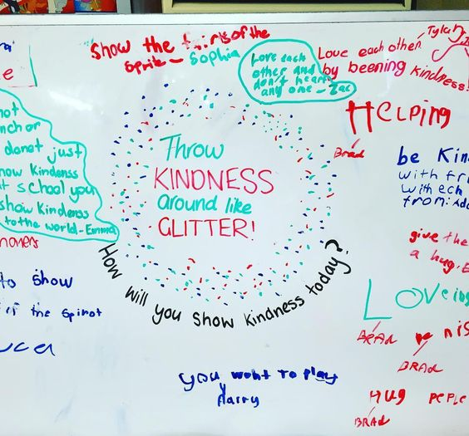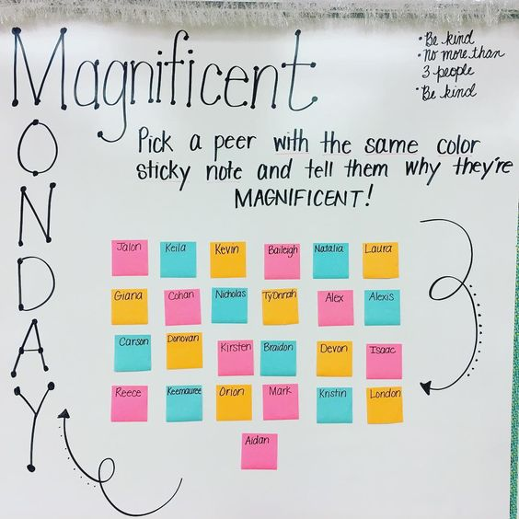
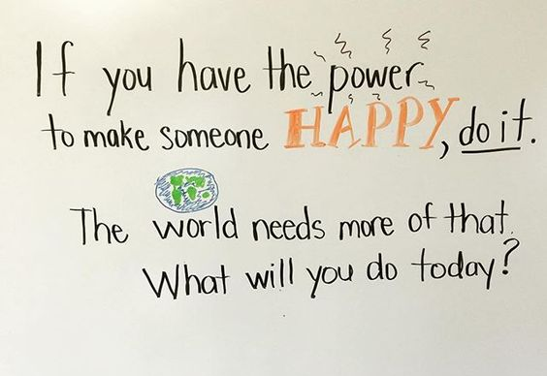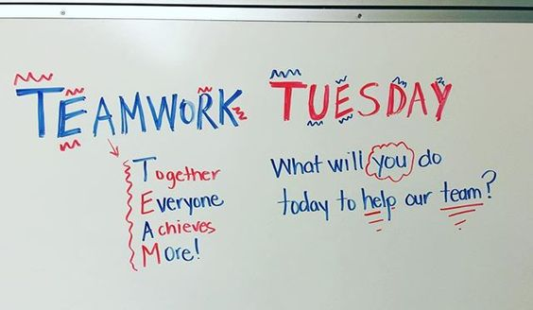
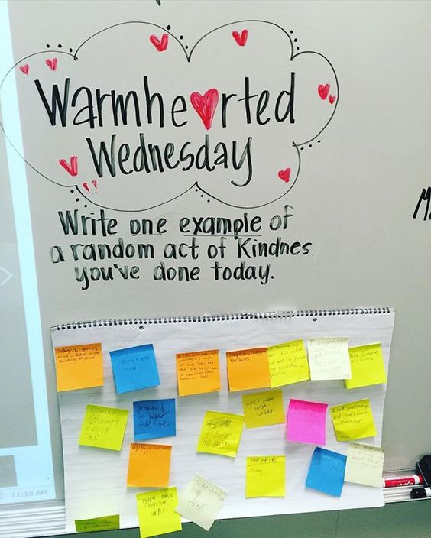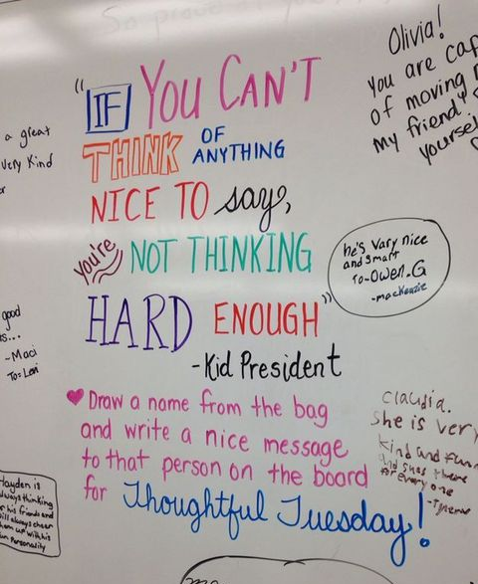

Morning Meeting Examples

Hello Friends! Circle Game
All students stand at their spots. One chair (or spot marker, depending on your room and set up!) is taken away. The first student who volunteers goes to the middle of the room and says “Hello Friends!” All students say back “Hi Friend!” The student in the middle says “I like all my friends in my class, but especially those who…” and shares either something about themselves or something they like to do (i.e., has two sisters, likes to ride bikes, loves chocolate ice cream, etc.). All students on the outside who identify with that statement move across the circle to find a new spot. There is one spot less than students, so the last student to find a spot will be in the middle. Cycle through the game until all students who want to be in the middle have had a turn. Point out to students what they have in common/how despite their differences they can all still be friends.

Chain of Connection
Materials: Strips of paper, half as many as the number of students, stapler
Directions: Divide students into pairs of two. Give each pair a strip of paper and ask them to figure out something they have in common and write or draw it on their paper strip. As the pairs finish, they can stand and present their common interest to the group. Students who also have that in common can raise their hand and have their link stapled to the first pair. Then the second pair stands and shares out their common interest and so on until all the links are connected. The chain can be used to decorate the classroom during Kindness Month!

Mix-Pair-Share
Students Mix (walk around the room) while music plays, when it stops they turn to the person closest to them and give them a high-five to “pair up.” Then they share their thoughts about the question.
- Round 1: Smile at your partner and greet them by name.
- Round 2: Give your partner a hi-five!
- Round 3: Compliment your partner.

Music Options: What I Am, Happy, Can’t Stop the Feeling

Wrap Up: Ask students to share how it feels to get a compliment from their classmate, to be smiled at, or to get a high five! Ask if they felt their school would be a happier place if these things happened more often.

Looking for more ideas?
Take a look at Bristow Run Elementary School’s webpage for a collection of Kindness videos, books, songs, quotes and more!

